CPP CONNECT

Disability Resource Center Advising – Student Guide
Please follow the steps to schedule an appointment:
Step 1: Log-in to CPP Connect at www.cpp.edu/cppconnect. The login button may be located below one of the YouTube videos.
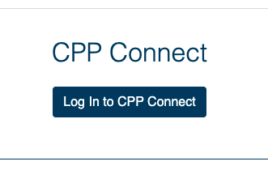
Step 2: On your CPP Connect Home Page, Go to the Appointments menu blue button located in the top right corner.
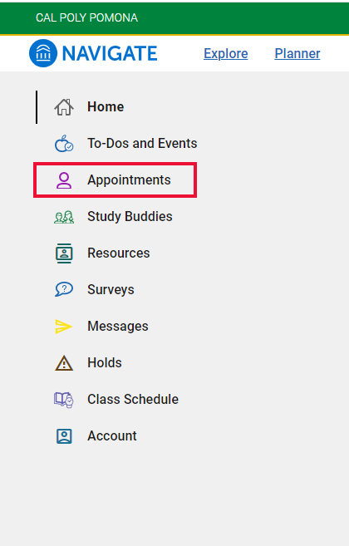
Step 3: Click
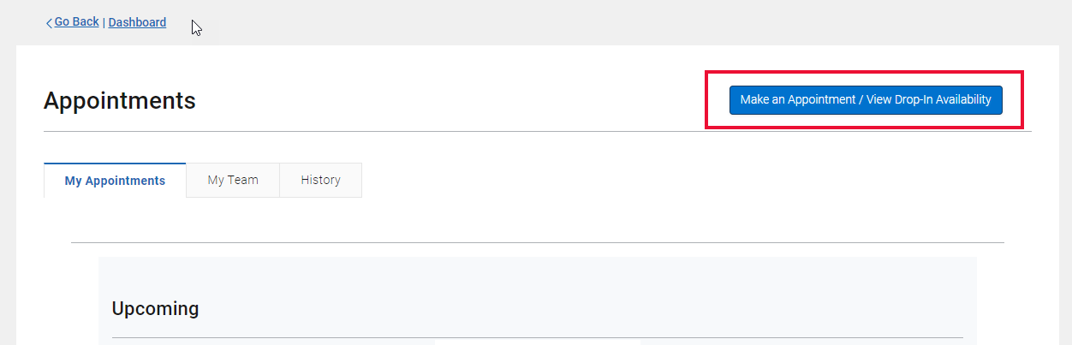

Step 4: Select the following options for the three questions below, then click Next.
- What type of appointment would you like to schedule? Choose “Advising” from the dropdown menu.
- Choose a reason for your appointment from the following options and click Next. Choose “DRC Advising” from the dropdown menu.
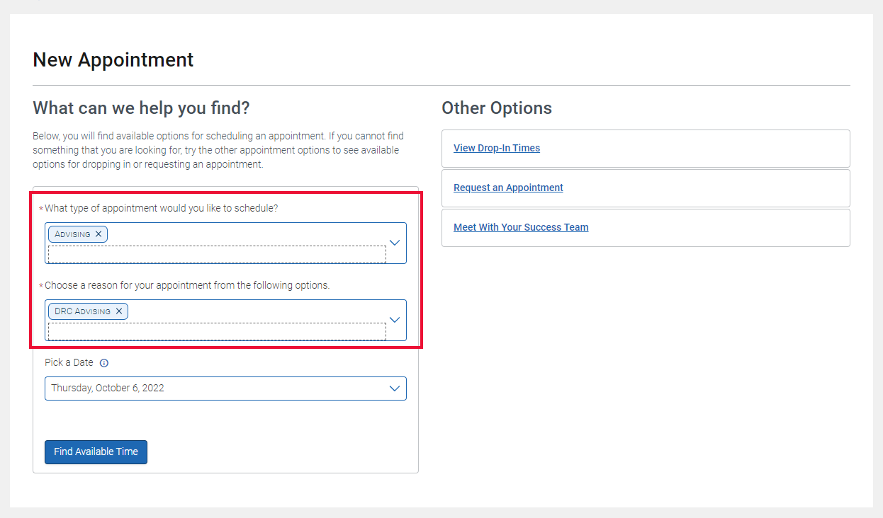

Step 5: Select a date and time that works best for you. All times are in Pacific Time.
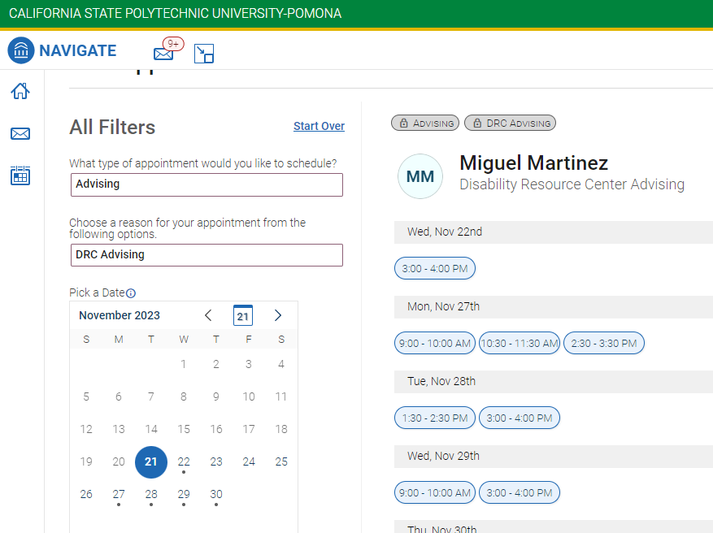

Step 6: Review your appointment details and confirm the appointment.
