Kurzweil for Mac
If you have Kurzweil installed on your computer, open Kurzweil and log-in with your credentials. If you need to install Kurzweil install the newest version (choose Subscription/Web-License Version).

Setting-up the App
- Open Kurzweil app and login.
- For easier access to Kurzweil 3000, make sure to right click the app icon and in the options section, select “keep in dock.”
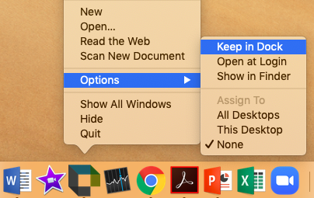

Turn off Tip of the Day
- Click the “Kurzweil 3000” Menu, click “Preferences…”

- General tab you can uncheck “Show Tip of the Day” if you don’t want to see the tip every time you open Kurzweil
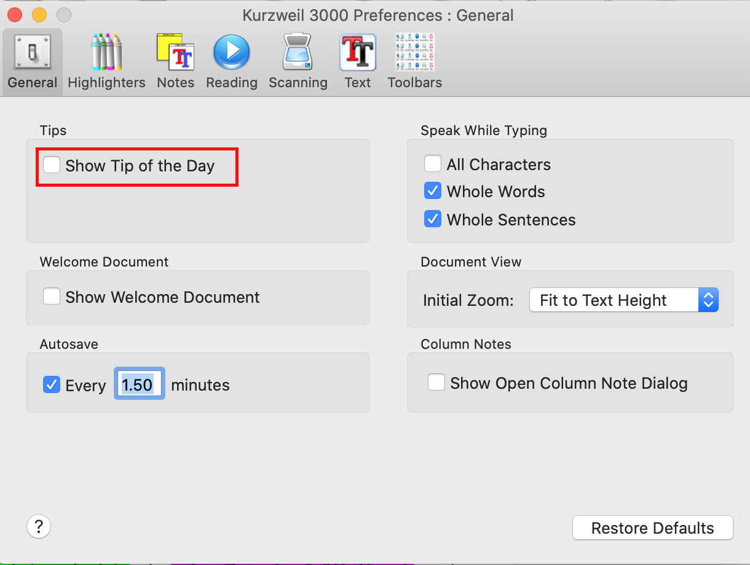

Classic View
Open a Kurzweil file, select the “View” menu, and in “Current Toolbar” select “Classic”
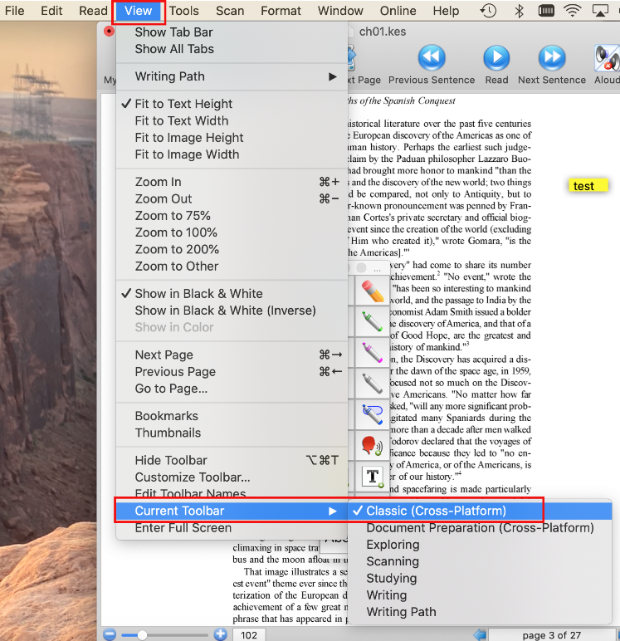

Reader Window
The reader window is a small window with quick access to the audio settings, play, forward, back and pause buttons.
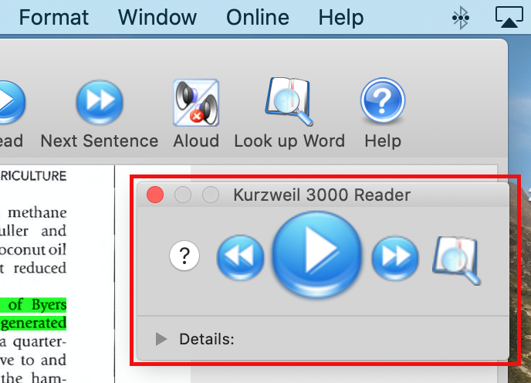
You may have accidently closed the Reader window and now cannot find it. You can open the Reader by clicking on the Window menu at the top and clicking Show Reader.

Tools Window
The tools window allows for quick access to the highlighter and note tools.
To see the tools window with the highlighter and sticky notes, click Window menu at the top and choose Show Tools
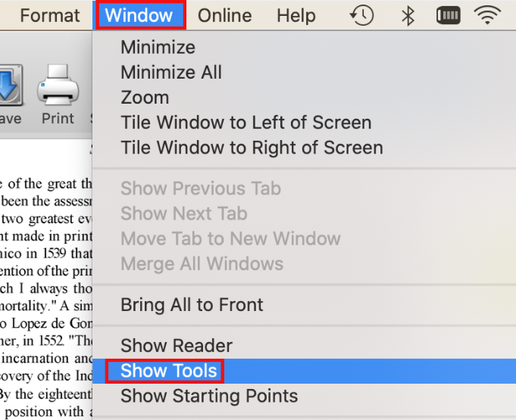

How to Upload Books to your Kurzweil Library
- Click the File menu, then choose Open
- Find the file on your Mac that you wish to upload
- Once the file has been opened, Click on the “File” menu at the top and select “Save to Library...”
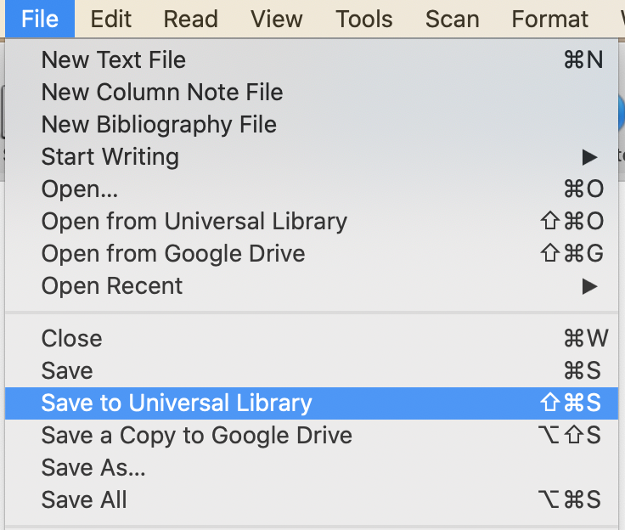
- Locate the folder you want to save it in or use the New Folder button to create a new folder
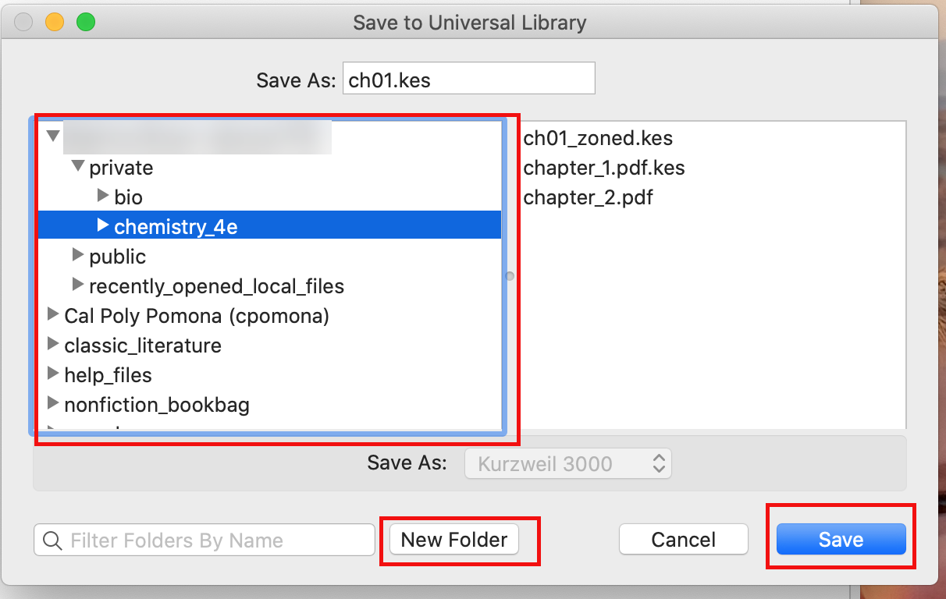

Reading Options
- To start reading click the “read” button, looks like a play button.
- Whenever you want to pause the reading, click on the “pause” button.
- To move on from page to page, click on the arrows on the bottom right of the window.

Changing Reading Speed and Voice
- From the Reader window click the “Details” button window
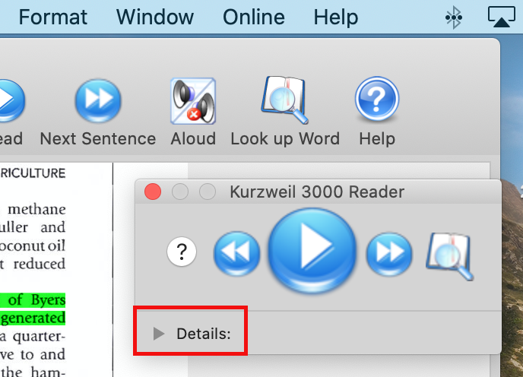

- To change the reading voice, click on “Read” and then click “Reading Voice” and select your choice, as demonstrated below.
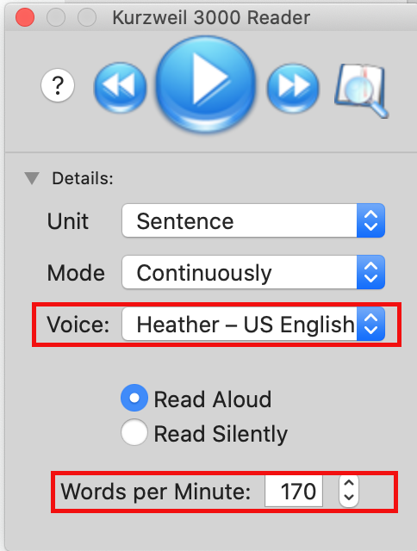
If you cannot find your Reader window, see steps above how to open it again.

How to Highlight
- From the Tools Window choose your highlight color
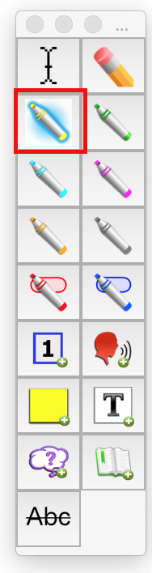
- With your cursor, highlight the desired text.
If you cannot find your Tools window, see steps above how to open it again

How to Annotate
- From the Tools window, click on the sticky note.
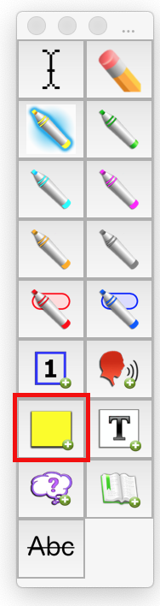
- Click on document where you want to add the note.
- The note should appear
- To type in the sticky note, just click the note once and typing should now be an option
- You can change the size of the note by dragging the corners to the preferred magnitude.
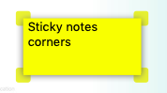
- To move the sticky note, simply click and hold the note and move it to your desired location.
If you cannot find your Tools window, see steps above how to open it again

How to extract Highlights and Annotations
- Hover with your cursor over “File” in the top screen menu.
- Click “Extract Notes & Highlighted Text...”
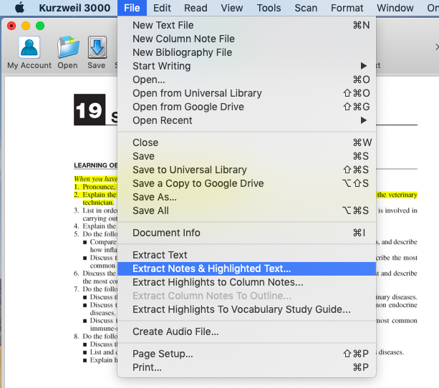
- Select the format and type of notes you would like extracted.
- Once your preferences are selected, click on “Extract.”
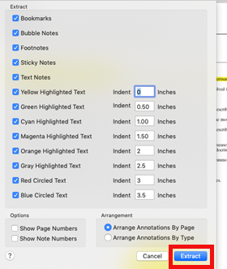
- The notes will be displayed in a new window as displayed below, with your text ready to be copied to another document.

How to Create Audio files
- Once you have your document open, Click “File”
- Click on “Create Audio File”
- Once you click “Create Audio File,” there will be many options on the menu that should be selected according to your personal preferences. The choices will be the following as presented on the image:
  - What voice and in which language to include.
  - What texts to include in the audio file.
  - The format of the file, MP3 works on iPhone and other android devices.
  - Check or uncheck “Copy to iTunes/Music as audiobook Named:” according to personal preference.
- Once you are finished selecting your preferences, click “Ok.”
- If you unchecked “Copy to iTunes/Music as audiobook Named:” you will be prompted to save the file to a location of your choice on your computer.
