Kurzweil 3000 Online

How to Upload Books to your Kurzweil Library
- Kurzweil files, PDFs and Word documents must be saved to your computer before they can be uploaded. If your file is in a zip folder, you must unzip the folder first.
- Go to https://www.kurzweil3000.com/KLogin.php# and log in with your credentials.
- Create a Folder with your textbook name by right clicking on one of the yellow folders. Note: Folder names may not contain spaces and must be created only using letters, numbers and underscores.
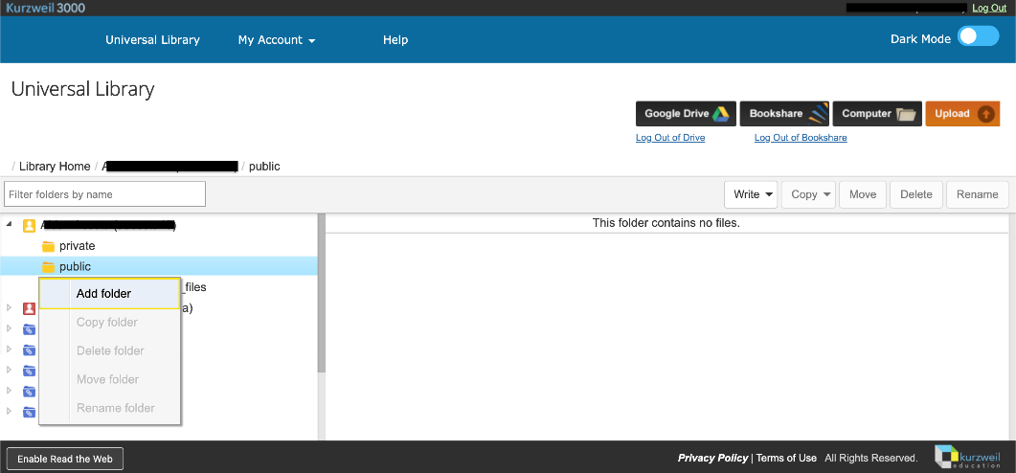
- Once the folder is created, click the Upload button on the top right of the screen.
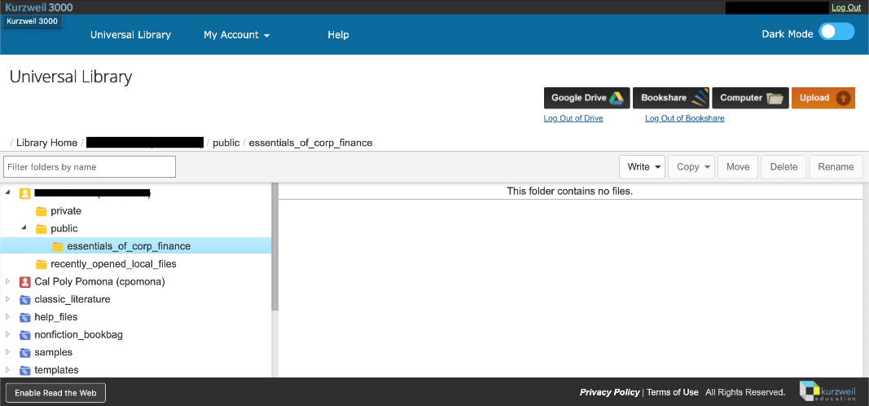
- Once you have selected the file to upload, click the open button on the lower right-hand side of the screen. Note: Files must be uploaded to the universal library one at a time.

How to Read your Document
- Begin by configuring your reading options, which can be found on the top ribbon. Use this to configure reading speed, voice, and units.
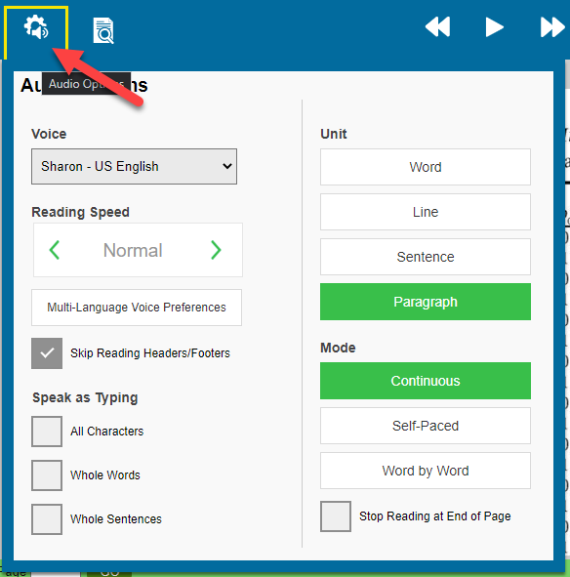
- Next, use the View tab to configure how you want your page to look. Use this to change zoom, page color, and to show bookmarks.
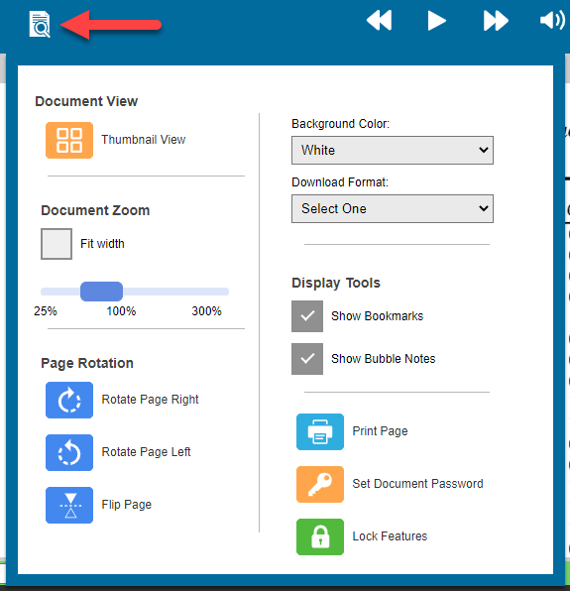
- Start reading by clicking the play button on the top ribbon. The next, or back arrows, are used to skip by which unit you have selected as your preference.
- Use the three bars in the top left to return to the library or access another document.
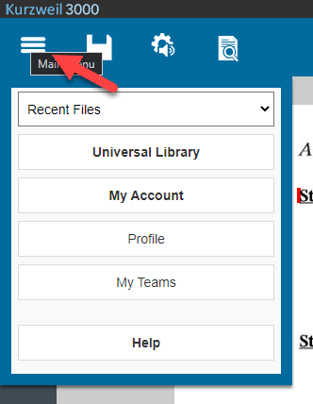

How to Highlight and Add Notes
- To highlight, select the highlight tool, and choose your color
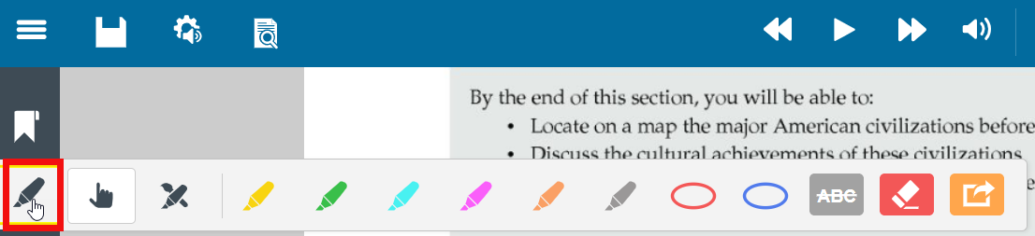
- Click and drag on the text that you wish to be highlighted.

- We recommend the use of the sticky notes option.
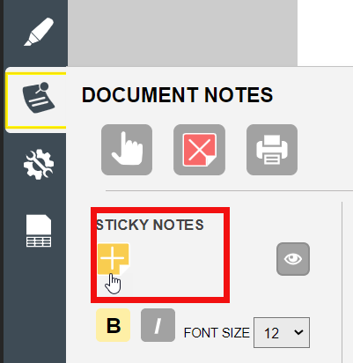
- Click on the “Sticky Notes” icon in the toolbar menu. Click on the book where you want the note and start typing
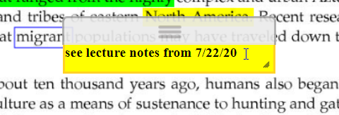

How to Extract Highlights and Annotations
- Click the highlighter tool
- Click “Extract Notes & Highlighted Text...”
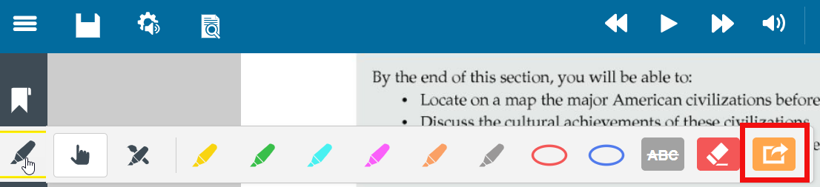
- The notes and highlights will be added to a blank Kurzweil document. We recommend copying and pasting this to a Word document for ease of access later.

Kurzweil offers video tutorials on the following:
- Upload Local Content in The Universal Library
- Overview of Kurzweil 3000 Web

