Parking Online Site Tutorial

Step 1:
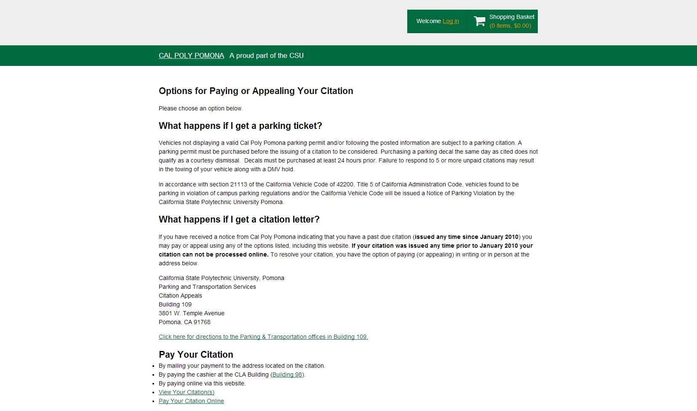Log onto http://csupomona.t2hosted.com and select “Log in” at the top right corner.

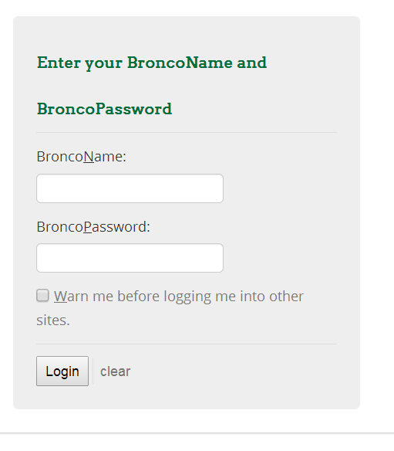Step 2:
When you select “Log in”, it will give you the option for Affiliated Login or Guest Login. All students must login under Affiliated Login.

Students will use their Cal Poly Pomona
University email user name and password.

Your Bronco name should not include
@csupomona.edu

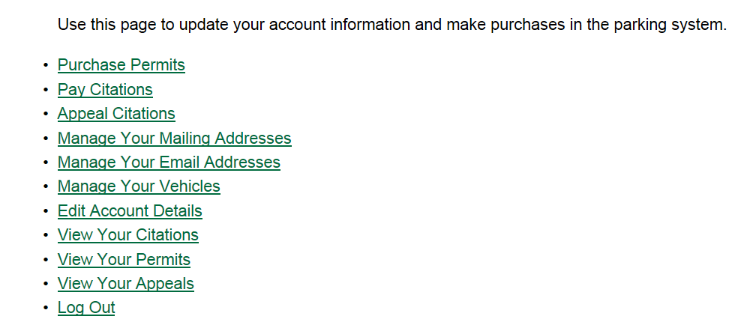Once logged in, all users will see the page below.

Step 3: Manage mailing address, email address, and vehicles.

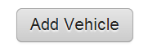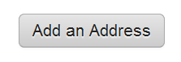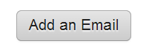Please ensure to add in your current mailing address, email, and vehicle information to receive your permit.

On any address, email, and vehicle if you have multiple entries you will be allowed to select a priority of the one most used or your preference.

Additional Features
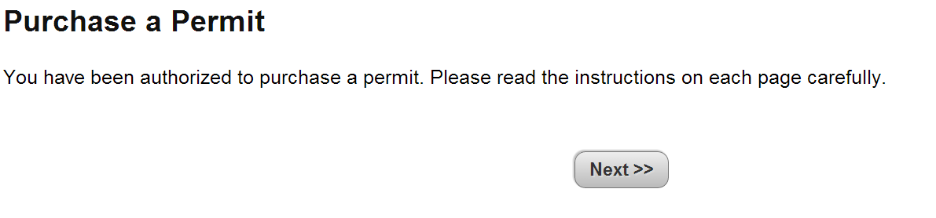4.1 Purchase Permit

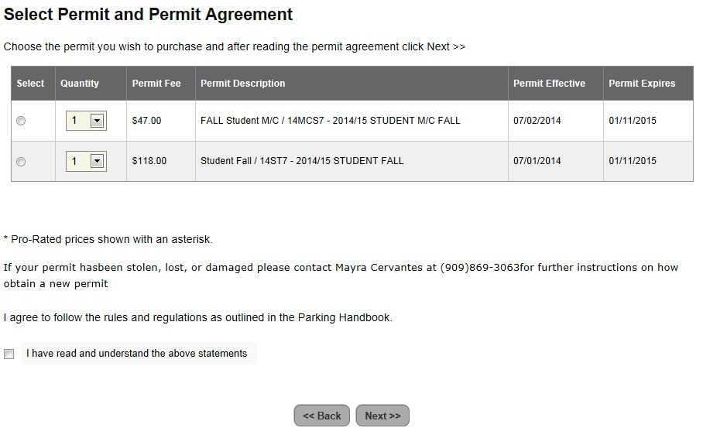Based on your classification determined by the University, the permits listed are the only ones you are authorized to purchase. Housing students will only see a housing option, etc.

You will be required to assign a vehicle to your permit. There is an option on the site to assign multiple vehicles under Manage Your Vehicles. The permit will only request one vehicle to be directly assigned.

For any special circumstance in relation to parking and permits, please contact the Parking
Office at (909)869–3061 for further assistance.

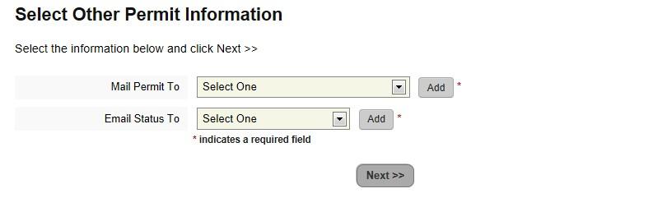It is highly important that the “Mail Permit To” is the address where the permit should be delivered. Please double check it is the correct delivery address.

Continue through each screen until you are directed for your payment information. If you encounter any issues please contact (909)869–3061 for further assistance.

4.2 Pay Citations, Appeal Citations, View Your Citations

In the event you receive a citation, through this site you’ll be able to view, appeal, or pay your
citations linked to your account.

