How to change a class to fully online using (A) Asynchronous or (S) Synchronous Instruction Modes

What is Asynchronous? Instruction Mode A is used for classes that are fully online and the students will not need to meet online at a scheduled day/time with the instructor.
Instruction Mode A Setup:

- Leave the meeting pattern blank (no Facility ID, Times and Days)
- Enter TBA in the PAT field

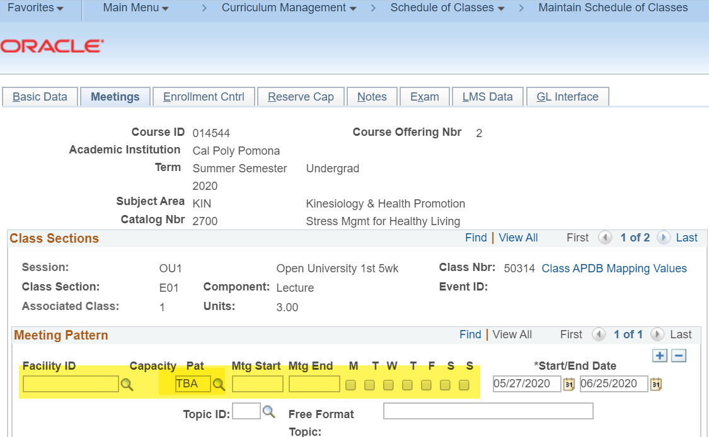

What is Synchronous? Instruction Mode S is used for classes that are fully online, however, the students will meet online at a scheduled day/time with the instructor.
Instruction Mode S Setup:

- Enter in the meeting pattern with the days and times the class will meet together online.
- Enter a facility ID of 998 1000 (the description is “OnCamp OnL 1000” and is not on campus)

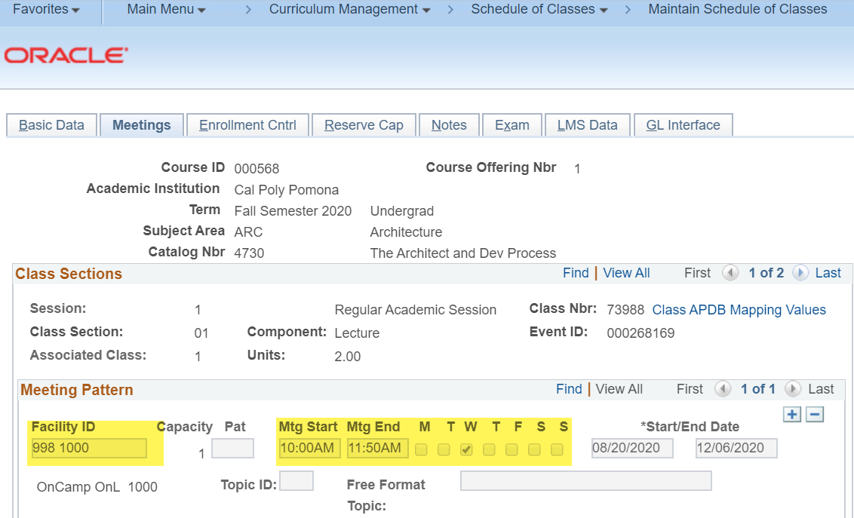

If the class needs to meet online a few days of the term, use Instruction Mode S.
- Enter the specific days that the students will need to meet online
- Leave one meeting pattern blank, with only TBA entered in the Pat Field
