California State Polytechnic University, Pomona * 3801 West Temple Avenue, Pomona, California 91768

Cars Visiting BioTrek

*** Driving Directions ***
From Los Angeles:
Take the 10 freeway EAST and exit at Kellogg Drive. Make a right onto University Drive. Follow University Drive past two stop signs until you reach M lot (just before third stop sign) and make a right.
From Orange County:
Take the 57 freeway NORTH to Temple Avenue and exit west (left-hand turn) to the campus. Make a right at University Drive. Follow University Drive until you reach M lot and make a left.
From The Inland Empire:
Take the 10 freeway WEST and exit at Kellogg Drive. Make a right onto Kellogg Drive and then another right onto University Drive. Follow University Drive until you reach M lot and make a right.
From the Pasadena area:
Take the 210 freeway EAST to 57 Freeway SOUTH. Exit on Temple Avenue and turn west (right-hand turn) towards the campus. Make a right onto University Drive. Follow University Drive until you reach M lot and make a left.

10 Freeway
Exit Kellogg Drive
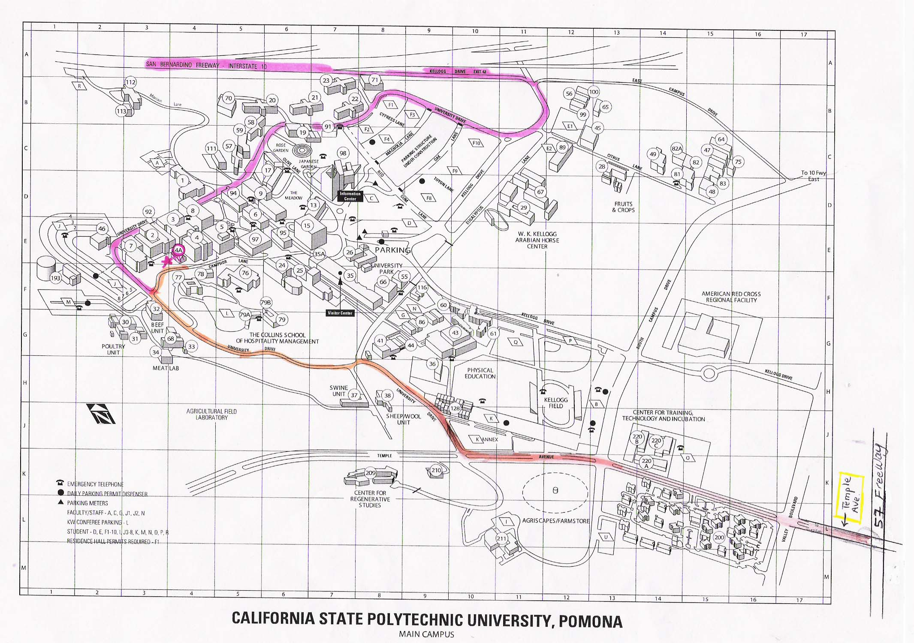
University Drive

University Drive
Temple Avenue
57 Freeway
Exit Temple Avenue
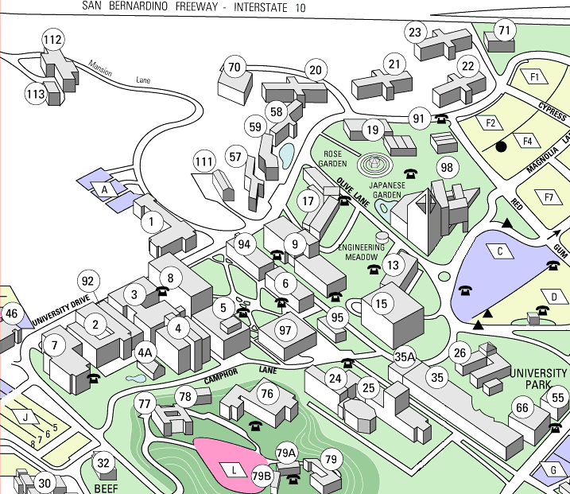

BioTrek

M Lot

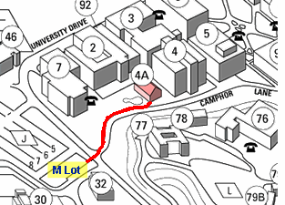

*** Parking Information ***

Parking passes are available for $5 from vending machines in student parking lots J or M above us on University Drive. On Saturdays parking is $3.

*** Questions/Concerns ***
Contact Michael Brown - BioTrek Curator
Office: (909) 869-4072, Cell: (909) 762-4230

