Cal Poly Pomona Black Thriving Initiative
2022-2023 Report
Kayla Mayweather, CPP Student
“America has lied to its children for centuries, offering them songs about freedom instead of the liberation of truth. We must get on the same page before we can turn it. It is time to tell the truth with a process that enrolls all of us in facts, truth, and love, so that we can move forward with a new story together.” - Heather McGhee, author of The Sum of Us

Table of Contents
Section | Page
Co-Chairs Joint Statement | 1
President's Message | 2
The Urgency Behind the Black Thriving Initiative | 3
The First Listen: Understanding Our Black Community's Experiences | 5
Data and Testimonies: Cal Poly Pomona's Reality
Juneteenth: Solidifying Institutional Commitment
Community Reflections | 8
The Black Thriving Initiative Overview | 11
Conceptualizing an Institutional-Level Initiative | 11
Convening the Black Thriving Initiative 2022-2023 Working Group Members | 12
2022 Black Thriving Initiative Symposium Launch Event | 13
Black Thriving Initiative Excellence Fund | 14
The Deep Listen (Phase I): Build Capacity and Critical Consciousness | 15
Preparing for Campuswide Feedback Sessions | 15
Approaching The Feedback: Data Overview, Considerations and Advice | 16
BTI Member Checking Process | 18
Theme #1: Cal Poly Pomona does not Live up to its Equity, Diversity, and Inclusion Rhetoric | 19
Theme #2: Listen to Black Voices—Anti-Blackness Harms All Communities | 20
Theme #3: Campus Community Members Need Tailored Educational Experiences | 21
Theme #4: The Improvement of the Black Experience Improves Equitable Outcomes for All | 22
Theme #5: Institutional Accountability Without Personal Accountability Will Not Work | 23
Black Thriving Initiative's Preliminary Recommendations | 24
Recommendation #1: Proactively Address Cal Poly Pomona's Complex Racial Climate | 26
Recommendation #2: Increase Education, Trainings, and Workshops Around Racial Justice | 28
Recommendation #3: Make Policies, Practices, and Procedures More Equitable & Culturally Relevant | 30
Recommendation #4: Increase and Retain Black Student, Faculty, and Staff Numbers | 32
Recommendation #5: Provide Black Students, Faculty, and Staff with Equitable Professional Development Opportunities | 33
Next Steps (Phase II): Leverage the Mission | 36
CSU Black Student Success Report: Institutional Commitments | 39
Supporting Black Student Success | 40
A Call To Action: Expressions of Gratitude and Hope | 41
Conclusion | 42

Page 1

Co-Chairs Joint Statement
Campus Community,
Despite deep-seated systemic racism and inequities that are still woven into the fabric of our institution and world, CPP's Black community is brilliant, beautiful, resilient, powerful, excellent, magical, unbreakable, legendary. Black students, faculty, and staff at Cal Poly Pomona (CPP) continue to clamor for the campus's promise of inclusive excellence and justice. As a campus, we must truthfully confront our history of racial injustice and anti-blackness before we can repair its painful legacy. The Black Thriving Initiative focuses on creating an equitable, just, and inclusive campus culture where Black students, faculty, and staff can truly thrive. As a result, this must be a collective effort. To reclaim full humanity, it will take all of us working together as critical stewards of equity, diversity, and inclusion (EDI), contributing and centering blackness in all that we do. All lives can never matter at CPP until we address the specific concerns and challenges Black students, staff, and faculty face and endure. To be an institution where Black students, staff, and faculty can truly thrive (not just survive), we must continuously work to create the conditions where Black students, faculty and staff can show up as their full and authentic selves anywhere on campus without fear of judgment or retaliation, and ensure Black students, faculty, and staff are physically and psychologically safe, as well as respected, acknowledged, and loved, for their Blackness and brilliance.
The stakes are high. As a campus and as individuals, we must challenge ourselves daily to promote equity, justice, and inclusion in our classrooms, programs, units, meetings, budgets, promotions, interactions, policies, and procedures. We must also stop being afraid to talk about race at this institution. It is evident that there is a lot of hurt that needs to be addressed and healing that must occur. As you review this report, we ask that you continue to educate yourself, challenge your own discomfort and prejudices, actively listen and observe, accept feedback, recognize your own privileges, become a confidant, understand the importance of allyship, and take action.
We can and must do better as an institution and community to support the well-being and success of our Black students, faculty and staff and must create institutional and collective efforts to address anti-Blackness in our community. It is time to tell the truth so that we may move forward with a new story, together. We believe wholeheartedly that with time, CPP can create spaces of reconciliation and forgiveness where we can work through past hurt and hold one another close across difference, beyond conflict, and through change.
In Solidarity,
Jonathan Grady, Ph.D., Senior Associate Vice President, Equity & Belonging
Cindy Pickett, Ph.D., Presidential Associate for Inclusion & Chief Diversity Officer
Teshia Roby, Ph.D., Associate Vice President, Learning & Research Technologies

Page 2

President’s Message
Campus Community,
Building an inclusive and diverse community and advancing the success of all students, faculty and staff is critical to our mission here at Cal Poly Pomona. Yet, we continue to receive feedback from our Black community that they have experienced racism on campus, including instances of racial trauma, microaggressions, and tokenization. We are committed to enacting meaningful change in response to this feedback.
As a campus, we must come together to rectify these concerns and build a community that everyone can be proud to be a part of. This will require accountability across campus divisions and units and at every level.
I want to thank everyone who has participated in the work we have accomplished to this point, specifically those who participated in our listening sessions and working groups to gather and clarify our Black faculty, staff and student concerns. I also thank members of the Black Resource Center, the Black Student Union, and the Black Faculty and Staff Association for their invaluable input throughout this process.
I, along with my senior leadership team, are devoting resources to creating a healthier and safer campus for the members of our Black community. The campus is currently in the process of hiring a new Ombuds to help address the racial tensions and conflicts that negatively impact campus climate and culture. In addition, the campus has recently completed an inventory of the campus' efforts at promoting Black student success based on the recommendations outlined in the CSU Chancellor's Black Student Success Workgroup Report. Based on this inventory, the campus has articulated a set of institutional goals that will guide our efforts over the next 18 months and beyond.
This is just the beginning of the work we will undertake to address the concerns and needs of our Black students, faculty and staff. And, as we implement, we will refine, reevaluate and reconnect throughout the process to ensure we hold ourselves accountable to our mission.
The responsibility for creating this reality is a collective one, and I will continue to keep the campus apprised of our progress as we move forward in building a better Cal Poly Pomona for all.
Soraya M. Coley, Ph.D. President
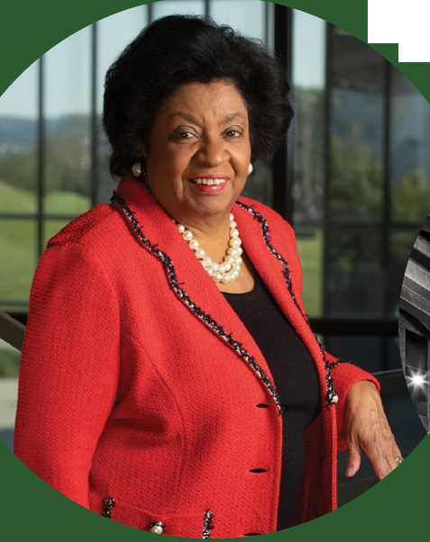

Page 3

The Urgency Behind the Black Thriving Initiative
Racial prejudice has been and continues to be a social toxin with deep historical roots. Our Black community at Cal Poly Pomona has had enough. Justice must be urgently and boldly addressed. Through nationwide advocacy demands and calls for transformative change across all sectors, through the leadership of various racially discriminated groups, historical experiences of racism have bubbled into clear visibility linking the past with the present and today's reality with tomorrow's possibility.
At Cal Poly Pomona, the pandemic and racial protests came on the tail ends of Black Faculty and Staff Association's (BFSA) 2019 Executive Report on “Racial Bias Experiences from the Black Community at Cal Poly Pomona.” This report effectively localized the national racial justice conversation to seek a commitment - what will it take for Cal Poly Pomona to support the success and vibrancy of its Black community? Furthermore, in Cal Poly Pomona's 2019 WASC Senior College and University Commission (WSCUC) report, the first recommendation made it clear that something transformative at the institutional level needed to be done as it relates to equity, diversity, and inclusion.
By 2020, Cal Poly Pomona took its stance, with a clear charge provided by President Soraya Coley:
"As an institution wholly grounded in our values of inclusivity and social responsibility, we too must reflect on institutional racism and continue to ask ourselves honestly and intentionally, "What has Cal Poly Pomona done to identify and dismantle institutional racism?” "What actions will Cal Poly Pomona take to further identify and dismantle institutional racism?” And on a personal level to ask: "What can i do to dismantle systemic racism?” -President Coley, Our Commitment to Action, Summer 2020
With such a statement, the campus community reflected on the work needed to dismantle systemic racism. However, the question of “how" began to get louder. How do we stop the incidents that are causing harm, hurt, pain, and sorrow? What policies, practices, and procedures need examination and revision? How can interpersonal dynamics move away from toxicity and towards respect? These questions, amongst many more, revealed a need to develop a campuswide strategy that balances the structural and interpersonal domains of racial injustices.
In 2022, building upon the advocacy of Black leadership at Cal Poly Pomona, the campus community was invited to Juneteenth: A Day of Remembrance, Reflection, and Promise. During this courageously honest and illuminating four-hour event, the campus community realized that it needed to become critically self-reflective. This “something" also needed to honor a grander vision of the eradication of racial hierarchies for all. To take an irreversible step towards this vision, Cal Poly Pomona needed to respond to the calls for justice called by its own Black community.
While uncomfortable, this recognition also came with the commitment to carve an uncharted path forward. By 2022, no more time could pass, not another situation can go unseen, and no more injustices could persist without proactive addressing these incidents as a united campuswide community.
Thus, 2022 formalized Cal Poly Pomona's commitment to do something - and do something culturally-affirming and organizationally sustainable. Building from Black Thriving Initiatives at campuses such as UC Irvine, UCLA, and UC Merced, this commitment inspired the launch of the Black Thriving Initiative, the first initiative of its kind within the Cal State University system.
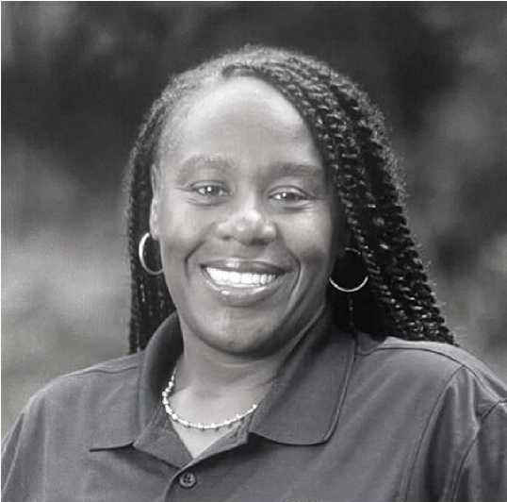
La’Keisha Beard, Director, Residence Life

Page 4

Being Curious: Why Focus On Our Black Community?
Black Americans more likely than other adults to say structural sources of racism are a bigger problem than individual ones.
% who say that, when it comes to racism against Black people in our country today, the bigger problem is...
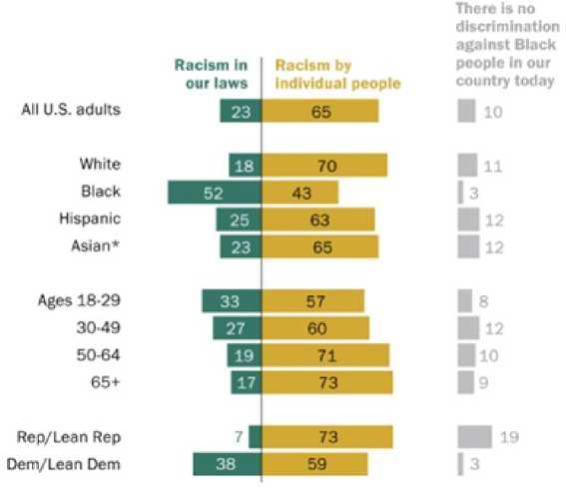
* Estimates for Asian adults are representative of English speakers only. Note: Black adults include those who say their race is Black alone and non-Hispanic: multiracial, non-Hispanic Black: or Black and Hispanic. White and Asian respondents include those who report being only one race and are not Hispanic. Hispanics are of any race. Share of respondents who didn't offer a response not shown.
Source: Survey of U.S. adults conducted Oct. 4-17. 2021. Pew Research Center
Focusing on the Black experience does not mean Cal Poly Pomona will not address the needs of other groups. The racism the Black community receives is widespread and is not only from White communities. If we can address our racial biases and prejudices towards the Black community, we can develop the skills and strategies to support all communities impacted by structural racism. We can open the possibility of deep coalitional work where liberation for Black people embodies liberation for all.
Racism has been horrifically impacting Black communities for centuries. The emotions that come with a lack of change or measurable outcomes are real and valid. Anger is a valid emotion when we cannot acknowledge the pain and harm the Black community has experienced at Cal Poly Pomona. The BTI is a way to start that restorative healing process. To start focusing on structural elements that support racism. To educate our community on the culture, triumphs, and contributions to American culture. Heather McGhee (2021) reminds us that as an institution, “we must challenge ourselves to live our lives in solidarity across color, origin, and class and we must emerge from this crisis in our republic with a new birth of freedom. Rooted in the knowledge that we are so much more, when the we in we the people is not some of us, but all of us. We are greater than and greater for the sum of us."

The Power in Focusing on our Black Community
In 2015, the California State University (CSU) launched Graduation Initiative 2025, its ambitious plan to increase graduation rates, eliminate equity gaps in degree completion, and meet California's workforce needs. At Cal Poly Pomona, this initiative led to proactive efforts to close the equity gap between underrepresented minority students and Pell-grant receiving students.

Students
In Fall 2022, Cal Poly Pomona enrolled approximately 25,000 undergraduates and 2,000 graduate students.
- 57% First Generation
- 55% URM
- 53% Latino
- 22% Asian
- 14% White
- 3% Black
LaShelle M. Hudson, CPP Alum 23'

Page 5

The First Listen: Understanding Our Black Communities Experiences

Data And Testimonies: Cal Poly Pomona's Reality
The following graphics show the story of disproportionality, of who is succeeding at the university while also providing a compass on what institutional behaviors will shift these indicators in the right direction.
Black/African American students make up 3% of the CPP student population
In Fall 2022, Black/African American Students Passed Their Courses At Lower Rates
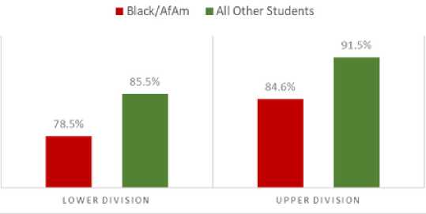
Black/African-American community college transfers graduate in 4-years at a lower rate than the overall university average.
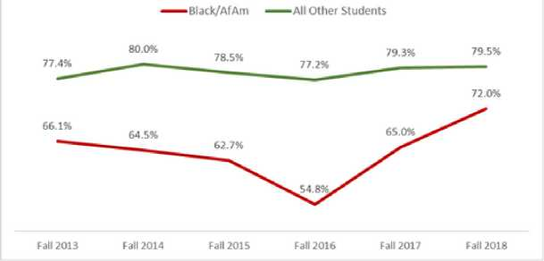
Black/African-American Students graduate in 6-years at a lower rate than the overall university average.
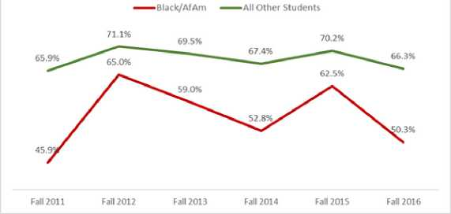
Black/African-American community college transfers graduate in 2-years at a lower rate than the overall university average.
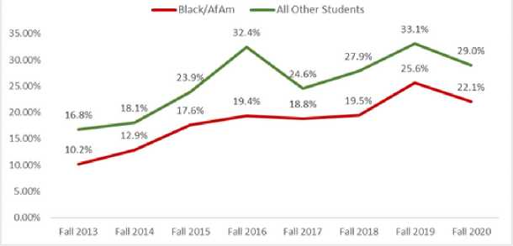
To truly be a student-serving institution, these gaps must close. The power to close them lies in how the institution critically thinks about admissions, affordability, engagement, career development, university navigation, relationship development, and dreams. Work must also be done around how people feel about their experiences at Cal Poly Pomona, a climate and experience reality that can either exist as a cherished memory or a traumatic event.

Page 6

Black Students

Derick Porter, CPP Student
To give a sense of how our Black students move at Cal Poly Pomona, these graphs capture 4-year and 6-year graduation rates by gender.

Black First-Time Freshmxn Graduation Rates
Womxn Freshmxn Graduation Rates
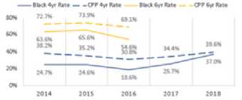
Male Freshmxn Graduation Rates
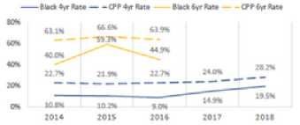
Black students comprise 2.7% (n=741) of the total Fall 2022 student body and 2.1% (n=142) of the incoming class.
Equity gaps are, as a result, clear. This pattern contextualized with the qualitative data captured by Black Girl Doctor in their 2022 Black Student Wellbeing Assessment Report: "Our Voices, Our Story, Our Truth": Understanding the Black Student Experience at Cal Poly Pomona, requires an institutional solution that is procedural and relational. Programs and services absent of a culture of dignity and respect may not move the needle forward and vice versa - a vibrant culture without the resources and know-how necessary to successfully navigate the institution will not transform persistence and graduation rates. Both are strategic actions necessary for transformation.

Report highlights included:
- Black students consistently reported that their ability to remain hopeful is constantly challenged by their experiences with administration.
- Black students indicated frustration with the lack of consistency and follow- through of institutional efforts and noted that they have had to learn to temper their expectations to combat disappointment and hopelessness.
- Black students shared concerns about Black issues being minimized and subsumed under the more general label of "POC" or "diversity" issues.
- An astounding 95% of Black student participants reported microinvalidations are either somewhat or extremely likely to occur on campus
  - Microinvalidations are a type of microaggression that seeks to exclude or invalidate a person's thoughts, feelings, or existence.
- 87% of Black student participants endorsed a perceived lack of representation and feelings of tokenization.
- 87% of Black student participants indicated they do not feel Cal Poly Pomona is a safe space to show up as their authentic selves, without fears of repercussion.

Page 7

Black Faculty And Staff
To make sense of the experiences of Cal Poly Pomona's Black staff and faculty, representation figures from Fall 2022 comprised of 5.7% of Cal Poly Pomona's employee population (n=3,059), with 7.4% serving in staff or administrator positions and 4.3% in faculty positions.
Coupled with the student report, Black Girl Doctor produced “Our Voices, Our Story, Our Truth“: Understanding the Black Staff and Faculty Experience at CPP.

Report highlights included:
- Black faculty/staff feel that their concerns are either overlooked completely or subsumed under broader diversity initiatives that fail to address anti-Black racism issues specifically.
- 80% of Black employees reported micro-assaults to be somewhat or extremely likely to occur on the campus.
- A perceived lack of a critical mass of Black people creates a psychological burden by othering your faculty/staff. The sentiment was strong in this area, with 91 % of attendees endorsing a perceived lack of representation and feelings of tokenization.
- 75% of participants somewhat, or strongly related to scenarios of hitting a glass ceiling when it comes to securing the necessary support and connections to advance their career and professional goals.
- An overwhelming 87% of participants indicated that they do not feel Cal Poly Pomona is a safe space to show up as their authentic selves, without fears of repercussions.
These data points demand an exploration of how these experiences are being created. For students, how are university processes and the people who carry them out complicity involved in these outcomes? For staff and faculty, what conditions are fostered that allow another colleague or coworker to enact behaviors that add to/create feelings of disrespect, invalidation, and harm? As uncomfortable as it may be, the solution to change these findings will require self-awareness and a realization that until these realities change, our efforts will not be effective. This feedback is the foundational marker of progress - how does Cal Poly Pomona's Black community echo back an improvement in their experiences on campus?
Ocena Corbin, Psychology Department Coordinator

Page 8

Community Reflections
Anonymous reflections from CPP students, staff, and faculty from the 2022-2023 BTI feedback sessions:
“Black people do the majority of the labor—and need to be met halfway. This is painful.”
“There is no accountability at Cal Poly Pomona. We have removed ‘diversity’ as a competency in performance appraisals for mangers. We have still not addressed the multiple microaggressions that occur in the classroom by faculty. Every member in our community must be held accountable for addressing racial climate concerns. Senior leadership must also be held accountable and demonstrate how they contribute to inclusive excellence. Anything less is unacceptable.”
“The 'what about my community' perspective is harmful to progress. Focusing on the black experience does not mean Cal Poly Pomona will not address the needs of other groups. Liberation for black people embodies liberation for all.”
“Racism does exist at Cal Poly Pomona and it needs to call out. I'm not calling a racist in. I'm not calling a sexist in. Harm needs to be called out. It hurts faculty, staff, and students.”

Page 9

Community Reflections Continued
- “I've had students crying from feeling that sometimes a faculty member's approach would make them feel like they weren't good enough to be in the program...not having the ‘intellectual capacity'...not having ‘growth mindset.' we need to think about who teaches in the program.”
- “We need buy in from senior leadership. It's been a funky place. We need to change culture — be more supportive of black faculty, students, and staff. We could do all this great work but if they don't buy in, then this will not work.”
- “You can't expect students to come equip with the tools to have the hard conversations because that is not modeled. Something that can help is for faculty [and staff] to acknowledge discomfort. It's ok to be uncomfortable. Model that for them. Give them the vocabulary and tools before they engage in the difficult conversation. It can help mitigate that students don't have those tools.”
- “[We need to] get to a place where we unpack White privilege and racism and how it impacts students of color on this campus, especially in the classroom in non- performative ways. Diversity does not equal inclusiveness and equity. Cal Poly Pomona covers up racial issues and acts as though nothing happened.”
Derick Prince, M.S., Black Resource Center Retention Coordinator

Page 10

An Intersectional Perspective: The Relentless Goal To Become An Inclusively Excellent Institution
Student success is a vital outcome for any university. At Cal Poly Pomona, Black students are not the only students who experience success challenges. As an example, the graphic below highlights that Black students face the greatest gap in sophomore status persistence. Moving along the graph, the unique combinations of being a First Generation, Pell-Eligible or Female student reflect increasingly unacceptable persistence patterns, patterns that can be understood through the lens of intersectionality. They are unacceptable because from a strengths-based perspective, the question focuses on what the institution is doing to address this as opposed to what more a student must overcome to succeed at Cal Poly Pomona.
Linking this information to Graduation Initiative 2025, it becomes clear that intentionally focusing on our Black community's success will support the success of all socially and economically marginalized communities. Thus, the inclusive excellence framework equips Cal Poly Pomona with a comprehensive strategy to ensure various institutional efforts and commitments have the power to close the equity gap for multiple communities.
2019 Cohort Differential Progression To Sophomore Status After 1st Year
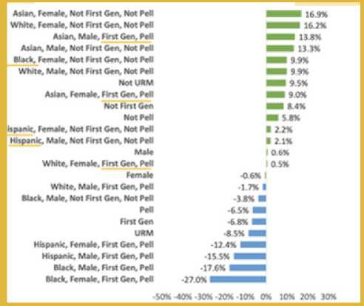

Inclusive Excellence Framework Core Concepts
- Student intellectual, social, and professional development via diverse and inclusive curriculum and co-curricular experiences
- Development and utilization of organizational resources to enhance student learning (infrastructure, capacity, and partnerships)
- Attention to the history and present-day realities of historically excluded communities to deliver experiences that yield equitable outcomes
- The cultivation of campus environment that engages its diversity in the service of organizational learning (everyone contributes to inclusive excellence goals)

Page 11

The Black Thriving Initiative Overview

Conceptualizing An Institutional-Level Initiative
The reports listed above, and their findings can be found at Black Thriving Initiative (cpp.edu), launched in December 2022.
These courageous milestones set the foundation for what an initiative can look like, an effort responsive enough to address current realities yet equipped with the visioning necessary to attain institutional transformation. This wisdom yielded four commitments that have the power to not only transform the experience of Cal Poly Pomona's Black community but accelerate Cal Poly's embodiment of an inclusively excellent institution.
As an institution, Cal Poly Pomona must situate the work as an experientially transformative journey. The Black Thriving Initiative provides the campus with a roadmap towards success where truth-telling drives cultural transformation. Between both poles - a dynamic process to centering the challenges boldly named by our Black community as behaviors shift towards investments and accountability.
Build Capacity & Consciousness
- Truth and Healing
- Awareness & Education
- Investment and Accountability
Leverage The Mission
- Institutional Policy & Procedural Review through a Racial and Gender Equity Lens
Engage Black Communities
- Divisional and Area-Specific Action Plans & Recommendations
Transform The Culture
- Identifiable Measures of Success, Sustainability, Ongoing Education, and Future Accountability

The Black Thriving Initiative
Over the course of three years and starting in 2022, Phase I is designed to bridge the effort-to-date with the need to build CPP's institutional capacity to proactively redress racial bias while also providing direct support and resources to Black students, faculty, and staff. The three strategies are intertwined to all Cal Poly Pomona to be proactive, responsive, and accountable.
Phase I: Build Capacity And Critical Consciousness
- Strategy 1: Prioritize truth-telling and racial healing
- Strategy 2: Increase campus awareness, cultural humility, and critical consciousness
- Strategy 3: Invest in a sustainable infrastructure and develop campus-wide accountability metrics
Phase II: Leverage The Mission
- Strategy: Institutional policy and procedural review through a racial and gender equity lens
Phase Iii: Engage And Re-Engage Black Communities
- Strategy: Divisional and area-specific action plans and recommendations

2022-2023 Select Highlights Of Phase I:
- Racial Healing Circles: Truth, Racial Healing, and Transformation / Staff & Faculty One-to-one Individual Wellness Coaching for Black Students, Staff, and Faculty
- Hiring of a CAPS counselor with a Black community focus
- The Intercultural Development Inventory use with senior cabinet and the Division of Student Affairs
- The Inaugural Advancing Racial Justice and Cultural Humility Learning Series, Division of Student Affairs
- The establishment of the Black Thriving Initiative Workgroup
- The recruitment of Cal Poly Pomona's Chief Diversity Officer
- The milestones attained and insights gained from Phase 1 ensure Cal Poly Pomona stays on track to enter Phase 2 and Phase 3. The wisdom gained via campuswide engagement, courageous discomfort, and honest self-reflection reflect a comprehensive capacity-building strategy to ensure the work is sustained.

Page 12

Convening The Black Thriving Initiative 2022-2023 Working Group Members
With a goal of ensuring Cal Poly Pomona (CPP) is an institution where Black people can thrive, the momentum of Juneteenth 2022 spurred the creation of the 2022-2023 Black Thriving Initiative Working Group. This group was convened in July 2022 during the launch retreat to develop recommendations that will enable Cal Poly Pomona to strengthen holistic and culturally- relevant resources and support for Black students, staff, and faculty within three overarching areas: racial healing, cultural humility and critical consciousness development, and accountability.

The 2023 Black Thriving Initiative Working Group Members:
- Dr. Jonathan Grady, Senior Associate Vice President, Equity & Belonging, Student Affairs (co-chair)
- Dr. Cynthia Pickett, Presidential Associate for Inclusion & Chief Diversity Officer (co-chair)
- Dr. Teshia Roby, Associate Vice President, Learning & Research Technologies (co-chair)
- Dr. Betty Alford, Program Director, College of Education and Integrative Studies
- Kimberly Allain, Associate Vice President, EODA
- Dr. Mary Ann Akers, Dean, College of Environmental Design
- Jared Ceja, Executive Director/CEO, Foundation
- Cynthia N. Cortez, Interim Executive Director of Access, Equity, & Belonging, Student Affairs
- Justyn Fulton, Student Black Thriving Initiative Intern
- Nyla Harris, Student Representative
- Pat Hawthorne, Dean, University Library
- Nicole Hawkes, Chief of Staff, Office of the President
- Ashley Mascarenhas, ASI Student Representative
- Dr. Arah Parker, Budget Analyst, University Advancement & Black Faculty/Staff Association (BFSA)
- Dr. Kaitlyn Sedzmak, Chief of Staff, Student Affairs
- Ronald Whitenhill, Assistance Vice President, Outreach & Educational Partnerships
- Marla Williams, Intake, Coordinator, Care Center

2022-2023 Black Thriving Initiative Working Group Charge
- Garner campuswide BTI feedback and recommendations.
- Ensure our campus community understands why a Black Thriving Initiative at Cal Poly Pomona is important.
- Ensure the campus community understands that the Black Thriving Initiative will require campus-wide commitment to ensure Black students, faculty, and staff can thrive.
- Ensure the campus community is committed to supporting the Black Thriving Initiative at Cal Poly Pomona.
- Launch the BTI campus-wide initiative related to Phase 1 Strategies: Prioritize Campus Racial Healing, Increase Campus Awareness, Cultural Humility, and Critical Consciousness, and Invest in a Sustainable Infrastructure and Develop Campus-Wide Accountability Metrics
To truly transform our culture, a strong unambiguous stance against racial inequities requires everyone's involvement. While concrete in concept, the process of engagement campuswide is complex. Building upon the energy of Juneteenth, the Division of Student Affairs spearheaded informational presentations to leaders within various units, departments, and divisions to inform the campus community of the urgency behind proactively addressing the issues impacting Black student, staff, and faculty experiences. As a result, Cal Poly Pomona formalized an official commitment to the inaugural, multi-year, campuswide Black Thriving Initiative.

The Black Thriving Initiative is centered on the following principles:
- Racial human hierarchy is a persistent societal belief that has caused immeasurable human suffering. This belief must be eliminated.
- High expectations, financial and personal investment, and accountability must be in place and prioritized.
- Curricular and co-curricular mapping and integration must be considered to avoid duplication, identify gaps in service, and ensure procedural efficiency and effectiveness.
- Ongoing equity, diversity, and inclusion growth and development opportunities must be provided to students, staff, and faculty.

The Black Thriving Initiative Core Values:
- Honor: Going back to go forward. The important of Black/Diasporic history to understand our identity and culture. We stand on the shoulders of those who come before us.
- Excellence: Valuing Black academic, professional, scholarly, cultural, and institutional excellence. Valuing and promoting pro-Blackness: respecting the excellence and talents of our Black community at Cal Poly Pomona.
- Unity: Collective work and responsibility. Working together as a Bronco community to ensure the success of the Black community at 'Cal Poly Pomona. Our collective strength is magical.
- Humanity: I am because we are; we are, therefore, I am; the value of collectivism and respect. Humanity is paramount; affirming the humanity of Black people.
- Love: "When you know better, do better.” Open your heart and mind to imagine new possibilities. Love is transformative.

Page 13

Symposium Launch Event
On December 8th, 2022, approximately 350 campus community members attended the Black Thriving Initiative Symposium to engage and explain the significance and important of this initiative not only for our Black community but for our vision of being an inclusively excellent institution. This launch event did not mark the beginning of the initiative - it represented its rollout to the entire campus community.
Recognizing our campus community gravitates towards different topics, the launch symposium offered three sessions to host crucial conversations aimed at strengthening our understanding of the significance of the initiative:
- Session 1: Racial Healing and Truth Telling led by Dr. David Turner
- Session 2: Co-Creating Common Language around Racial Justice and Cultural Humility led by Dr. Rigoberto Marquez
- Session 3: Allyship and Advocacy, led by Godfrey Plata
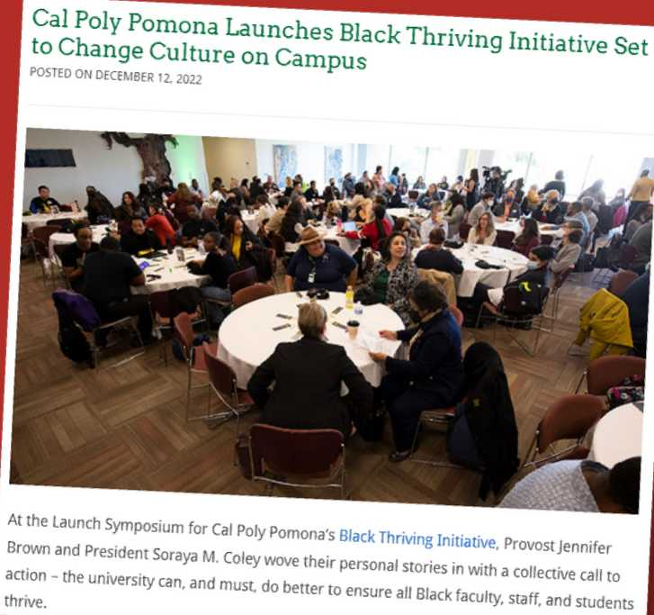
Event Feedback Data: 67% of attendees completed the survey.
- I Have A Better Understanding Of Why CPP Is Launching A Campuswide Black Thriving Initiative.
  - A Great Deal/Considerably: 82% of Respondents
  - Moderately/Slightly: 15% of Respondents
  - Not at All: 3% of Respondents
- I Am Excited About The Black Thriving Initiative
  - A Great Deal/Considerably: 88% of Respondents
  - Moderately/Slightly: 6% of Respondents
  - Not at All: 6% of Respondents

Page 14

Black Thriving Initiative Excellence Fund
One major win of the Black Thriving Initiative has been the creation of the BTI Fund. In November, 2022 an anonymous donor contributed $1 0,500 to establish the Black Thriving Initiative Excellence Fund in the Cal Poly Pomona Philanthropic Foundation. The donor wished to be recognized only as "a Good Ancestor Inspired by Layla Saad”. The donor is a student of Saad's book, Me and White Supremacy, and asked not to be named so they could keep the spotlight on the Black Thriving Initiative while encouraging others to work through Saad's book and build their capacity for cultural humility.
Since the fund's founding, 14 new donors have contributed over $1,300. While most of these donors are current or former faculty and staff, we look forward to future phases of the initiative when we hope to build on awareness and interest from external community stakeholders.
Justyn Fulton, CPP Alum, 23'

Page 15

The Deep Listen (Phase I): Build Capacity and Critical Consciousness

Preparing For Campuswide Feedback Sessions
To prepare for this work, the working group members participated in four topical modules to strengthen facilitation skills and comfort in leading discussions on race. These modules had two goals:
- To further develop the capacity of the working group members to engage in the intentional and authentic cross-race conversations about race and racism, specifically in addressing anti-Blackness.
- To prepare the working group members to develop dedicated initiatives and interventions to support Black students, faculty, and staff at the group and systems level.
In Spring 2023, campuswide feedback sessions began and yielded participation of over 480 individuals representing students, faculty, and staff. These sessions led Cal Poly Pomona through campus wide feedback sessions to learn about our racial climate, institutional assets proactively addressing race, and challenges and barriers to the work. For each session, working group members explained their positionality as a critical asset to the work thus linking our personal investment in racial justice to our professional one.
Students, Faculty, and Staff were invited to in person and virtual meetings to respond to four questions over the course of 90 minutes.
- Describe the current racial climate at Cal Poly Pomona
- What actions and/or behaviors positively add to Cal Poly Pomona's goal of inclusive excellence?
- What barriers and/or behaviors prevent Cal Poly Pomona from achieving our goal of inclusive excellence?
- What does the campus need to further our growth and development in equity, diversity, and inclusion? What do you need?
From January 2023 through April 2023, over 20 sessions were held across campus divisions, departments, and units. This means the data is composed of individuals who have different lenses and contexts for discussing Cal Poly Pomona's racial climate. For example, while there is notable abundance of voices that express stark, firsthand experiences with racial hostilities, the complexities of these perceptions are informed by: a participant's social identities and lived experiences, institutional role, years of experience in Higher Education, or magnitude of engagement with individuals who hold different cultures and worldviews that themselves.
Additionally, these feedback sessions have provided critical insight to Cal Poly Pomona's institutional assets that have positively impacted the institution's racial climate. This is a powerful foundation to situate the feedback on, inviting insights on rich descriptions and overall mapping of where these assets exist throughout the institution. This information is in the “Next Steps” section of the report. Conclusively, this process represents the campus's strategic exploration on issues of race while building its collective capacity to embrace discussions on what can be an emotionally and intellectually challenging topic.
Data Overview
Each session had the same four questions posed and yet received a wide variation of commentary, insights, critiques, and questions. Therefore, the feedback has been processed to illuminate Cal Poly Pomona's racial climate complexity to highlight opportunities that bridge institutional commitments to the issues raised in the community. While more work is needed to carefully contextualize the feedback, an important milestone in the initiative has been attained: campuswide perspectives have expanded the feedback gathered from our Black community. As a result, the institution is more prepared to identify and name the factors that are linked to racial justice the themes that have emerged in the data.

Page 16

Approaching The Feedback: CAMPUS CONSIDERATIONS AND SUGGESTIONS
Jailyn Mitchell, CPP Student
Coming off the tails of the pandemic's work-and-learn-from-home structure, students, staff, and faculty returned to campus with the inescapable awareness of our nation's widespread racial injustices coupled with the visibility of how minoritized communities' social, physical, mental, and economic wellbeing have been impacted by major social events.
The feedback shared during Spring 2023 bridges experiences that occurred before the pandemic and experiences that continue today. The first listen ranges from 2019 to 2022 and captures the core-rattling truth of the Black community's racialized and harmful experiences on campus. The workgroup's "deep listen” expands upon these testimonies by extending the invitation to other members of our campus community to share what they think, feel, and understand about our racial climate.
The findings of the deep listen capture racial climate perspectives, sentiments, and experiences various units, constituency groups, and leaders. When providing an overview of the Black Thriving Initiative, many reported not knowing about the life-damaging instances that were occurring on campus. Others, the information was acute and emotionally intense. When delving into this information, some may question the "truthness” of the perspectives shared but the goal of reviewing this feedback is to illuminate what people think not on challenging someone else's truth.
Thus, approach the data with curiosity. In 2023-2024, the institution will create space to co-create our collective racial climate truths but for now, explore the themes and practice awareness. As you read, what comes up for you? If members of the Cal Poly Pomona seek to be staunchly against all forms of systemic prejudice, then we must listen. If we cannot listen, we cannot dialogue. If listening with humility does not occur, new decisions cannot emerge and more importantly, relationships cannot be repaired.
“If listening with humility does not occur, new decisions cannot emerge and more importantly, relationships cannot be repaired.”

Page 17

Descriptors of Cal Poly Pomona’s Racial Climate
These descriptors reflect how sensitive conversations are race currently are. Terms like "hostile," "stereotypes," and "fearful" reveal the emotional undertones of our participants. When participants express negative race-related responses such as "unsupportive," "resistance," and "ignored," they describe both individual and institutional responses. It is important to highlight though, individuals of different races have different experiences, there is an "openness" to discuss race, and that there are "insecurities in saying the wrong things." As a result, this feedback suggests high variation in how race is felt and perceived across the campus community. However, it is vital to recognize an undeniable impact racism has had on Cal Poly Pomona's Black community because failure to do so has the power to dilute effective responses and recommendations.
At large, there is a need to address climate boldly and in a process that honors history, fear, and harm and moves toward actions that rebuild trust that the institution is firm on its stance against racial injustices.
The 20 sessions and hundreds of commentaries are distilled into 5 major themes (in no particular order):
- Cal Poly Pomona does not Live up to its Equity, Diversity, and Inclusion Rhetoric
- Listen to Black Voices—Anti-Blackness
- Harms All Communities
- Campus Community Members Need Tailored Educational Experiences
- The Improvement of the Black Experience Improves Equitable Outcomes for All
- Institutional Accountability Without Personal Accountability Will Not Work
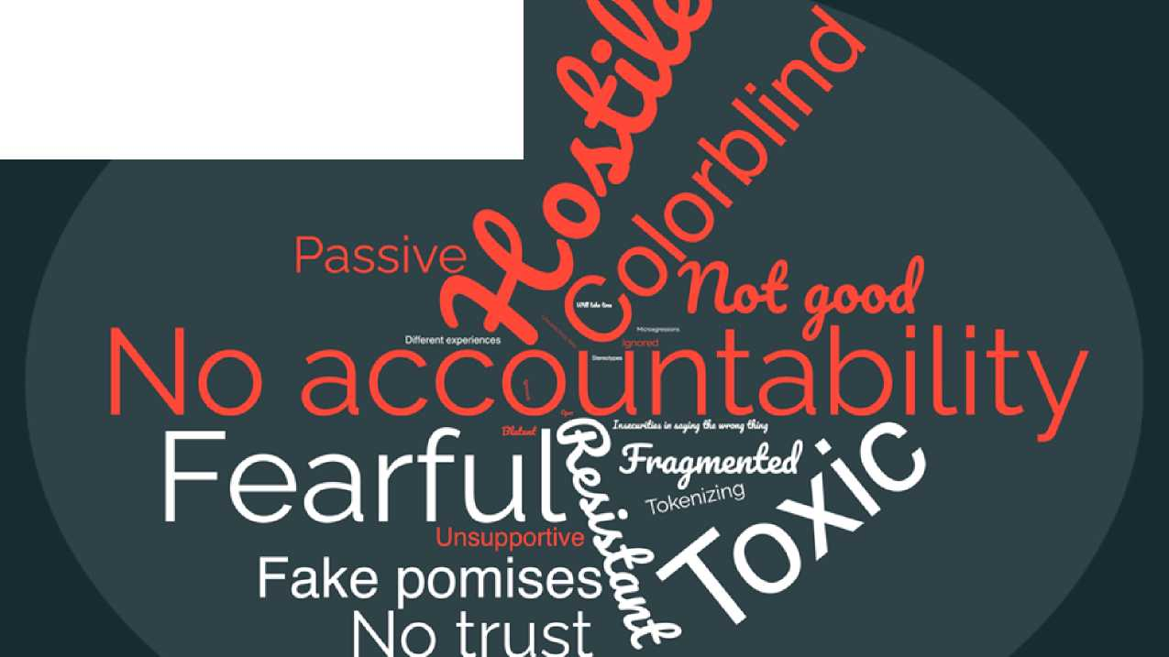

Page 18

BTI Member Checking Process
Before finalizing the themes and recommendations for the Black Thriving Initiative, during early Fall 2023, Black students, faculty, staff, and alumni were convened to review draft statements and explanations. This member checking process intentionally focused on the careful review of what was heard during the “first listen” of the experiences Cal Poly Pomona's Black community and the campuswide “deep listen" on its racial climate. Each theme and recommendation was discussed.
The member checking process focused on discerning truthfulness - is this information valid, accurate, and credible? Due to the richness of these conversations, feedback from Black students, faculty, staff, and alumni have helped finalize the language on themes and recommendations used in this report. This step has been vital because it concretely establishes a baseline of expectation - a guide for Cal Poly Pomona's resulting actions and commitments.
As the campus community explores the themes and identifies the role they will play in advancing the work, the following insights can powerfully serve as a trust-building foundation of the Black Thriving Initiative. The “what" must be done should be coupled with “how" the work should be done. Important ideas and reminders include:
- It is difficult to for the community to feel the campus community cares when there is only one Black person in an office, unit, or classroom and racial microaggressions are still taking place. The campus community can get lost on the idea of diversity when practices that support inclusion are key.
- The work toward racial justice must include an explicit focus and understanding of what anti-Blackness is, how it operates, and how individuals regardless of race can not only act on it but also cause great harm because of it. It is not the responsibility of individual Black students, faculty, or staff to educate the broader campus community of anti-Blackness and other key concepts.
- Acknowledging and integrating the unique history, experiences, cultures, and advocacy goals of the Black community will make efforts feel genuine - not performative. The proactive involvement of all, especially senior leaders, will communicate that the Black Thriving Initiative is truly a priority.
- For students, the Black Thriving Initiative's on-the-ground implementation, resources, and accountability is of upmost importance. Staff and faculty echo students and uplift the structural elements that must be put into place or augmented to address climate, hiring, retention, and promotion concerns.
- Last, the community wants to see unambiguous institutional accountability - who will be responsible for this work? Who will coordinate the campus community? Who will advocate for transformation? How will the campus community know the needle is moving forward? Who will hold individuals and the institution accountable when harm occurs?
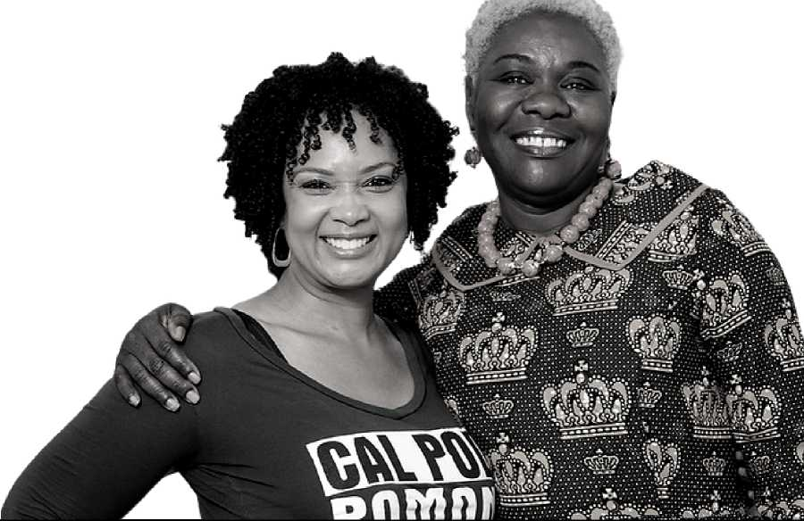
Teshia Young Roby, Ph.D., MBA, Associate Vice President, Learning & Research Technologies
Olukemi Sawyerr, Ph.D., Associate Vice President, Academic Innovation

Page 19

Theme #1: Cal Poly Pomona Does Not Live Up To Its Equity, Diversity, And Inclusion Rhetoric
Cal Poly Pomona is a minority serving institution, a Hispanic Serving Institution (HSI), and an Asian American and Native American Pacific Islander Serving Institution (AANAPISI). However, the day-to-day feeling of diversity valued cannot be reduced to the percentage of community members who identify as an underrepresented or racial minority. When data reveals equity gaps in persistence and/or graduation rates, or in staff and faculty hiring and promotion patterns, how Cal Poly Pomona values diversity is put into question. Thus, the paradox: how can the institution be diverse but not feel like its diversity is precious enough to be nurtured, cared for, and protected? Specifically, the practice of valuing diversity has been called into direct question by the Black community's and the broader campuswide community's feedback on Cal Poly Pomona's current racial climate.
A sense of belonging and equitable opportunities for success must be designed and embedded into daily practices. They must be felt and empirically observed. Otherwise, while the institution meets the concept of diversity by virtue of its demographics and identity-specific resources throughout campus, based off the feedback, the campus may be falling short of the truest embodiment of this value.
To bridge the campus's demographic diversity towards a campus culture where equity and inclusion milestones are also unambiguous, this work must include knowing how historical acts of racism impact present day realities. Bold leadership will be necessary to navigate power and privilege dynamics in decision making, the influence of explicit and implicit interpersonal bias in diversity outcomes, and personal behaviors on who is perceived to deserve access to success.
Diversity without Inclusion and Equity erases the uneven playing field individuals have had and continue to navigate at Cal Poly Pomona. It also allows dangerous deficit-thinking to persist in designing and resourcing programs, services, and initiatives, whether this way of thinking is conscious acknowledged or not. If the three EDI concepts are not coordinated together and with comparable strength, the campus may bypass accountability to create a campus culture that is physically and emotionally safe for all—while still existing as a diverse institution.
This feedback captures the growing awareness that true diversity is a lived, felt, and practice value by every Cal Poly Pomona stakeholder. Demographic representation does not have the power to create inclusive excellence—intentional commitments do.
Two vital tools are necessary: : 1) practices that support sense of belonging, respect, and value and 2) resources that drive professional and university success.
“Thus, the paradox: how can the institution be diverse but not feel like its diversity is precious enough to be nurtured, cared for, and protected?"

Page 20

Theme #2: Listen To Black Voices—Anti-Blackness Harms All Communities
Cal Poly Pomona's Black community has demanded the campus community pay attention to not only instances of racial harm but the additional effect of anti-Blackness on how students, faculty, and staff experience respect, support, and opportunities. When the campus community learned about these raw testimonies, some responded in shock and disbelief. It was heavy to learn that the Black community has been oppressed, attacked, and harmed in different ways. Yet, for some, it was even more sobering to realize that their ignorance and obliviousness was a form of complicity. Navigating what to do, or how to do, may not be clear but not doing is unacceptable. "Doing better,” even if imperfect, is the only path forward.
The first listen revealed the incredible pain our Black community has had to endure at Cal Poly Pomona. Thriving takes the backburner to surviving. The deep listen captures racialized experiences as experienced by different races and identities. Because of the pervasiveness and persistence of racial injustices, the combined feedback also captures subtle or overt resistance to racial progress through the forms of White-fragility, color-blind policies, and/or erasure. Additionally, some perspectives reveal emotional disbelief, guilt, and/or staunch desire to transform the institution. It is also acknowledged that some campus community members want the discomfort to stop or desire to effectively end the conversation. This creates a tense and awkward climate. As a result, the existence and tolerance of racial bias and harm ultimately creates a campus culture that ends up negatively impacting all students, faculty, and staff.
Black voices have effectively made visible that the racial climate at Cal Poly Pomona cannot continue to persist. Even though many other races encounter racism, no strategy for racial justice will be strong enough without a clear understanding of how anti-Blackness operates. Anti-Blackness has been used to disguise visibility with terms like underrepresented minority (URM) hiding the Black community's experiences. This cannot continue. To move forward, the campus community must listen to Black voices and understand that unless Cal Poly Pomona's racial climate changes, the campus community will be held back in becoming a vibrant, dynamic, and healthy climate community.
This feedback captures not only the advocacy efforts of Cal Poly Pomona's Black community but also the toll it has taken. The responsibility now falls on the institution to listen and name pathways for justice.
“‘Doing better,’ even if imperfect, is the only path forward.”

Page 21

Theme #3: Campus Community Members Need Tailored Educational Experiences
In the vision of racial equity, all are imagined having access to the knowledge, resources, and support necessary to thrive. In acknowledging the gap between where we are at and where we want to be, education and professional development opportunities are required resources. But the types of resources will need to vary. Education is not limited to providing access to a webinar, lecture, book, workshop, or training. The process of building consciousness around race or gender or more, requires the ability to locate oneself within equity, diversity, and inclusion (EDI) topics. The cultural competency and consciousness development of students, faculty, and staff needed to advance the Black Thriving Initiative is fundamental. The campus must equip students, faculty, and staff with skills and strategies needed to move through tough conversations on race itself. Spaces of acknowledgement, healing, and advocacy are vital because of the physical, mental, emotional, and spiritual impact of racial trauma.
The work ahead will need an EDI perspective to unpack questions around readiness and learning growth. The work must consider perspectives that posit they do not see race. Because everyone does have a unique relationship with something that has become a taboo topic, it may not be the wisest decision to start someone's race educational journey with complex frameworks such as Critical Race Theory. But it is necessary to intentionally expose them to how racial injustice shows up at Cal Poly Pomona. Educational and professional development stewards must consider how to responsibly introduce the EDI knowledge to individuals beginning their structured learning while also continuing to intellectually challenge those who are well familiar with social justice work at large.
This feedback illuminates educational barriers and opportunities for the campus community. The ability to talk about race is of high priority. Regardless of the educational pathways chosen, the big question on the horizon: How can we educate students, staff, and faculty to serve as agents for racial justice and eradicate how prejudice, oppression, and hate show up in our campus community?
“The cultural competency and consciousness development of students, faculty, and staff needed to advance the Black Thriving Initiative is fundamental. The campus must equip students, faculty, and staff with skills and strategies needed to move through tough conversations on race itself."

Page 22

Theme #4: The Improvement Of The Black Experience Improves Equitable Outcomes For All
Racial equity is a complex topic. It must acknowledge how racism is experienced by different racial and ethnic communities, each with their unique history, key events, advocacy agendas, and needs. At the center of these experiences are Whiteness and White Supremacy Culture that has set the sociocultural norm of all racial identities in the United States. Efforts to transform racial injustices can begin at understanding the structural forces that drive inequal racial outcomes, unpacking why certain groups are incarcerated at high rates, have poorer healthcare outcomes, and experience barriers in accessing high quality education. They may be focused on fostering racial healing and restorative processes especially if reprieve is urgently needed. To be racial justice advocates in the meetings we join, the emails we read, and the people we speak too, students, faculty, and staff should be able to understand how racism functions, how it shows up, and when it's unclear if a situation is racialized or not.
A critical highlight in this feedback is the "what about my community” concept - how do all communities receive the visibility, resources, and support needed at Cal Poly Pomona given their varied experiences, histories, and cultures? How can the institution meet these needs considering its fiscal and political realities? One of the hardest perspectives to navigate will be tensions between racial groups, such as the dynamic between the Black community and the LatinX community. Scarcity mindset, "the finite pie" and Us versus Them thinking at large has the power to derail collective liberation processes. Without a robust framework to guide equity in ways that honor diversity and inclusion, it will be difficult to create a common campus identity that all racial communities connect with. One of the most powerful tools will be the principles of community.
This feedback illuminates how complex the racial equity and advocacy conversation is for the campus community. How race is experienced is as diverse as the campus community itself, with deep variation between individuals of the same racial identity. When describing Cal Poly Pomona's racial climate, some perspectives may be deemed controversial while other testimonies may be applauded for their courage to capture truth. Whether they are factually correct or not, before moving into commitments and action plans, the campus community must reckon with the fact that they are perceptively real. As a result, the campus community must reconcile these different experiences, within different departments and units, in a way that supports a collective vision of racial justice. Navigating the perception of privilege can be particularly difficult especially when there is not a clear or collective framework to make sense of these power dynamics and historical factors that perpetuate scarcity thinking.
“Without a robust framework to guide equity in ways that honor diversity and inclusion, it will be difficult to create a common campus identity that all racial communities connect with. One of the most powerful tools will be the principles of community.”
“As a result, the campus community must reconcile these different experiences, within different departments and units, in a way that supports a collective vision of racial Justice."

Page 23

Theme #5: Institutional Accountability Without Personal Accountability Will Not Work
No one should ever be put in a situation where their college or career goals feel unattainable because of their race or identity. When testimonies and examples of racial injustices were shared, many located these experiences on campus grounds and spaces (physical and virtual). Consequently, Cal Poly Pomona has an undeniable responsibility in being held accountable to the circumstances and behaviors that allow racial harm to occur. As painful and as harmful situations and experiences can be, without honest self-awareness it will be impossible to redress past and present harms. An exploration of how university polices, workflow procedures, and individual work practices either replicate, stop, or resist racism is a necessary step of this process, despite the time and resources required to do it well.
Individual accountability is particularly important because all students, faculty, and staff, the very people who bring the campus community to life, directly influence how racism is practiced, felt, and delivered. Incidents of racial harm involve an actor— someone else was involved in the incident or as complicit in allowing the circumstance to persist. Resistance is not an uncommon observation in racial justice efforts. Inevitably, the tools that support racial justice will demand accountability in resources, expectations, tolerance, and priorities. Each person's commitment has the power to define and uphold a campus culture where racism is not tolerated.
From incident to response, Cal Poly Pomona has an opportunity to begin the strategic process of understanding how did we, as a campus community, get to this point? What resources and responses can effectively meet the various needs at hand? From leadership through to external supporters such as funders and alumni—not everyone will rise in joy and enthusiasm to this work. However, nothing can improve if leadership does not hold the institution and students, faculty, and staff accountable to racial justice.
This feedback illuminates the various forms accountability has or should have.
These five themes provide Cal Poly Pomona with insight into its racial climate. Due to the conversational nature of the feedback sessions, it was clear that this conversation was as emotional as it was hopeful. Participants expressed sincere gratitude to the workgroup leader facilitating the session because it increased trust that the campus community was taking our Black community seriously, that something is and will being done. This step is vital. However, as the campus community provides the workgroup and leadership direct testimony on what the climate has been like, it is now the responsibility of campus leaders to cultivate this hope by identifying the appropriate next steps.
From incident to response, Cal Poly Pomona has an opportunity to begin the strategic process of understanding how did we, as a campus community, get to this point? What resources and responses can effectively meet the various needs at hand?
Samuel Kala, CPP Student

Page 24

Black Thriving Initiative's Preliminary Recommendations
The following recommendations synthesize the insights derived in the “first listen” of the Black Thriving Initiative— the Black community's voices and testimonies—and its “deep listen" which captures the experiences of students, faculty, and staff throughout Cal Poly Pomona. The high-level, preliminary recommendations are:
Phase I: 2022-Beyond - Build Capacity and Critical Consciousness
- Proactively address Cal Poly Pomona's racial climate.
- Increase education, trainings, and workshops around racial justice.
Phase II: 2024-Beyond - Leverage the Mission
- Make policies, practices, and procedures more equitable and culturally relevant.
- Increase and retain black student, faculty, and staff numbers.
- Provide black students, faculty, and staff with equitable professional development opportunities.
Each recommendation requires thoughtful decision-making to move them forward. However, pre-planning and strategic engagement processes must move first for resource commitments to solidify. Specifically, students, faculty, and staff must understand the context and intent behind the recommendations and their alignment with not only the university's strategic plan, but with the institution's mission itself.
To start, the institution must take stock of the institution's current commitments that are aligned to these recommendations. This will help recognize powerful assets and critically diagnose high-impact opportunities. Second, a process must be identified to help all units map out their contributions to inclusive excellence. This step will localize the conversation and subsequent commitments to strengthen how values of inclusive excellence are implemented. Lastly, to maximize the impact and efficiency of cross-divisional contributions to the Black Thriving Initiative's goals, a campuswide coordination strategy can structure regular reflection on what is moving forward, what is not, and what needs to be re-conceptualized.
Cal Poly Pomona has existing programs, efforts, and initiatives that are evidence of its commitment to inclusive excellence. Some are already in clear alignment with these preliminary recommendations. Others support broader equity, diversity, and inclusion such as the Namecoach Initiative, a name pronunciation tool used to foster inclusion and community into daily interactions by sharing individual name pronunciations and pronouns with others via Canvas, email signature, campus directory, documents, social media spaces and more.
Whether focusing on racial justice or equity, diversity, and inclusion, the complimentary nature of all efforts that fall under the inclusive excellence umbrella is an incredible asset for the Black Thriving Initiative. However, to truly honor the feedback from the first and deep listen, the institution must also be thoughtful in implementing efforts that focus on its Black community.

Page 25

Black Thriving Initiative's Preliminary Recommendations
Of the five recommendations, two stand out given the concrete commitments already underway for the 2023-2024 academic year. The following implementation summary table illustrates commitments directly linked to these recommendations. Please note that it is not a comprehensive list as its purpose is to highlight the dynamic, capacity building backdrop of Cal Poly Pomona's continuously developing inclusive excellence infrastructure.
BTI Preliminary Recommendation | 2023-2024 Commitments*  List is not comprehensive
Proactively Address CPP's Racial Climate | • Office of Inclusive Excellence's Principles of Community Campaign  • Inclusive Excellence Speaker Series  • National Assessment of Collegiate Campus Climates (NACCC) Survey  • "The Sum of Us: What Racism Costs Everyone and How We Can Prosper” by Heather McGhee as CPP's 2023-2024 Common Read  • Black Thriving Initiative Member Checking Process
Increase Education, Trainings, and Workshops Around Racial Justice | • Advancing Racial Justice and Cultural Humility Learning Series for Student Affairs Professionals  • Advancing Racial Justice and Cultural Humility Learning Series for Students  • Pilot Programs: Black Male Excellence Retention Program and Black Female Support Programs  • USC Race and Equity Center's Racial Equity Leadership Alliance Trainings for Cal Poly Pomona Faculty and Staff  • The Division of Information Technology and Institutional Planning's Campus-wide Implementation of Namecoach Technology
Core Outcomes:
- To understand the impact of these efforts, anticipated next steps include success-enhancing actions such as logic modeling, guiding frameworks, budgets, and clearly stated leading indicators and success outcomes.
- To see an example of building an institutional EDI strategic plan, please visit University of Michigan's Diversity, Equity, and Inclusion Strategic planning Toolkit.
As these efforts and more, questions around impact, efficacy, funding, high-impact practices, duplication of services, gaps in services and more are inevitable. To prepare for these anticipated and vital conversations, the Office of Inclusive Excellence's (OIE), will be developing an institution-wide Equity, Diversity, and Inclusion (EDI) strategic plan. This macro-level plan will coordinate and amplify various contributions to inclusive excellence. Without OlE's strategic plan, it will be difficult to map out accountability, resourcing commitments, and evaluation strategies for inclusive excellence, and in turn, the Black Thriving Initiative itself.
Keeping in mind the various efforts already underway, the following section delves into the preliminary findings. The sections are designed to contextualize the recommendations and answer their "why." The questions that accompany each finding's narrative serve as the campus community's invitation to think critically about the recommendation while also minimizing reactive conclusions. Not all questions will resonate with each person but as a collective, answering each question will move the finding forward in a meaningful way. Furthermore, it is important to emphasize that everyone must feel responsible for this work. Subsequent discussions will be invaluable for the next and incoming university strategic plan.

Page 26

Recommendation #1: Proactively Address Cal Poly Pomona's Complex Racial Climate
Race and how racism is experienced, addressed, and acknowledged in profoundly different based off one's racial identity and intersecting identities. Some, the racial climate has been oppressive and incredibly violent. For others, it shows up as a multi-cultural, enriching experience. And still others, the line is blurred on whether a situation is linked to race or something else. Even when individuals may share the same racial identity, experiences can vary dramatically.
Talking about race is still a taboo topic for distinct reasons. Undergirding these perspectives is how individuals understand the racial history of the United States, truths stemming from Native American genocide to chattel slavery to racism's impact current day economic realities and immigration patterns. The pathway to become an advocate for racial justice can personally tumultuous. A person may wonder, with intensity or fear: Are they doing enough? Would they risk their job or education in speaking out against racial injustices? Has racial battle fatigue taken its toll to the point where the idea of a conversation spurs revolting energy?
A true comprehensive understanding of race as a sociopolitical construct and racism as both a structural and interpersonal reality will be necessary to foster a healthy racial climate. Racism does not only affect the Black community but to try to address racism without centering the Black community will be a
hard battle to win. Additionally, trying to address racism without including the narratives of resilience and violent histories of other racially oppressed groups will be an irresponsible and unpopular approach towards racial equity and racial justice. Furthermore, a movement that excludes the work of White co-conspirators and resists addressing performative Whiteness can cause major barriers to success.
In brief, the work is complex and requires careful stewardship.
At Cal Poly Pomona, racism is not just a White-Black issue—various minoritized communities of color also experience racism and as a result, the institution needs to explore strategies that can effectively respond to perspectives, whether these perspectives are true, helpful, strategic, or problematic. Examples include: Cal Poly Pomona, as a designated Hispanic Service Institution, primarily focuses on the success of its Latinx community; White-identifying individuals be more noticeably involved in campus conversations on race if the institution is deeply committed to racial justice; and, involvement in the Black Thriving Initiative should be narrowly set for Black identifying individuals. These varied perspectives reveal how complex the racial discussion has been, currently is, and can be.
To address this recommendation, a combination of strategies can help Cal Poly Pomona navigate these complimentary or divergent perspectives.
Some may require more information and discussion to conclude to what extent these perspectives are true and what can be done about them. Others may require deliberate decision making to move issues forward in a way that adds to inclusive excellence goals. At large, the looming tactic will be how the institution approaches equitable resourcing - when and how do different racial groups gain access to resources that will make them feel included, supported, and valued?
“At large, the looming tactic will be how the institution approaches equitable resourcing - when and how do different racial groups gain access to resources that will make them feel included, supported, and valued?”

Page 27

Sample Discussion Questions
The following questions seek to distill conversations into concrete action steps. Leaders can pose them at team meetings or individuals can reflect on them to identify their perspectives on the matter. These questions do not have any "right" answers - rightness falls on the degree the issues are understood and how solutions align with racial justice goals.
- What would a racially safe and welcoming climate look like, sound like, feel like? Use words, phrases, symbols, and images to capture this vision.
- What common language is needed to talk about race productively? What communication techniques, tools, and technologies can help campus move through the discomfort in talking about race?
- What role can the principles of community play to positively impact our collective understanding of the type of culture and climate we want to embody at Cal Poly Pomona?
- How can all members of the community be held accountable?
- How can conversations be designed so that individuals feel both empowered and assured that they can embrace the courage needed to participate in sensitive dialogues around race?
- What can we learn from faculty who have been implementing strategies to talk about race in their classrooms? How can we leverage these tools into the broader campus community?
- How can misinformation and misunderstandings on race be addressed? What is the fine line between personal accountability and access to educational spaces? What would it mean to take the danger of racial battle fatigue into how learning is designed?
- What can be done to address the “what about my community” perspective within diversity, equity, and inclusion work? What approaches or framework can constructively support healing and liberation for all?
- In what ways can tools like the Intercultural Development Inventory help empower teams to localized conversations on identity, confidently speak about their backgrounds, and build meaningful relationships with others?
- What type of reflections and analysis can help units understand how racism, anti-Blackness, and Whiteness show up in services, programs, operations, communications, funding, and priorities?

Page 28

Recommendation #2: Increase Education, Trainings, And Workshops Around Racial Justice
The work of racial justice -and inclusive excellence—must be situated as a campuswide and ongoing professional development strategy. This requires a knowledge base, a common language, a collective value system, and a commitment to creating a vibrant and inclusive workplace environment. To commit to this, there is a widespread echo on "who" will do racial justice work. The unequivocal answer: everyone. All Cal Poly Pomona stakeholders - students, faculty, staff, alumni, community partners, and funders-contribute to its racial climate. Individual practices and overall attitudes on race impact how behaviors directly foster our current racial climate. This means the institution will have hot spots where racial justice feels real and dark nooks where it feels taboo or resisted.
In this work, all students, faculty, and staff all exist on a spectrum of intercultural competencies and how they engage with difference. Some can adapt their behaviors meaningfully within a context of racial and cultural diversity and others will double down on their own cultural perspective as a form of existence. Of particular concern is the "us versus them" mentality and the polarization of what racial justice means in practice that elevates our differences in a way where fear of the intentional distribution of resources overrides the possibility of true racial justice. Racial justice is not diversity - it's the dynamic experience of representation, sense of belonging, and access to resources that consider systemic inequities.
Because every enters the racial justice conversation informed by their social identities, power, and privileges, and lived experiences, a variety of intentional educational opportunities can help individuals understand and contribute to racial justice efforts. For individuals who prefer processing information, some educational opportunities must include primary and secondary sources that explain the United States racial reality. Others may need a more relational approach to activate their advocacy. Recognizing the diversity of the campus community, some may need a more international exploration of race, colorism, and class. If understanding education from a perspective of readiness, some may need a foundational introductory experience into the foundational concepts of equity, diversity, and inclusion. Strategies may require spaces created for specific identities, such as White-identifying individuals while others my require a more healing- oriented approaches.
Cal Poly Pomona has different assets to promote education on racial justice. However, for the value to be felt on a climate and culture level, everyone must have working knowledge on what they can individually do to stand against racial discrimination and promote racial justice.
To address this recommendation, Cal Poly Pomona must increase its educational offerings both institutionally and within individual units that support racial justice but do it in such a way that focuses on the emotionality of learning. Meaning, it will be important to meet people where they are and at a pace that makes sense. Two unique engagement strategies are significant: 1) Workshops, trainings, lectures, and related skill-developing modalities and 2) Dialogues, projects, convenings, and related relational modalities that support coalition building, transformative healing, and advocacy.
“Racial justice is not diversity - it's the dynamic experience of representation, sense of belonging, and access to resources that consider systemic inequities.”

Page 29

Sample Discussion Questions
The following questions seek to distill conversations into concrete action steps. Leaders can pose them at team meetings or individuals can reflect on them to identify their perspectives on the matter. These questions do not have any "right" answers - rightness falls on the degree the issues are understood and how solutions align with racial justice goals.
- How can existing equity, diversity, and inclusion (EDI) related training be amplified and leveraged for racial justice goals? How can a list be curated that captures these efforts' different resources, strategies, and approaches?
- What refreshing and new racial justice experiences and training can excite and engage our entire campus community ranging from senior administrators to student interns?
- What possibilities exist to situate racial justice conversations and education as other "mandatory" institutional modules? Why is making this knowledge base controversial? Who is this controversial for and why?
- What can the campus do to meaningfully engage individuals that do not support racial justice efforts? How does the institution respond to resistance? How does leadership manage this while staying true to its principles of community and inclusive excellence values?
- Have there been instances where educational approaches or campaigns resulted in negative, unanticipated outcomes? What have we learned from them? What expertise may we need to professionally move racial justice work forward?
- When engaging the "choir" on race-related issues, what types of content will engage and challenge them the most? When engaging new individuals to the racial justice conversation, what type of content will engage and challenge them the most? When engaging resisters and advocates against racial equity, what type of content will engage and challenge them the most?
- How can Cal Poly Pomona create respectful and caring spaces to redress the racial injuries and harm experienced by individuals on campus grounds, amongst with campus employees, as individuals seeking to sustain their livelihoods?
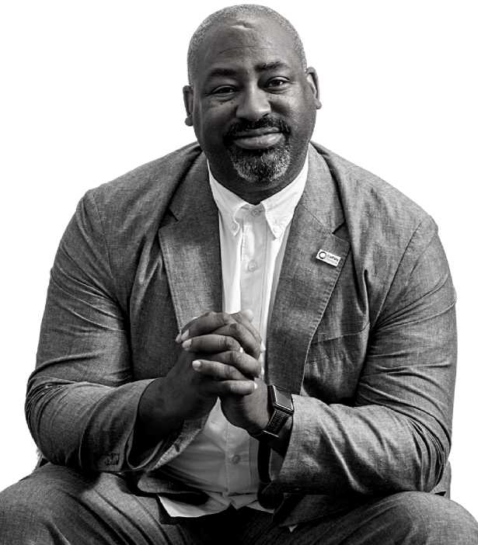
Bryant D. Fairley, Director of the Incubation Inventory

Page 30

Recommendation #3: Make Policies, Practices, And Procedures More Equitable And Culturally Relevant
The campus community expects the institution to move away from "just talking” about race and other EDI issues. However, to move from listening to action, a strong understanding of university operations and governance will be invaluable. The testimonies linked current policies, practices, and procedures to what type of racialized experiences are tolerated on campus. Therefore, a truth-oriented, self-reflective process on how students are educated, faculty are developed, and staff are promoted will reveal opportunities that either enable or stop incidents of racial injustices.
Policies at large seek to govern large groups of people. In the United States, due to backlash against the racial justice goals of the Civil Rights Movement of the 1960s, policies have evolved to be colorblind. This means that even if certain racial groups experience inequities and disparities amongst various quality of life indicators like education and health, public policies default to "equal treatment" implementation approaches. "One-size- fits-all" thinking has become a comfortable, de facto way of doing business for students, faculty, and staff, even if outcomes show sobering success gaps in recruitment, persistence, promotion, or retention.
The required conversation has two prongs: interpersonal racial experiences carried out by individuals and structural racism embedded into daily operations.
The latter creates the institution's operational structure and effectively connects policies, practices, and procedures to individual behaviors. What is allowed or not can enter the blurry reality of wondering if something is fair or not. Governing policies are particularly powerful because they set parameters on all university functions such as outreach and recruitment practices, promotions procedures, and how the institution responds to identity-based harassment and discrimination.
If racial equity is a goal, it is important to first acknowledge which policies are barriers to the goal's success. Actions include taking inventory of what exactly are the policies, how the CSU systemwide governance structure influences them, and how the institution interprets them. For example, one controversial statewide policy is Proposition 209, one of the most misunderstood, outcome-harming, and debated policies when it comes to racial equity goals. Despite its direct influence on racial justice efforts, there are various degrees of agreement to its intent, application, and value.
At large, institutional data and feedback clearly suggest that something our institution does within in its policies, practices, and procedures—or lack thereof—either drives some of the racial injustices observed or can proactively improve gaps. It is not acceptable to approach the problem with a "business as usual” mentality. This is not to say that Cal Poly Pomona has sole power in addressing all societal issues linked to racial inequalities. However, if a historical understanding of race and racism can be factored into how services, programs, business functions, and resources are designed and implemented, it is likely that a notable and positive shift within various equity gaps will be observed.
To address this recommendation, good, robust, and rigorous thinking around policies, practices, and procedure impacting enrollment demographics and promotion opportunities should be an institutional priority. Additionally, clear processes should be in place to address grievances when policies, practices, or procedures are deemed discriminatory, unjust, or harmful.
“If racial equity is a goal, it is important to first acknowledge which policies are barriers to the goal's success. Actions include taking inventory of what exactly are the policies, how the CSU systemwide governance structure influences them, and how the institution interprets them.”

Page 31

Sample Discussion Questions
The following questions seek to distill conversations into concrete action steps. Leaders can pose them at team meetings or individuals can reflect on them to identify their perspectives on the matter. These questions do not have any "right" answers - rightness falls on the degree the issues are understood and how solutions align with racial justice goals.
- What has been the real and ideological impact of Proposition 209 and can a collective, accurate understanding be cultivated for the campus community? What ideology drove Proposition 209 and colorblind ideology forward and when can this thinking be detrimental for racial justice goals?
- What can Cal Poly Pomona do to strategically lead conversations on colorblind thinking and values amidst a social climate increasingly demanding for more race-aware strategic actions?
- What is the policy governing how race-conscious efforts can be implemented within student outreach and recruitment activities, staff and faculty hirings, and promotions? How well do we understand their intent and their effect today? Are the outcomes they produce satisfactory, allowable, and worthy of celebration?
- Are there certain hiring and promotion practices and procedures that vary in implementation by person, department, or division? When incidents of unfairness emerge, what can an individual do to seek redress?
- What policies govern how diversity as a knowledge base and value is promoted in the curriculum? How are these 21st century learning outcomes promoted for all students and how are all faculty expected to cultivate them?
- What kinds of conversations can help policy reformers or designers think through the differences between policies, practices, and procedures? How can each component be viewed in a way that supports racial equity? What thinking can center equitable outcomes in the conversation?
- What is the mandatory policy change process and what steps must be taken to navigate it? Who needs to be involved and engaged? Who is the ultimate decision maker on policy change? How are policy changes managed so that the revised policy is implemented as intended?
- What policies are CSU systemwide and which ones are unique to Cal Poly Pomona? Where can Cal Poly Pomona exercise control?
- What data is available to understand the effects of policies? Is there a balance between quantitatively derived information and qualitative testimonies?
Chris Okoro, CPP Student

Page 32

Recommendation #4: Increase And Retain Black Student, Faculty, And Staff Numbers
Black students, faculty, and staff have made their experiences clear: the racism and prejudice they have experienced on campus is incredibly harmful. Various testimonies provide insights on factors that bring Black people to campus and those that move them away from it. To support Cal Poly Pomona's Black community, the campus community must understand and cultivate the power of representation. Not being the "only one” in the classroom or an office has a profound impact on sense of belonging, motivation, camaraderie, and satisfaction.
Named factors linked to the low representation of Black students, faculty, and staff include: the need to have clear outreach and recruitment practices for Black identifying individuals, the pervasiveness of anti-Blackness in thinking and behaviors that impacts how Black people make sense of their merit and value on campus, the lack of access to transformative professional development opportunities for Black identifying individuals, the need for the campus community to engage in structured education to halt racial microaggressions, invalidations, and other forms of racialized harm, a lack of trust with campus leadership due to unresolved past harms, institutional redress that has the power to promote a pathway towards racial healing, and an underdeveloped infrastructure to promote equity, diversity, and inclusion goals campuswide.
To address this recommendation, a funded and clear Black Thriving Initiative implementation strategy holds the highest potential in transforming the experience of the Black community and rebuilding trust between the institution and its Black community.

Sample Discussion Questions
The following questions seek to distill conversations into concrete action steps.
Leaders can pose them at team meetings or individuals can reflect on them to identify their perspectives on the matter. These questions do not have any "right" answers - rightness falls on the degree the issues are understood and how solutions align with racial justice goals.
- Given Cal Poly Pomona's climate, is it more urgent to recruit more Black students, faculty, and staff to increase our institutional representation of the Black community or is it more urgent to transform how anti-Blackness shows up on campus? Can it be assumed that recruitment will improve our racial climate? Will improving our racial climate improve retention?
- What division, department, or unit can spearhead these efforts first? Should graduate division start it or undergraduate programs? Does it need to be a pilot effort that becomes scaled out? Is a top-down approach more beneficial than a bottom-up approach?
- How can the institution promote critical dialogues behind the idea of increasing Black numbers is somehow removing someone else's opportunity? How can deficit- thinking be observed, named, and wrangled when it comes to diversifying the campus community?
- Where and how does colorblind thinking show up the most on campus? What does it sound like? What phrases or words capture this type of framing? How does campus understand how harmful or detrimental a colorblind approach can be on equity outcomes?
- What will Cal Poly Pomona state as enrollment or recruitment priorities for the next few years? How can the university strategic plan validate commitments to increase the representation of Black students, faculty, and staff? What will each division need to do?
- What level of "tolerance" does the campus community have for racial justice in principle as opposed to racial justice in practice?

Page 33

Recommendation #5: Provide Black Students, Faculty, And Staff With Equitable Professional Development Opportunities
Because racial injustices are real and have real impact on opportunities and successes, professional development needs to blend traditional workplace competencies such as communication, problem-solving, project management, and collaboration skills with education and navigational strategies that acknowledges the needs of individuals who hold marginalized identities.
As the institution moves towards the vision of inclusive excellence, it is still important to equip individuals who have been harmed by racism with the discussions, tools, and resources that will help them be successful. This includes critical conversations on how to make sense of imposter syndrome, what does leadership development look like if a person does not identify as a Cis-hetero White male, or how to heal from workplace trauma, discrimination, and harassment. While all communities can benefit from skill-enhancing and career-expanding advice that is rigorous in content, relational in delivery, and clear in outcomes, they are critical necessities for historically marginalized and firstgeneration communities. Key tactics may include mentorship programs, sponsorships, communities of practice, transparent conversations, and culturally responsive experiences.
For equity goals, professional development opportunities must be designed responsive to different identities and from an intersectional perspective. For example, what a First Generation, Black, Christian, Cis-Hetero Male must navigate at work may be different from an 3rd Generation, Asian, Queer, Non-Gender Conforming person. How a LatinX person navigates the institution may be different from a person with eastern European roots. It is important to not assume that everyone who identifies with the tailored lens will gravitate towards the offering because intersecting identities influence an individual's needs and interests, with wealth and class serving as a dynamically influential identity. However, it is likely that the more individuals understand power and privilege, the more tailored lenses will be solicited.
The racial justice conversation is inextricably linked to social mobility and wealth-enhancing opportunities. Whether its students who seek preparation and training on how to enter the job market or mid-career professionals refining their interview and presentation skills, or seasoned professionals seeking to enhance their fiscal management and collaboration skills, professional development benefits everyone. The stakes are high when minoritized communities do not get the services, resources, and support they need to navigate a racialized society. Thus, situating professional development strategies effectively is a critical component in any racial justice effort.
To address this recommendation, professional development competencies must be explored from the lens of different social identities and lived experiences—otherwise efforts may not achieve their intended goals. For example, when women-identifying individuals enter conversations on leadership development, topics unfortunately may need to include an intersectional perspective on navigating sexism and sexual harassment, motherhood and the maternity-tax, likeability politics, body shaming and hair policing, and other issues that uniquely impact a woman's experience in the workplace.
“For equity goals, professional development opportunities must be designed responsive to different identities and from an intersectional perspective." -Anonymous respondent
Cindy Pickett, Ph.D., Presidential Associate for Inclusion and Chief Diversity Officer

Page 34

Sample Discussion Questions
The following questions seek to distill conversations into concrete action steps. Leaders can pose them at team meetings or individuals can reflect on them to identify their perspectives on the matter. These questions do not have any "right" answers - rightness falls on the degree the issues are understood and how solutions align with racial justice goals.
- To what extent is professional development race-neutral? When do strategies, advice, and tactics "fall short" for minoritized communities?
- How can professional development programs be designed to include topics such as navigating racialized workplace trauma, code switching, and other issues minoritized communities face?
- How can controversial professional development topics such as professional dress, proper speech and executive presence be in critically conscious ways? What does it mean to navigate "this is the reality" thinking when pushing back on what can be problematic social norms?
- How can leaders build racial justice and more broadly EDI competencies, especially those serving or seeking to serve in a managerial role? How can EDI practices show up in the performance evaluation system? What is the impact of not having EDI competencies as a professional expectation?
- Who is responsible to teaching the "hidden curriculum?" What responsibilities do leaders have in explaining the real rulebook to success and when is omission considered a form of harm?
- Who tends to receive grace when settling into their role? Who tends to be heavily scrutinized? How are new managers, directors, and administrative leaders supported especially when they hold marginalized identities? How are existing managers, directors, and administrative leaders responding to the changing demographics of their colleagues?
- How can campus create innovative spaces that engage students, staff, and faculty who struggle to engage in professional development opportunities due to time and/or capacity restraints? When and how are their needs considered?
- What communities of practice can be set up so that historically excluded communities access career-enhancing knowledge? What role may identity and experience affirming activities such as affinity groups, employee resource groups, and heritage and pride month offerings, have in putting theory into action?
- What resources are needed to create professional development opportunities that are transformative to the communities who have been the most marginalized, and in effect, under resourced? How can campus develop funds that support the ongoing professional development of historically minoritized communities? How can those funds be accessed with ease?

Page 35
These recommendations combine to create an institutional strategy for racial justice. From a capacity building perspective, the recommendations alone will not automatically yield instant commitments. However, they are a clear guide of what Cal Poly Pomona must do to ensure the Black Thriving Initiative is successful. Important steps will include the Office of Inclusive Excellence's camp wide EDI strategic plan, a comprehensive inventory of current assets that support inclusive excellence goals, and a campuswide engagement and coordination strategy focused on improving the institutions' racial climate.
Given the variety and depth of the feedback, the Black Thriving Initiative recognizes that improving our campus's racial climate may be difficult to 1) conceptualize or 2) act upon. Nonetheless, the commitment has been made to help campus move forward. Fundamentally, culture change is a tangible, unambiguous, trust-developing process. It requires the simultaneous orchestration of response, planning, action, and reflection. This is the core model behind the Black Thriving Initiative and is one of the driving reasons why it has been able to achieve so much in such a short amount of time.
The journey will not be perfect but if the campus can come together, especially if leadership can identify pragmatic actions that reflect a commitment to do better even if these actions are accompanied by discomfort, Cal Poly Pomona will experience important strides in creating a university that is an equitable and welcoming place for all.
“Nonetheless, the commitment has been made to help campus move forward. Fundamentally, culture change is a tangible, unambiguous, trust-developing process. It requires the simultaneous orchestration of response, planning, action, and reflection.”

Page 36

Next Steps: Leverage the Mission Black Thriving Initiative Phase II
Ongoing commitment will move Black Thriving Initiative forward. This collective effort will demand grace and stillness to sift through past pains, current pains, and future occurrences of violence. While institutional change is iterative, imperfect, and non-linear, commitment will sustain the initiative.
Phase 1 of the Black Thriving Initiative will continue to focus on building capacity - both institutional and interpersonal. Listening to what its Black community has experienced and identifying what accountability can look like serve as two guiding tools to ensure the work advances to Phase 2 and Phase 3. Leveraging Cal Poly Pomona's mission can drive the type of transformation the initiative seeks.
Mission: We cultivate success through a diverse culture of experiential learning, discovery, and innovation.
Vision: Cal Poly Pomona will be the model for an inclusive polytechnic university that inspires creativity and innovation, embraces local and global challenges, and transforms lives.
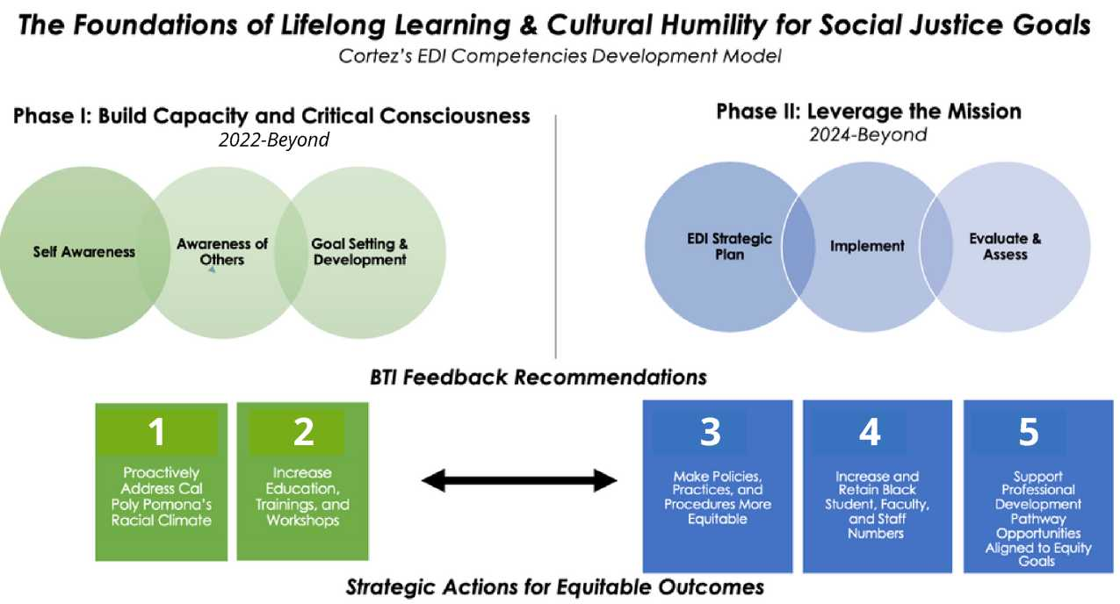

Page 37
Listening alone will not spur the actions needed for substantial change. The findings from the first listen and the deep listen steer Cal Poly Pomona towards an undeniable junction point: accountability. The voices of our Black community reveal how their physical and psychological safety has been impacted by tolerated workplace behaviors. The feedback of our broader campus community reveals the need to immerse the campus community in collective dialogue and the type of education where the terms equity, diversity, and inclusion are understood and operationalized. The process of creating a vibrant culture where all can thrive will take time but with guided reflection, clear strategy, and thoughtful implementation, transformation can occur.
These insights are substantial and connect the goals of the Black Thriving Initiative to the incoming Office of Inclusive Excellence's strategic plan. Decisions and investments should reflect the call to increase the number of Black students, staff and faculty on campus while also providing professional development resources. Efforts to promote persistence and retention should come with a critical examination of policies, practices, and procedures linked to equitable success outcomes. Lastly, campuswide education strategy holds the power to drive the uncomfortable work of shifting our racial climate realities.
The Office of Inclusive Excellence (OIE), in conjunction with the Division of Student Affairs (DSA), will play a key role in moving this work forward. One priority includes moving WSCUC Recommendation #1 forward: “Address issues of diversity and inclusion as a core value identified in the Strategic Plan with a sense of urgency.” Incoming and continuing efforts include invigorating campuswide engagement with the Principles of Community, a speaker series to illuminate collective consciousness of a wide variety of EDI topics, USC Race and Equity Center's Racial Equity Alliance e-convenings and the incoming National Assessment of Collegiate Campus Climates (NACCC) survey for student, faculty, and staff. OIE will build upon these efforts by developing its own strategic plan aligned to the values and goals espoused in our university's strategic plan. However, the entirety of the work needed cannot fall on the unit alone because everyone's involvement is required.
Upon reaching Summer 2024, the campus community will reckon with this question: “Are people's experiences changing?" It is undeniable that Cal Poly Pomona has an incredible set of assets that can contribute to the broader goal of inclusive excellence - but to maximize the success of the Black Thriving Initiative specifically, EDI champions must connect, coordinate, and collaborate. Furthermore, because the work required touches every single campus area - the involvement of all administrators will serve as the first clue of true accountability.

EDI Exists In All Strategic Initiatives Identified In The 2017-2025's Strategic Plan
- Deliver Quality Programs that Promote Integrative Learning, Discovery, and Creativity
- Enhance Student Learning, Development and Success
- Prepare Our Students for the Future of Work, Human, & Civic Engagement
- Strengthen Our Economic
- Vitality and Impact
- Advance Organizational Development and Employee Excellence

Page 38

Cal Poly Pomona Is Fully Committed To
- Addressing the systemic conditions that create injustice.
- Advancing racial justice, racial healing, and pro-blackness.
- Holding ourselves and others accountable.
- Considering ideas that previously seemed impossible and taking risks.
- Ensuring Cal Poly Pomona is a place where black students, faculty, and staff can thrive.
With 2025 rapidly approaching, it is acceptable to ask the question: "What have we done?” This powerful list confirms a lot is being done but the list alone does not reveal in what ways and to what extent. Nonetheless, it cannot be denied that Cal Poly Pomona has taken significant steps to listen to its community as changes are most evident in structural, capacity-building campus initiatives and staffing structures. To build upon these assets, it will be important to understand their effectiveness with keen observation on how campus implements, measures, and assesses its success. Without a coordinated strategy, these important investments may not automatically yield the type of change needed. An urgent priority will be to map out who these assets target, how support services are rendered, where partnerships make most sense, what barriers prevent success, and what gaps remain. The answers to these questions will be pivotal in evolving this list into a measurable strategic plan.
As an important note, if the goal is to create a campus community that honors and respects racial and cultural diversity, it merits an honest conversation on how these efforts, by design, may be replicating a deficit perspective to the communities they seek to help. In other words, are the target communities being viewed and approached with a deficit lens and served in a peripheral manner to "catch” up or become integrated into the institution or is the institution carry out its day-to-day academic, student support, and business operations in a way where everyone can be successful regardless of their identity?
With these important commitments to inclusive excellence, Cal Poly Pomona is in the interim space of letting go and becoming. Letting go a long-standing notion that the problem can fix itself and becoming in realizing that university leaders—and all students, faculty, and staff—play a role in embodying the institution's vision, mission, strategic plan, and principles of community.
When the fear of progress is greater than the need for progress, outcomes will not change. In the coming years, the commitment for inclusive excellence must be real enough, genuine enough, and protected enough to overcome the resistance and pushback social justice work is facing nationwide not limited to the harmful impact of rising economic inequities, declining mental and physical health rates, mass murders and state-sponsored violence, and the orchestrated ban and negative branding of Critical Race Theory within this country's psyche.
In contemplating the role everyone has in advancing the Black Thriving Initiative, these questions can help ensure all efforts, at a levels of the institution, are coordinated in meaningful ways.
Organizational Level | Questions To Contemplate
10,000 Foot View | What institutional-level commitments will align with our strategic plan, GI 2025, WSCUC recommendations, etc.? What resources, budgets, and priorities will ensure Cal Poly Pomona stays true to its strategic plan?
5,000 Foot View | What recommendations can be addressed at the operational level? What is a powerful way to assess and diagnose policies, practices, and procedures that produce inequities? How can a culture rooted in inclusive excellence be operationalized in every unit? What organizational structures can support this work?
1,000 Foot View | What programs, services, and resources can be offered directly to students, staff, and faculty that need and/or seek additional support? How can leaders ensure implemented efforts are scholarly grounded experiences? What kinds of leadership and professional competencies can best support the implementation and management of this work?
The Personal View | How will I navigate the day-to-day uncomfortable space of wanting racial justice but consciously or unconsciously resisting ideas that can make racial justice real at Cal Poly Pomona? What can I do to educate myself on these issues and what must I heal? To what extent do I understand my intercultural competencies and cultural humility skills?

Page 39

CSU Black Student Success Report: Institutional Commitments
In response to declining enrollment and retention of Black students across the California State University (CSU), Interim Chancellor Jolene Koester tasked CSU leadership with intensifying their commitment to support and promote the success of Black students. She framed this effort within Graduation Initiative 2025, which has contributed to increased graduation rates systemwide but has not yet been able to close stubborn equity gaps.
A strategic workgroup on Black Student Success was convened in fall 2022 to develop an approach to addressing these equity gaps that prioritizes the student experience and input. The result of that workgroup is a set of 13 recommendations that challenge both the CSU and Cal Poly Pomona to take bold action to drive the cultural changes needed to advance Black student success. As outlined in the Chancellor's Strategic Workgroup Black Student Success Report, it is the intent that the 13 recommendations outlined are implemented widely and consistently across the 23 universities. These efforts will be supported through the implementation of system-level recommendations that further advance campus efforts, including articulating systemwide policies and providing funding.
Because of the deep listening work of the Black Thriving Initiative, Cal Poly Pomona has a fuller and more accurate picture of the challenges and obstacles facing its Black faculty, students, and staff. It is with this grounding that Cal Poly Pomona will address the recommendations stemming from the Black Student Success Workgroup. Below are examples of the concrete actions that CPP will take to begin to catalyze the cultural change urgently needed to advance Black student success:
Institutional Priority 1: Develop a Comprehensive Retention and Persistence Strategy for Black Students
- Expand campus investment in high-impact programs (BASES, MSI, BRC, RISE, etc.) that support Black student persistence and retention.
- Establish a campus climate team that encourages culturally diverse and respectful communications; responds to biased speech or conduct not subject to First Amendment protection, and supports students, faculty and staff impacted by biased conduct.
Institutional Priority 2: Develop and Implement an Inclusive and Culturally Relevant Curriculum
- Expand the work of the Center for the Advancement of Faculty Excellence (CAFE) to include robust and repeated professional development for faculty that specifically addresses classroom racial climate and anti-Blackness.
- Create a Racial Justice and Cultural Humility Certificate Program for CPP Staff.
- Expand new faculty orientation to include a greater focus on creating inclusive classrooms.
- Provide Intercultural Development Inventory (IDI) coaching to CPP students, faculty, and staff.
Institutional Priority 3: Invest in Black Faculty and Staff Support
- Provide greater financial and administrative support to the Black Faculty and Staff Association (BFSA).
- Create equitable professional and leadership development opportunities for Black faculty and staff.
- Support and encourage the targeted outreach efforts of faculty search committee members so that recruitment efforts for Black faculty are more proactive.
The actions highlighted above are an initial subset of actions that Cal Poly Pomona will initiate to address the needs of its Black students. Fostering the success of our Black students demands a comprehensive and resolute strategy. Cal Poly Pomona is prepared to undertake this essential work.
Jaylynn Singley, CPP Student

Page 40

Supporting Black Student Success at Cal Poly Pomona
The Division of Student Affairs (DSA) continues to create intentional, holistic, and culturally- relevant programs, resources, and services to help address equity gaps and address Black student persistence and graduation at Cal Poly Pomona.

Reimagining Black Student Success at Cai Poly Pomona*
Not an exhaustive List
Engagement
- Black Clubs & Organizations
- Black Fraternities & Sororities
- Black Student Resource Guide
- EDI Action Grants
- Bronco Belong: Black Student & Family Orientation
- Black Scholars in Residence Program (UHS)
- Residential Intensive Summer Experience (RISE)
Education
- Racial Justice and Cultural Humility Learning Series
- Motivational Interviewing Coaching: Developing Black Student Grit, resilience, and Joy (BRC)
- EDI Training and Workshops
- 3Practives: Crossing the Difference Divide (In Development)
- Afrikan Black Coalition Conference
Points Of Contact: Jonathan Grady. Ph.D. (jgrady@cpp.edu) Derick Prince (dtprince@cpp.edu)
Academic
- Black Resource Center (BRC)
- Experiential Learning: Diversity Ambassadors (BRC and EWS)
- Academic Coaching (BRC and OSS)
- Sophomore Success Program (BRC)
- Black Achievement Success and Engagement in Science (BASES)
- Celebrating Black Student Achievement (CBSA) Program
Identity
- Intercultural Development Inventory (IDI) Coaching
- Cultural Exposure Opportune as (BRC)
- Black Men of Excellence (MSI)
- Black Womxn of Success (BRC & CAPS)
- Pan Afrikan Graduation Ceremony
Wellbeing
- Black Student Wellbeing Initiative (CAPS and BRC)
- Black Student Wellness Coaching (CAPS and BRC)
Career
- Lunch a Learn Dialogue Series: Community Cultural Wealth
- Black Student Leadership Training
- Black Alumni Family and Friends Collaborations and Mentorship
- Career Success Workshops (BRC)

Page 41

A Call to Action: Expressions Of Gratitude And Hope
The Black Thriving Initiative would not be possible without the love, investment, and support of President Coley, the Black Thriving Initiative Working Group, Cynthia. N. Cortez, Derick Prince, La'Keisha Beard, Elena Aleman, Dr. Armando Madrid, and the countless individuals who have demonstrated unwavering commitment to ensuring the success of the Black Thriving Initiative. Your support has been instrumental in driving positive change within our organization.
The future success of the Black Thriving Initiative will depend on the love, investment, and support of the entire community.
We believe, through and through, that with ALL of us working together, a brighter day is on the horizon. The path forward will need finesse, commitment, love, forgiveness, and unity. The path forward also requires us coming together, actively listening to one another, sharing our own personal testimonies, and giving grace.
As we journey forward together, we must continue to educate ourselves, challenge our own discomfort and prejudices, actively listen and observe, accept feedback, recognize our own privileges, become a confidant, understand the importance of allyship, and take action.
There may be times where our good intentions and good reasons have a negative impact on others. There may be times where we make mistakes. However, we must not allow fear to cripple our ideas, crush our experiences, nor stall our progress. Growth is not found in comfort nor familiarity.
Thus, today, and always, we must ask ourselves: What will I do to address systemic racism and ensure Cal Poly Pomona is inclusively excellent?
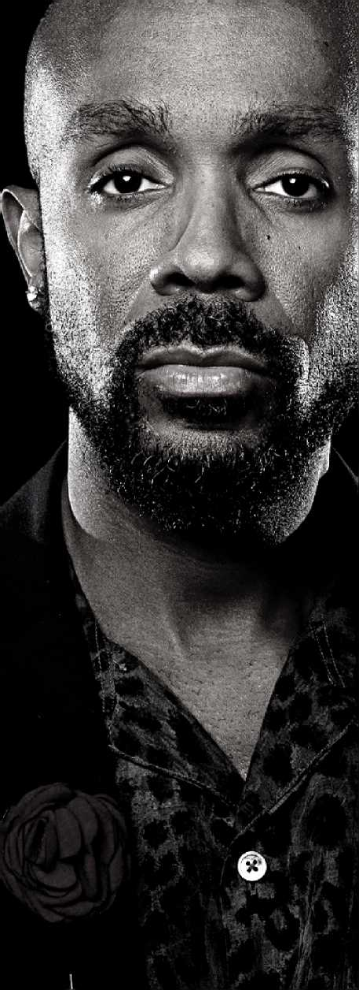
Jonathan Grady, Ph.D., Senior Associate Vice President, Equity and Belonging Division of Student Affairs

Page 42

Conclusion
With demographic shifts towards a more racially diverse society, increased debate on the value of a college degree, and intensified demands for equitable student outcomes, Higher Education is entering a stage of either incredible opportunity or profound unraveling. Institutions are not isolated from the social realities that are amplifying the impact of racism and anti-Blackness. As campuses continue to navigate pressures advocating for and against social justice, everyone must engage in critical dialogues that address what people know about injustices, how they think about true justice, and what ideas are real or mythical threats to true social change.
The Black Thriving Initiative intends to sustain its incredible momentum. The graphic below captures the progress to date during the 2022-2023 academic year. This journey that deep leadership engagement and widespread campus inclusive in the Black Thriving Initiative. As highlighted below, the process has reached the point where the campus community has enough information to ensure the initiative accomplishes what it has set out to do: support the success of Black students, faculty, and staff.
The Black Thriving Initiative has revealed that a relational approach is a non-negotiable if everyone's involvement is expected. Also, an approach rooted in truth-telling and education is mandatory if dignity and respect are core outcomes.
For the initiative to survive, support must come in the form of financial commitments, organizational infrastructures, and affirming messaging efforts. As a result, a pivotal step to the initiative's sustainability will be how leadership contextualizes the feedback's themes and overall initiative findings within their divisions and departments. To highlight a sobering lesson learned in inclusive excellence work at large, unless a process is put into place to hold everyone accountable to the Black Thriving Initiative's goals, this multi-year effort may easily be perceived as a waste of time, resources, and energy.
To stay connected and informed on the progress of the Black Thriving Initiative, please visit: cpp.edu/bti.
To donate to the Black Thriving Initiative, please visit: https://cpp.thankyou4caring.org/pages/black-thriving-initiative
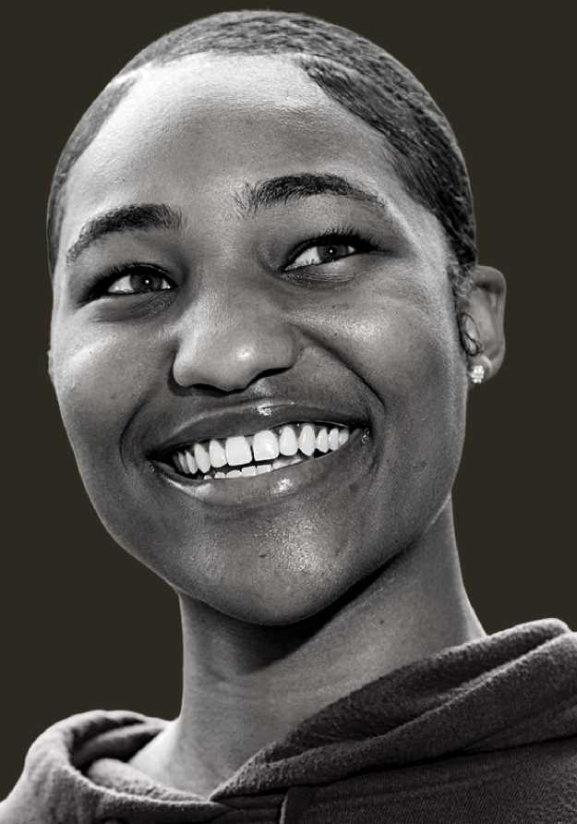
Kayla Atkinson, CPP Student

Page 43

Resources
10 Things Allies Can Do to Advance Racial Justice at CPP
An ally is someone who lends their power, privilege, and access to courageously support and advocate for someone who may or may not have the same privileges as you. To be an ally requires that a person not simply notice an injustice, but also requires action by bringing attention to the injustice and requesting/demanding that it be corrected. Allyship is not a badge you earn. Rather, it is a continuous process of learning about a range of intersecting identities and lived experiences to create a more equitable and inclusive community (Dr. Makini King, 2018).

Page 44

Join the Conversation
Under Our Skin Video Series & Campus Reflection
The "Under Our Skin" video series from the Seattle Times brings to light candid discussions around: Institutional Racism, Person of Color, Racist, Ally, Microaggression, All Lives Matter and Black Lives Matter, Politically Correct, Colorblindness, Safe Space, Diversity, White Privilege, and White Fragility.
These words have become more common in our mainstream media, and have long histories and origins in social and civil rights movements here in the U.S. and elsewhere.
“It's upsetting that a prevalent and racialized issue like police brutality is met with deflection. All Lives Matter is ignorant at best and malevolent at worst. It exists to maintain a status quo where we don't look try to address the root of racial inequity. I hope that as younger generations move into politics, this kind of deflection becomes unacceptable to campaign on and we can collectively move towards addressing racial inequity.” - CPP Staff Member, Video Watched: All Lives Matter
Tariqa Waters, Seattle Times Interviewee

