InfoReady Quick Start Guide

SPICE Award Online Application

SPICE proposals must be submitted through the Cal Poly Pomona InfoReady online application site. Navigate to the Cal Poly Pomona InfoReady Review website (URL: https://cpp.infoready4.com/)

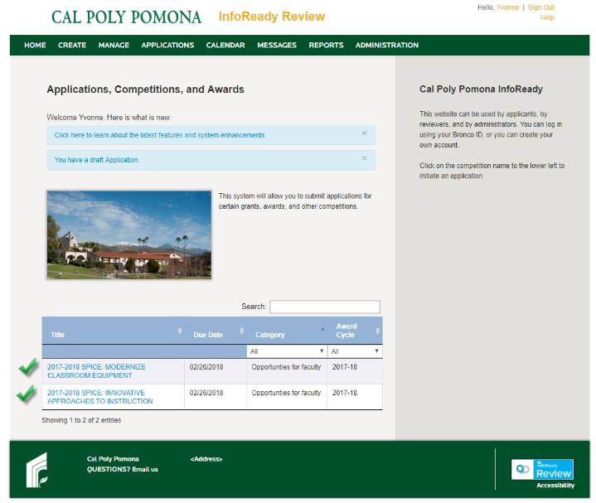
- At the InfoReady Review page, select the SPICE award application link to create and submit your online application.
NOTE: If you elect to log in first (yellow link on the right upper corner), the screen sequence will differ from this guide.

- At the Application Tools page, details of the award are display for your review. Click on the [Apply] button located on the right side of the page.

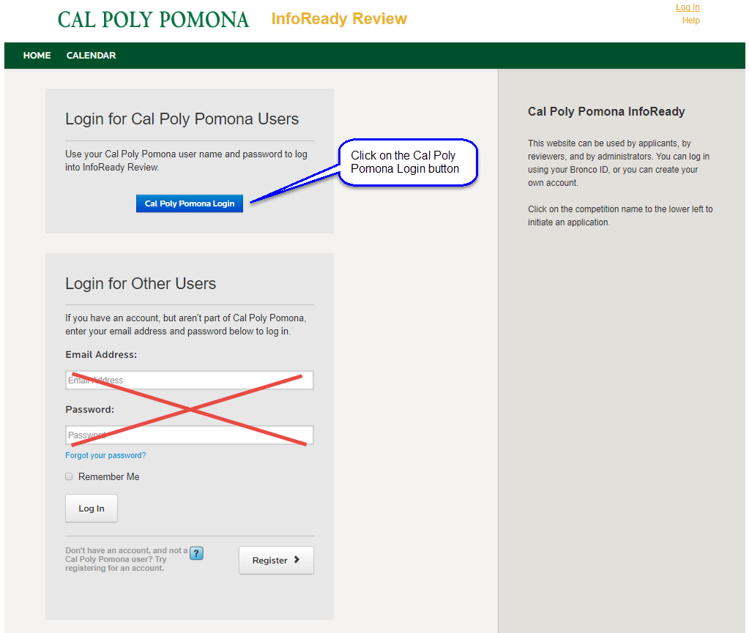
- Click on the [Cal Poly Pomona Login] button.

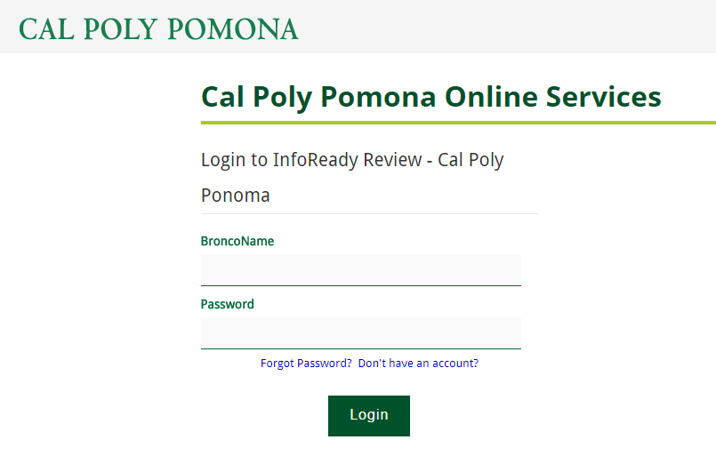
- Use your Cal Poly Pomona credentials to complete the login process.

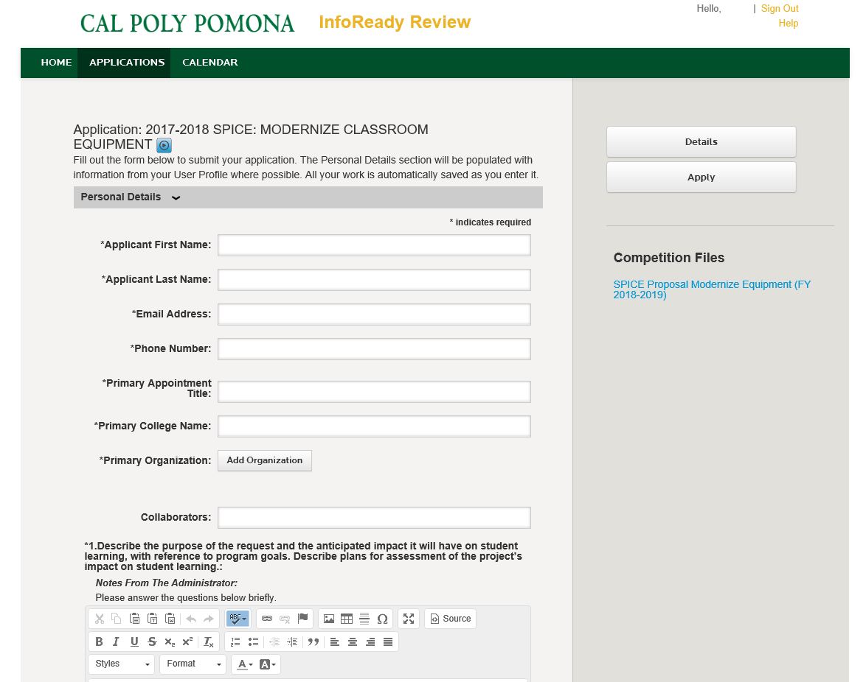
- Complete the SPICE application form. When you are finished, click on the [Apply] button.

