# Switching to Document Camera while on Zoom

The Campus has standardized on two HuddleCam versions; Ultra 8 and Duo

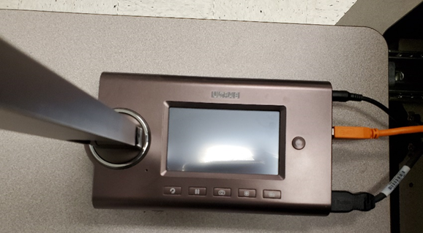 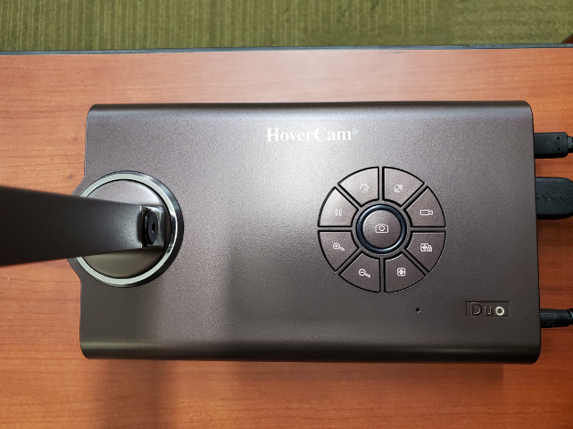

Ultra 8 Duo

1. Turn on Document Camera

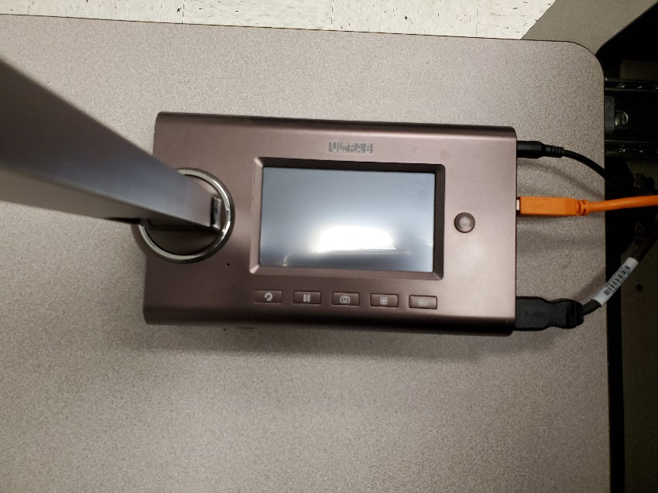 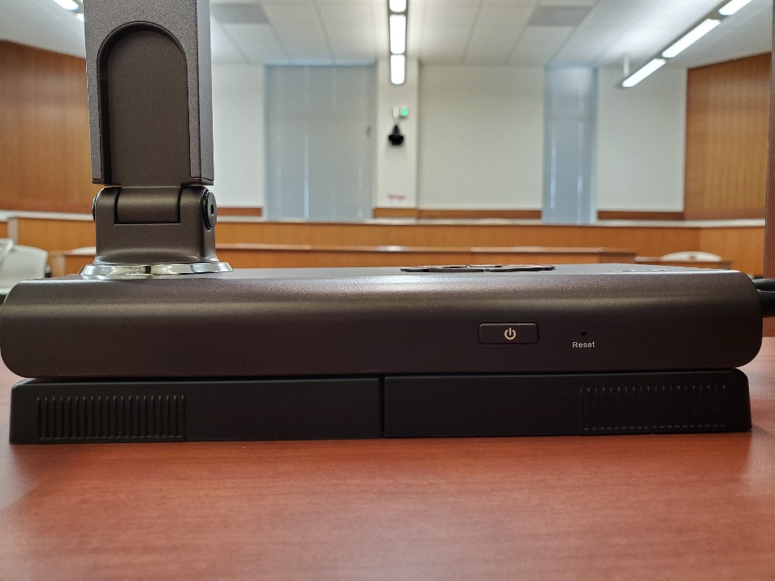

1. Press Video Selection

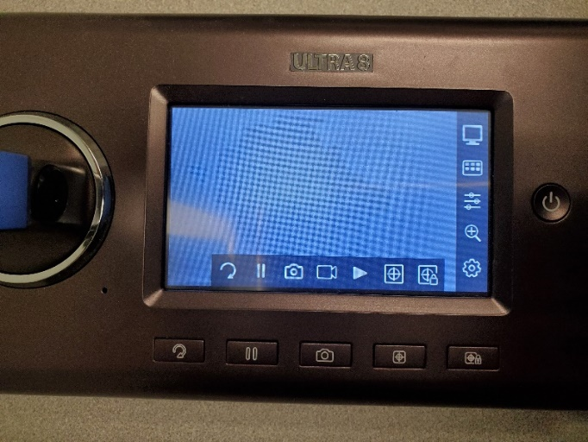 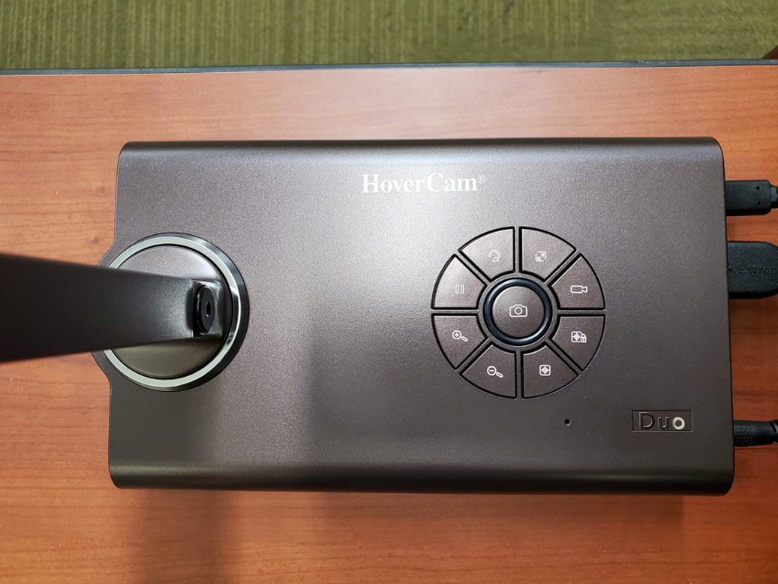

* 1. Ultra 8: Switch from HDMI to USB using the touch screen

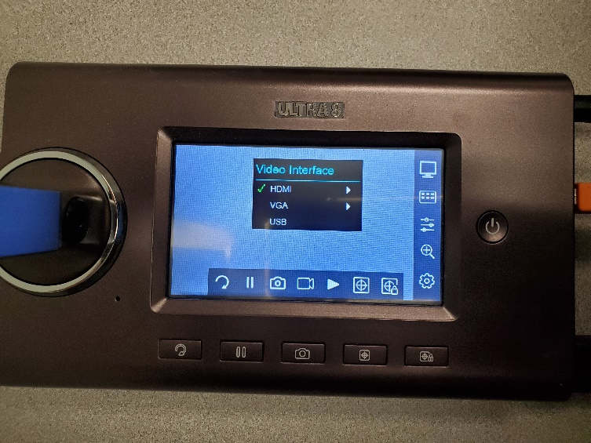 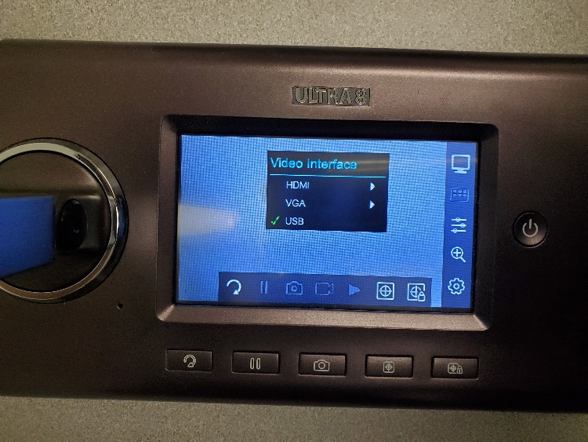

* 1. Duo: Switch from HDMI to USB using the video selector button - toggles between HDMI and USB

1. In Zoom Video Settings, Select HoverCam Ultra8 or Duo

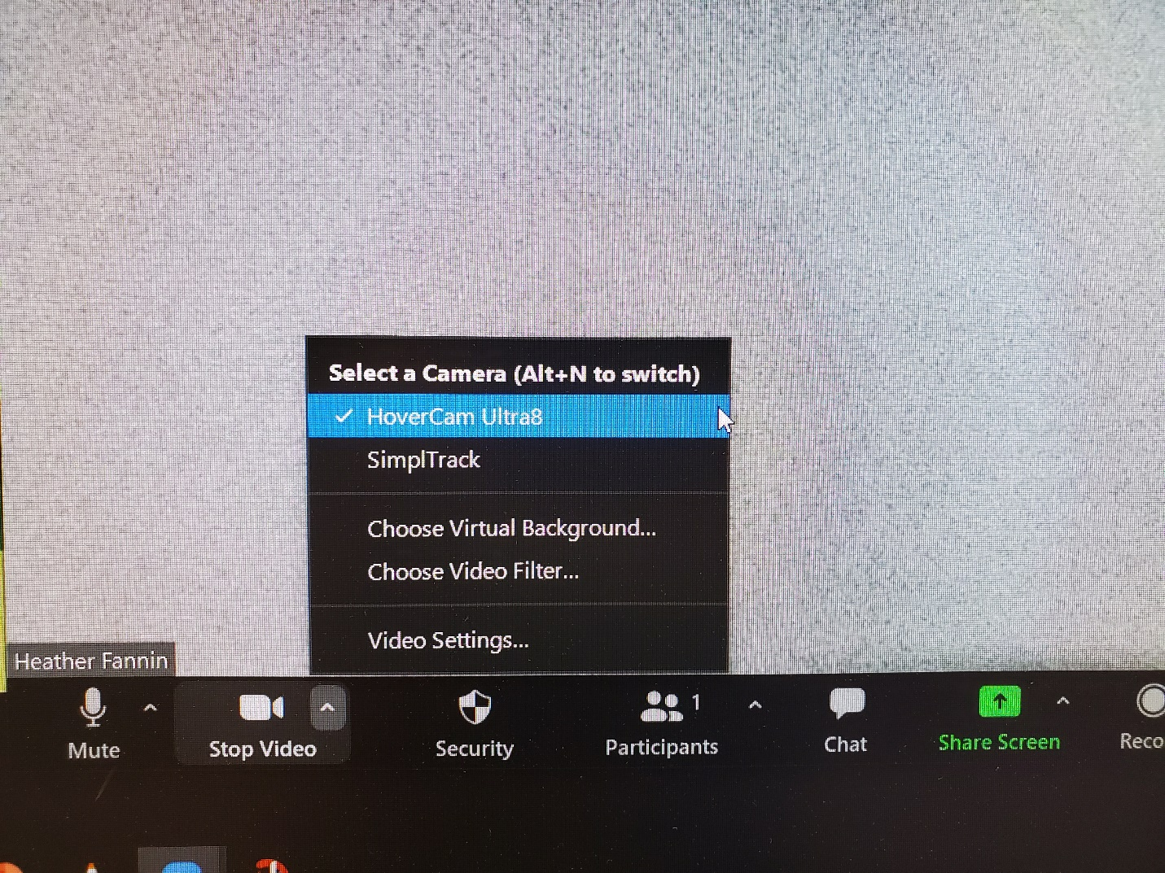

* After your session, please switch the video selection back to HDMI and shut off the document camera.

# Using the Software Application and Screen Share

1. Turn the document camera on first
2. Open Document Camera Software

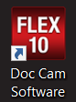 or 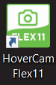

1. Open Share Screen on Zoom and Select appropriate Monitor to Share

## HoverCam Duo Controls:

HoverCam Duo Controls: Blue Light indicates camera is powered on (ring surrounding center button), HDMI/USB Video Selector (located at 2:00), Auto-Focus (located at 5:00), Zoom Controls (located at 7:00 & 8:00), Rotate Image (located at 11:00)


Rotate Image

Zoom Controls

Auto - Focus

HDMI / USB Video Selector

Blue Light indicates camera is powered on