PRINCIPAL LEADERSHIP OF THE COMMON CORE:
KEY PRACTICES AND PROCESSES

A Dissertation
Presented to the
Faculty of
California State Polytechnic University, Pomona

In Partial Fulfillment
Of the Requirements for the Degree
Doctor of Education
In
Educational Leadership

By
Emily W. Hanson
2020

SIGNATURE PAGE

DISSERTATION: PRINCIPAL LEADERSHIP OF THE COMMON CORE:
KEY PRACTICES AND PROCESSES

AUTHOR: Emily W. Hanson

DATE SUBMITTED: Summer 2020

Department of Educational Leadership

Dr. Donald Lin
Dissertation Committee Chair
Department of Educational Leadership

Dr. Harvey Smith
Professor
Department of Education

Dr. Elizabeth George
Assistant Principal
Marshall Unified School District

Signature page must be printed on the proper paper: White, at least 25% cotton, 20 pound paper, 12 point font size, Times New Roman.

ACKNOWLEDGEMENT

This is written after the Final Dissertation Defense.

ABSTRACT

The recommended abstract length is 150 words. No more than 250 words are allowed.

TABLE OF CONTENTS

SIGNATURE PAGE 38
ACKNOWLEDGEMENT 39
ABSTRACT 40
LIST OF TABLES 44
LIST OF FIGURES 46
CHAPTER 1: INTRODUCTION 47
Statement of the Problem 47
Sub Heading 2 47
CHAPTER 2: LITERATURE REVIEW 48
CHAPTER 3: METHODOLOGY 49
CHAPTER 4: RESEARCH FINDINGS 50
CHAPTER 5: CONCLUSIONS, IMPLICATIONS, AND RECOMMENDATIONS 51
REFERENCES 52
APPENDIX A 53

If you need to add sections to your Table of Contents, you would add those sections throughout the document. For instance, if you were adding a subheading under Chapter 1 called “Background to the Problem,” you would mark that as a “Heading 2” style under Styles. Then you could update your Table of Contents by right clicking the Table of the Contents, selecting “Update Field,” then selecting “Update entire table,” and then selecting OK. If need be you can delete an unnecessary line or manually enter text.

You will need to change the font in the Table of Contents after doing an update as it will keep the original format styles as it’s in your document. Such as changing text from all upper case to lower or sentence case, un-bolding text, color changes etc. To change the letter case of a section, select the text then use the Aa function next to your selection to change the letter case. 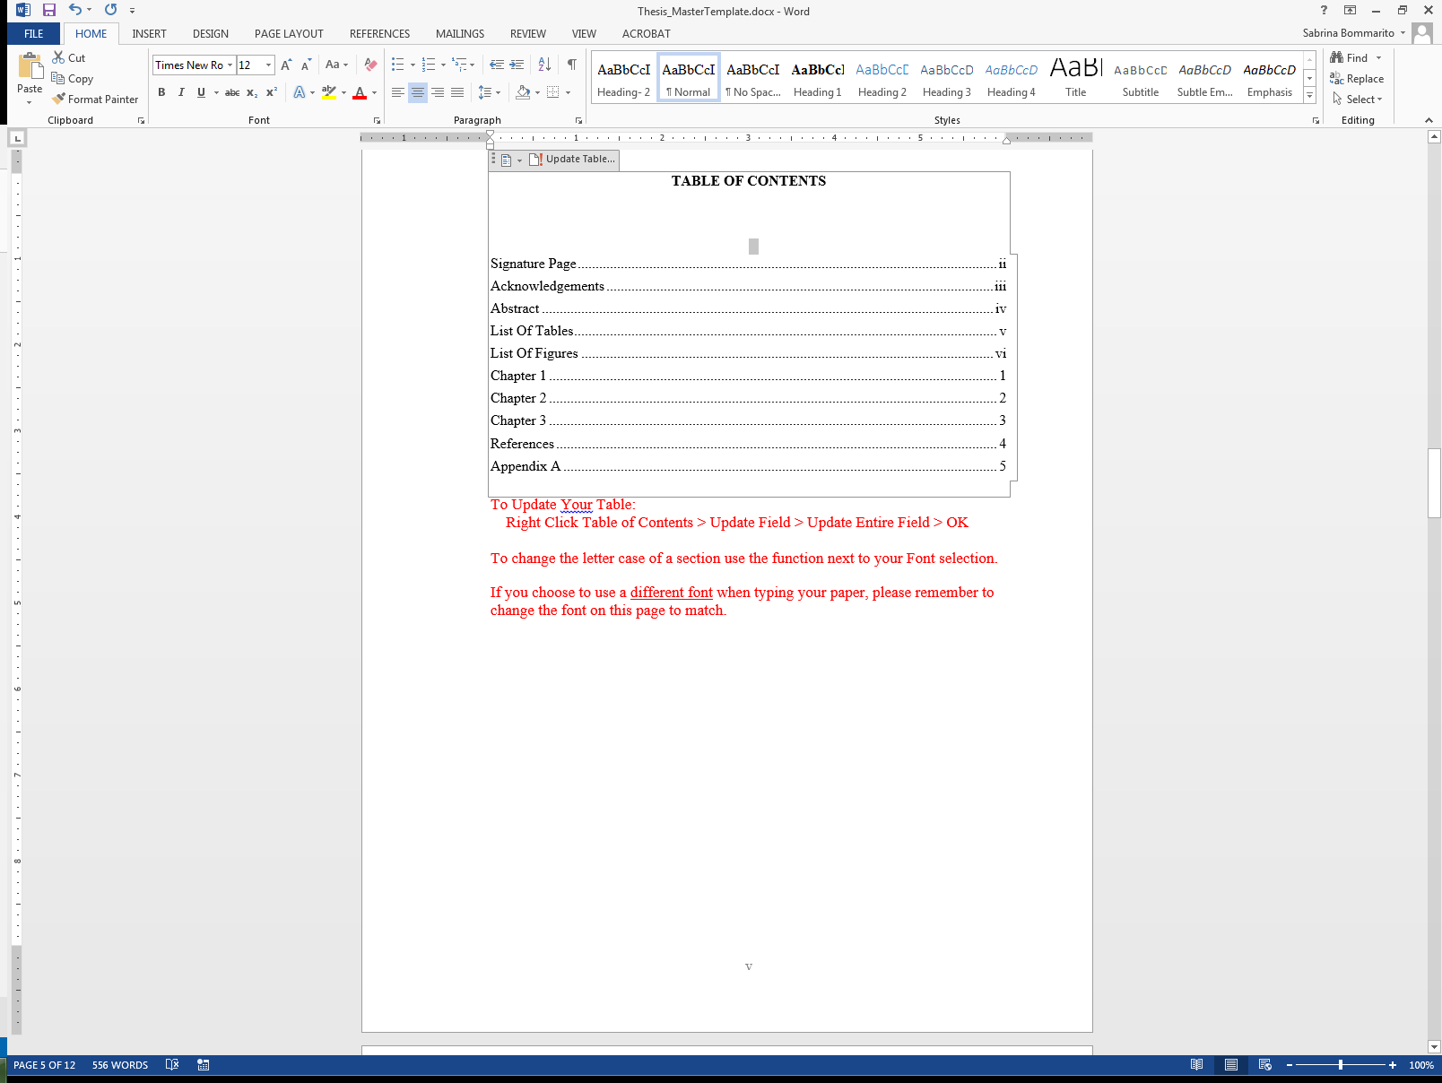

.

LIST OF TABLES
Table 1. Six Shifts of the Common Core State Standards 10
Table 2. AUSD Elementary School DL Language Instructin Percentages 15
Table 3. List of Interview Participant’s Pseudonyms 20

For the List of Tables to update properly you must use captions for your tables. Captions are titles or brief explanations for your table. To add captions, in your document body, right click your table(s), and select “Insert Caption.” A dialog box will open where you will input the title of your table. Next, in the drop down select “Type of Label.” Once you select the type of label, select the placement as either above or below the table and then click ok.

To update the List of Tables, you’ll need to be on this page listing all of the tables, not in the document body. First, right click the contents of the List of Tables, select “Update Field,” then select “Update entire field,” and then click OK. If you have used the captioning feature as suggested above, updating your List of Tables will automatically include captioned tables from your document.

If there needs to be a space between table # and text place the cursor before the text and hit the spacebar 6 times to appear as such: Table #. Sample Text
Remember to make sure your captions meet your formatting criteria such as (APA, MLA, etc.) by changing font, font size, placement and alignment of caption text as necessary.

LIST OF FIGURES

Figure 1. Principal’s leadership practices 30
Figure 2. Growth of language immersion in the United States, 1971-2011 40

For the List of Figures to update properly you must use captions for your figures. Captions are titles or brief explanations for your figure. To add captions, in your document body, right click your figure(s), and select “Insert Caption.” A dialog box will open where you will input the title of your figure. Next in the drop down select “Type of Label.” Once you select the type of label, select the placement as either above or below the figure and then click ok.

To Update the List of Figures you’ll need to be on this page listing all of the figures, not in the document body. First, right click the contents of the List of Figures, select “Update Field,” then select “Update entire field,” and then click OK. If you have used the captioning feature as suggested above, updating your List of Figures will automatically include captioned figures from your document.

Remember to correct captions to meet your formatting criteria such as (APA, MLA, etc.) by changing font, font size, placement and alignment of caption text as necessary.
.

CHAPTER 1: INTRODUCTION

CHAPTER 2: LITERATURE REVIEW

CHAPTER 3: METHODOLOGY

CHAPTER 4: RESEARCH FINDINGS

CHAPTER 5: CONCLUSIONS, IMPLICATIONS, AND RECOMMENDATIONS

REFERENCES

APPENDIX A

If you have more than one appendix, label them APPENDIX A, B, etc.

