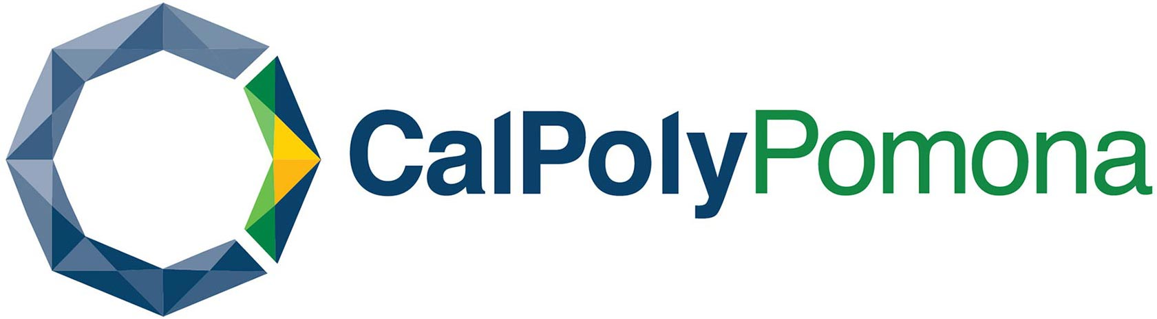

Doctoral Program
Educational Leadership Department
College of Education and Integrative Studies

Question and Answer Fact Sheet

How do I apply for the program?
The application process is comprised of two major steps: 1) application to the university, and 2) application to the doctoral program.

Step 1a: Applicants must first apply to the university online through https://www2.calstate.edu/apply Please select the Summer 2026 term from the dropdown menu as your application term.
Be sure to complete all application sections marked REQUIRED. Your application WILL NOT be moved forward through the administrative process if you fail to do this.

Step 1b: Submit official transcripts from all universities previously attended to the Cal Poly Pomona Admissions Office. Please make sure that you have completed the online application before sending your transcripts. Unofficial copies of your transcripts will also need to be uploaded into your Cal State Apply application. Please upload your unofficial Master’s transcript into the field marked REQUIRED. Upload your unofficial Bachelor’s transcript into the additional field. Please read carefully and pay attention to which fields are marked REQUIRED.

Step 2: The second part of the process requires that pertinent supporting documents be sent via email in PDF format to Betty Alford at btalford@cpp.edu. This is a comprehensive process that includes completion of a doctoral program supplemental application, a formal written statement in response to a series of questions, and an admission interview Further information is available in the doctoral program brochure and the Doctoral Studies Website: https://www.cpp.edu/financial-aid/index.shtml

What constitutes eligibility to the program?
To be eligible for admission into the doctoral program, you must meet both university AND doctoral program admissions requirements. Meeting university admissions requirements will only establish eligibility for consideration as an applicant, but will not guarantee your acceptance into the doctoral program. If you emerge as a finalist, based on the initial university and program screening process, you will be invited for an interview. After the interview window, the program admissions committee will convey formal admission decisions.

What are the requirements?
- Prior Education: You must already have earned a baccalaureate degree and a master’s degree from an accredited institution of higher education with a cumulative GPA of 3.0 or higher in upper division (junior/senior year) and graduate studies.
- Recommendation Letters: Cal State Apply will prompt you to enter contact information for three professional references who can provide letters of recommendation attesting to your leadership ability and scholarship potential. It is recommended that you contact your references and request a letter of recommendation prior to submitting their contact information.
- Ed.D. Program Application: The Ed.D. Program application requires responses to several writing prompts as well as the submission of a current vita.

What do I need to know about taking the GRE?
The GRE is no longer required for the doctoral program admission process.

What are the application timelines?

We are currently accepting applications for Cohort XV to begin May 2026. Applications will be screened during the winter and spring months. Selected applicants will be invited for an interview.

Once the Cal State Apply application has been submitted, there will be an automated letter of acknowledgement from the university that will be sent to you electronically. Keep it for your records as it will provide you with an Application Confirmation Number should you need to refer to it while going through the university admissions process. A second letter will then follow that will include your nine-digit identification number, or Bronco ID number, which you must use in all future communications with the university. You will also receive instructions on claiming/activating your Cal Poly Pomona account or Bronco Direct. Bronco Direct is the front door that you will use to access your application status, to do list, admission status, the course catalog, and financial aid information.

What is the selection process?
- Candidates must meet all requirements listed on page 1.
- Applications to the doctoral program will be reviewed and assessed by the program admissions committee and candidates will be contacted for a personal interview.
- After the interview process has been completed, candidates will be notified whether they have been admitted to the doctoral program.

How do I track my progress in the application process?
Admissions have a student-specific “to do list” that applicants can view on the web through Bronco Direct to follow their progress. You are strongly encouraged to monitor your progress in order to help facilitate completion of your file. If you encounter special difficulties, you may call the Doctoral Studies Co-Director for assistance at 936-554-5240, Betty Alford’s cell phone. Please do not call regarding your status as an applicant, however, since you will be notified as soon as decisions are made.

When will I know if I have been accepted into the program?
We anticipate notifying candidates who meet both university and doctoral program eligibility requirements on an ongoing basis after successful paper screening and an interview. Following the personal interview session, an email and formal letter will notify candidates if they have been accepted into the doctoral program.

What is the cost of the program and is financial aid available?
Although a potential to change by the CSU Trustees in future years, current program costs are approximately $21,600 per year excluding books and local fees for the three semesters. The cost is approximately $7,200 per semester. Doctoral students are eligible for Stafford Loans and a host of other loan-type aid that can range up to $20,000 per year. Every student case is different. Students may begin the optional financial aid process by filing the Free Application for Federal Student Aid (FAFSA) through http://www.fafsa.ed.gov/ . The process takes about 20 to 30 minutes to complete. The funds are awarded to eligible applicants on a first-come-first-served basis and the priority application timeframe is January 1 to March 2. It takes 6 to 8 weeks to receive the award notification from Financial Aid. Please note that for summer admission, you will need to complete TWO FAFSA applications. One for the 2025-2026 academic year, which will cover summer, and one for the 2026-2027 academic year. The deadline to complete the FAFSA application is June 30th, but you are encouraged to complete it as soon as possible. All inquiries regarding financial aid should be directed to the Office of Financial Aid at (909) 869-3700.

When will the program begin?
A new cohort of accepted candidates will start each summer. The summer term begins in early June. This is a rigorous, cohort-based, year-round program that is offered in a fixed sequence of courses that includes the dissertation culminating experience. The entire program, including the final dissertation, is designed for completion in three years.

When and where will classes be held?
Because the program is designed for working professionals, classes will be held on Saturdays with courses containing some online components. Courses will be held on the Cal Poly Pomona campus every other weekend unless the meeting times are adjusted for a holiday. A yearlong calendar of meeting dates will be provided each year.

How can I learn more about the program?
You may review the doctoral studies website https://www.cpp.edu/~ceis/edleadership/doctoral-program/index.shtml or attend a program information session, dates and times are available on the website. Further information is also available by contacting the program director, Betty Alford at btalford@cpp.edu or 936-554-5240.

Doctoral Program Co-Directors:

Betty Alford, Ph.D.
btalford@cpp.edu

Jose Aguilar-Hernandez, Ph.D.
jhernandez@cpp.edu

