Confirm Notetaking & Download Notes

Confirm Notetaking
Peer Notetaking is a 2-step process. Step one is described in How-To: Request your Accommodations. The second step of the Peer Notetaking process requires you to confirm your request
  - From My Accommodations menu, select Notetaking Services
  - Click on Confirm Now under each class
  - Confirmation – Done!

Download Notes
- From My Accommodations menu, select Notetaking Services
- Available notes from each class will be listed.
- Click on Available Notes for Download to open the list of notes.
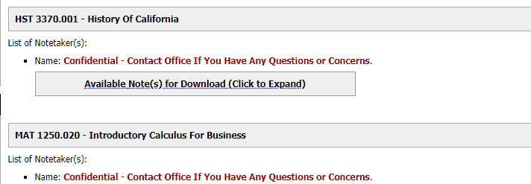
- Click on Download Note to view the file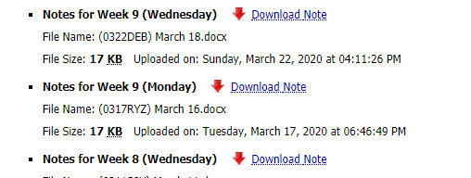

If you have any questions, please contact our office, we’re here to help!
Email: drcnotetaking@cpp.edu

