REQUESTING ACCOMMODATIONS

Accommodation Process Overview
Your FIRST STEP to using your accommodations each term is to request your accommodations for specific classes. Your accommodations do not go into effect until you have requested them for a class.
Step 1: After registering for classes each term, student submits a request for the accommodations they plan to use in each class thru DRC Online Services.
Step 2: DRC emails each Instructor a Notification of DRC Student Accommodations listing the requested accommodations.
Step 3: Student completes the NEXT STEPS outlined for specific accommodations they have requested.

How to Request Use of Your Accommodations
- From the DRC website, log into DRC Online Services
- Enter your Bronconame and password
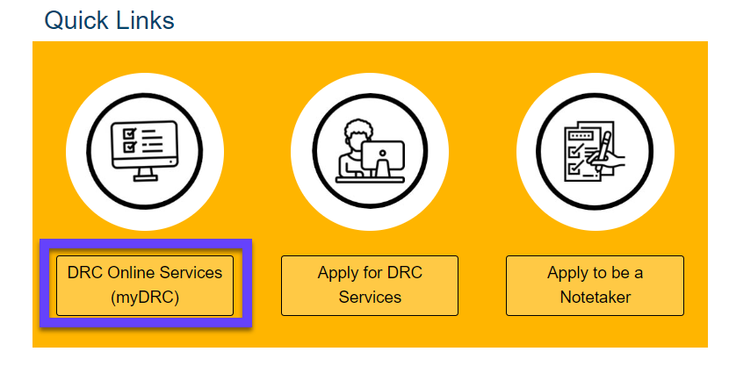

- The first time you log in each term, you will need to read and sign the Accommodation Agreements.

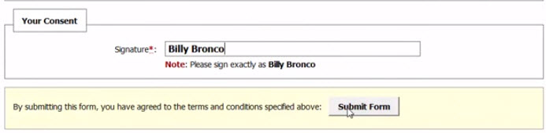
- From My Dashboard, scroll down to Select Accommodations for Your Class
- Select Classes. Check the box for each class in which you want to use your accommodations.

- Select Continue to Customize Your Accommodations
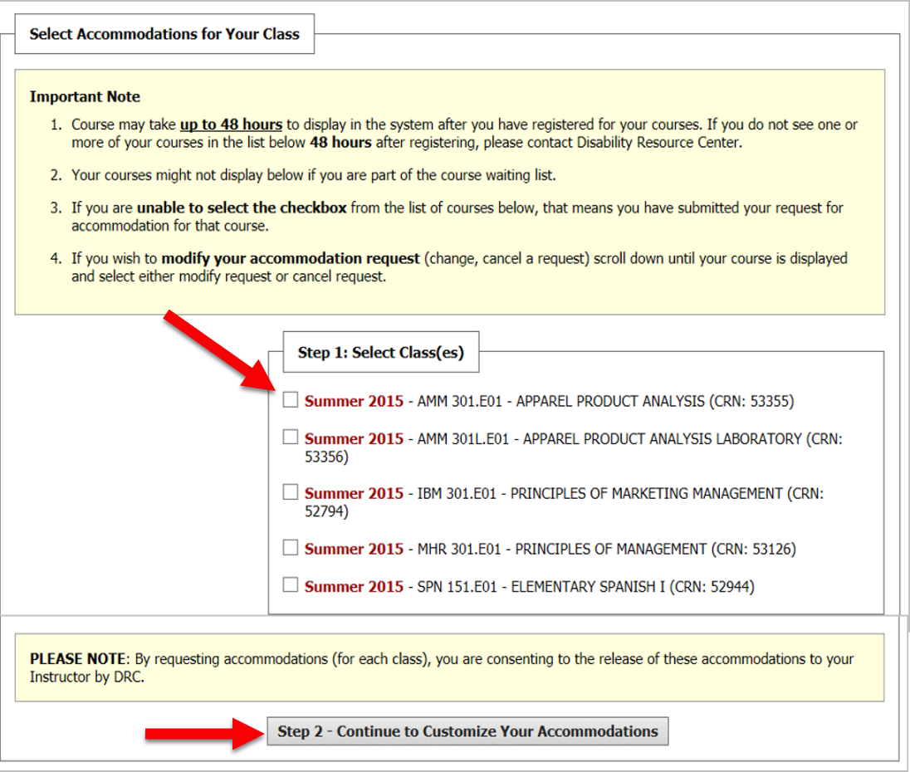

- Select Accommodations. Check the accommodations that you would like to use in each class and, select Submit Your Accommodation Requests.
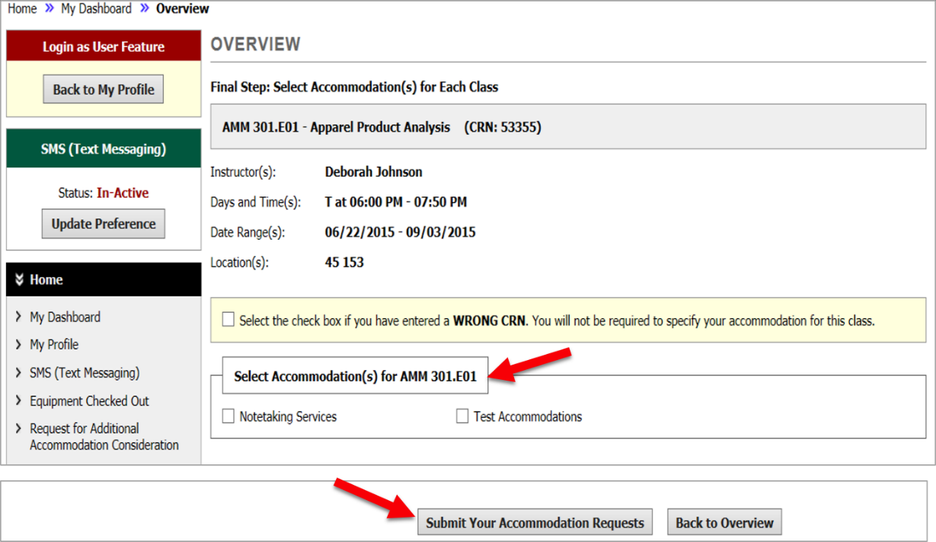
That’s It! DRC will send a Faculty Notification Letter to each Instructor listing your requested accommodations.
If you have any questions, please contact us at drc@cpp.edu office. We’re here to help!

