myDRC INSTRUCTOR ACCESS:

How to View Student Accommodation Requests

WHAT IS myDRC?
myDRC-Instructor Access is an online portal which instructors may use to view and manage accommodation requests for students enrolled in their classes. This is an optional tool for instructors to use. DRC will also send student accommodation information (Faculty Notification of Accommodations) via your CPP email.

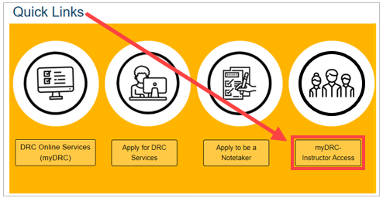
INSTRUCTOR PORTAL LOGIN
- From the DRC website Quick Links, click on myDRC-Instructor Access
- Using your CPP credentials, log into myDRC
- You will first see an important reminder about FERPA and confidentiality
- Then select:

VIEWING STUDENT ACCOMMODATION REQUESTS SUMMARY
- From the Overview page, you can preview the list of students who have requested accommodations in each of your classes
- To view the student’s detailed accommodation information, select View
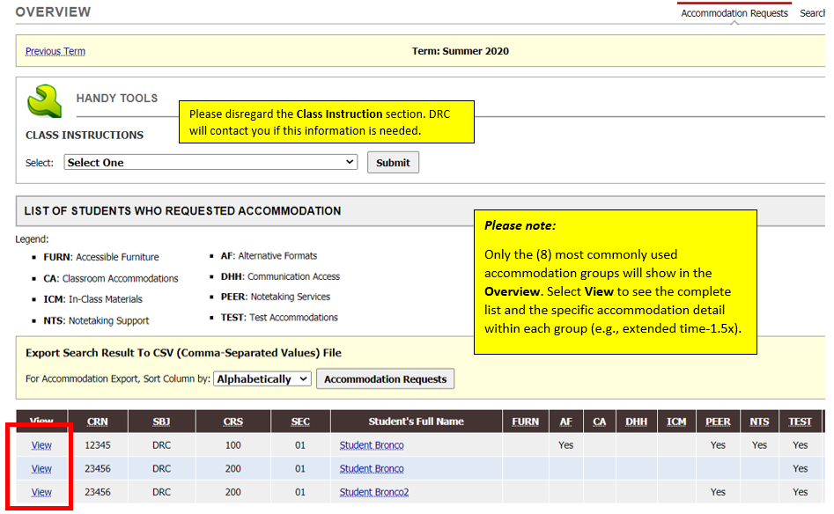

VIEWING STUDENT ACCOMMODATION REQUESTS DETAIL
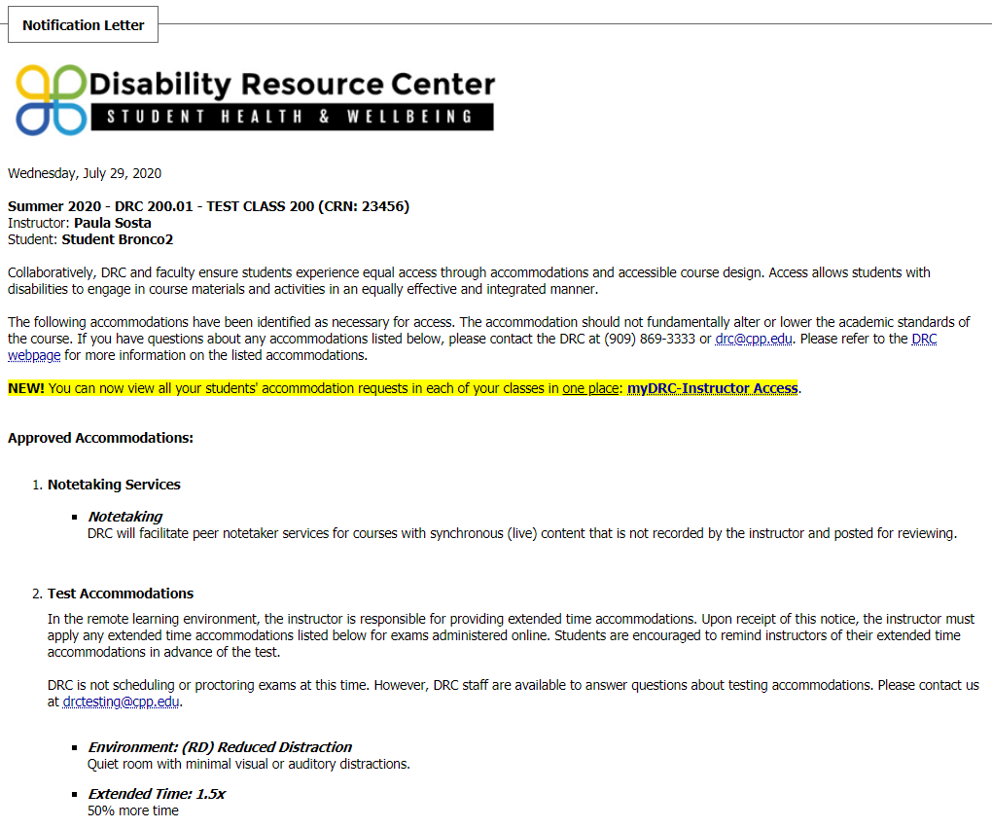
It is IMPORTANT to select View to see the specific accommodation details for each student:

