How to Upload a Recording to Notetaking Express Hub
- Log-in to Notetaking Express using this link: https://www.ntehub.com/
- On the left side of the main page, locate the blue button with the microphone icon titled “Record”. Under this icon, select the “Upload Recording” option.
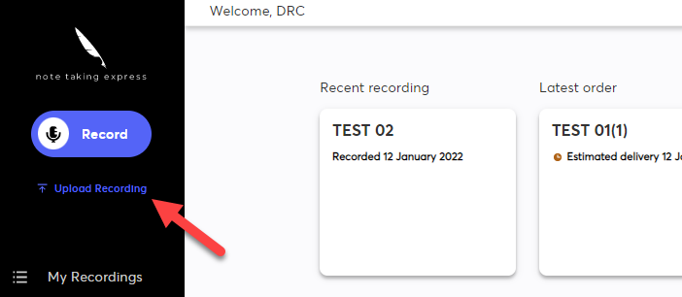
- Once selected, it will open your computer’s File Explorer or Finder. Select the desired recording and select “Open”.

- Once the recording is uploaded to 100%, title the file. To help with organization, try titling your class recordings based on date and course name. Once this is complete, select the “Save” button.
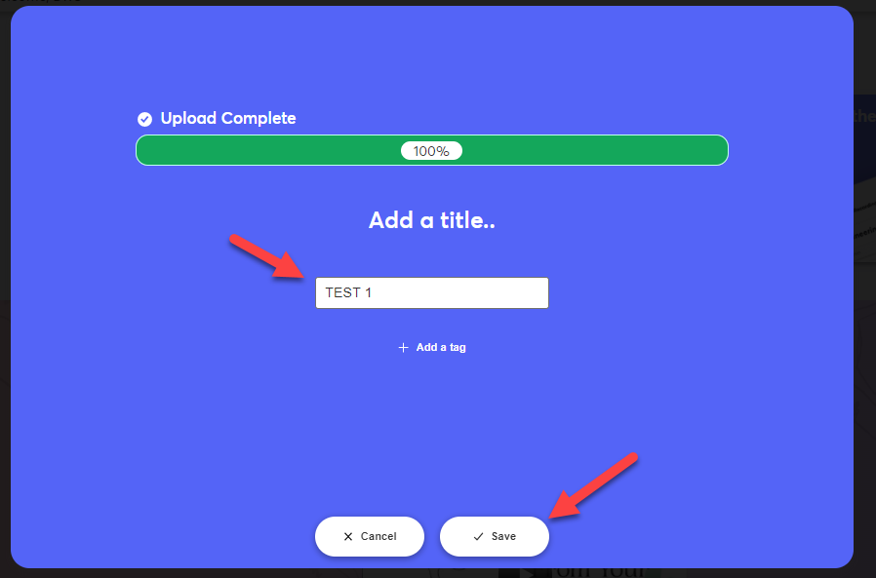
- On the next slide, confirm you would like to request notes for the recording by selecting the “Request Notes” button.
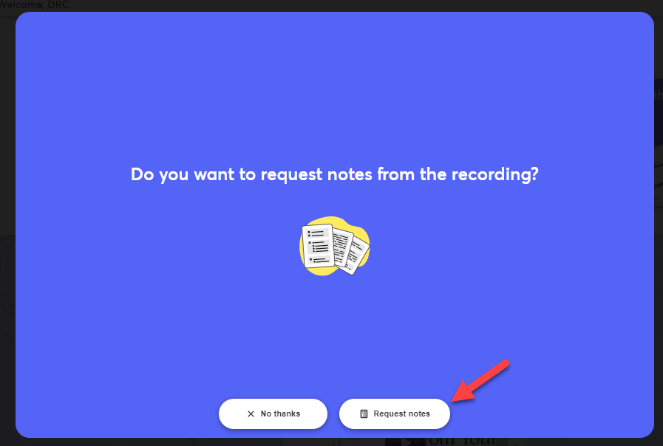
- If you have supporting materials for the recording they may help the note taker, such as PowerPoint slides, use the option to upload them with the recording. This step is optional, and is not necessary to receive notes. Use the “+Attach Material” button to add any additional classroom content.

- To upload the recording, select “Confirm Order” to send your recording. Wait for a confirmation to ensure the recording has been uploaded.
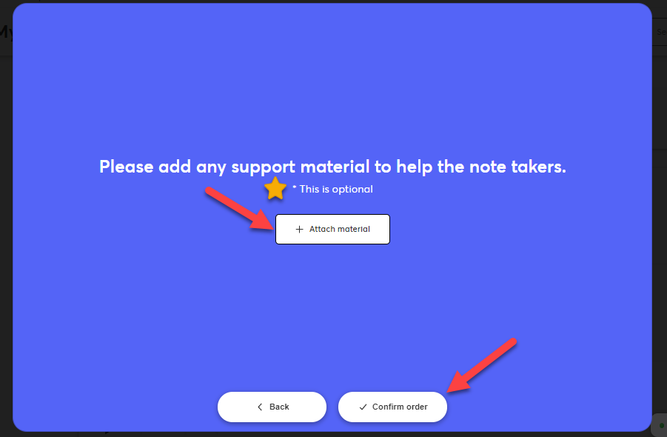
- To double check your recording has been uploaded, head to the “My Recordings” page. This can be found on the left side of your screen.
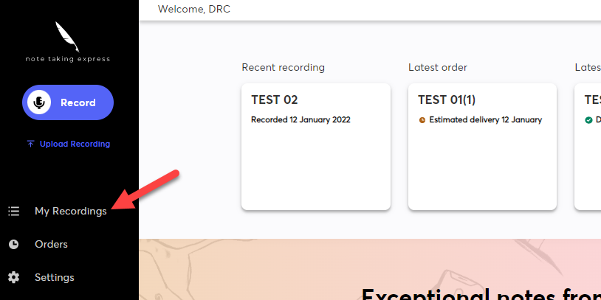

- Confirm your recording has been uploaded. Your most recent recordings should be located at the top of the page. Check if the recording has the “Requested” icon with the orange clock to confirm it has been sent to a notetaker. Once this is confirmed, you should receive your notes in 1 to 2 days! Notes will be sent to your Cal Poly Pomona email, or may be found on your Notetaking Express Hub Dashboard.
