# CPP Connect Tutorial

## How To Schedule an Appointment with a Bronco Access Mentor

1. Log into CPP Connect
   1. Go to [www.cpp.edu/cppconnect/index.shtml](http://www.cpp.edu/cppconnect/index.shtml)
   2. Scroll down and click on the blue “Log In to CPP Connect” button on the bottom left

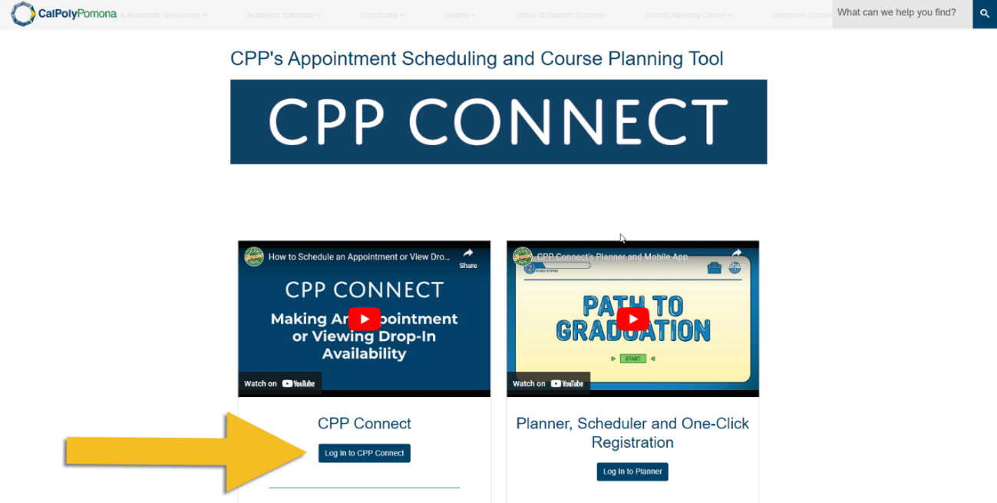

1. Click the blue “Make an Appointment/View Drop In Availability” button on the top right

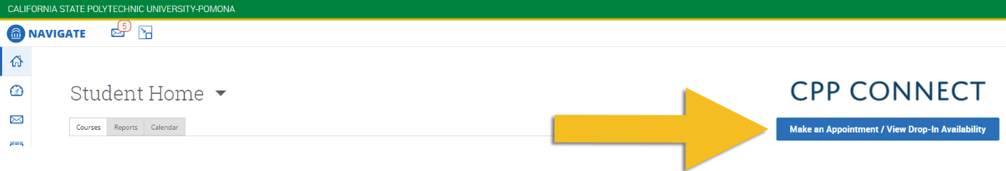

Your screen should now look something like this:

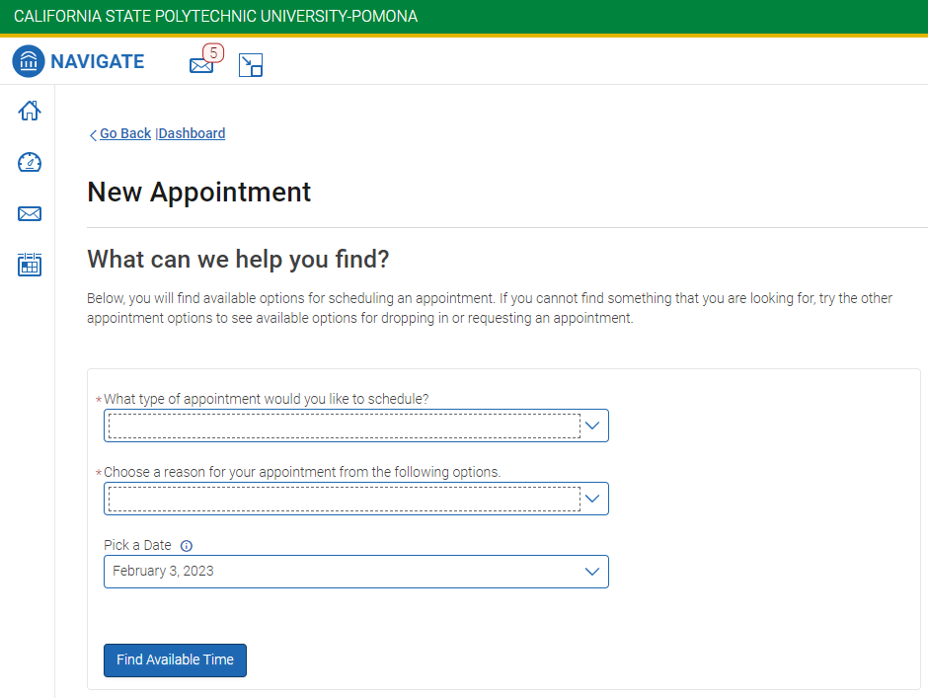

1. Click the first drop-down menu and select “Advising”

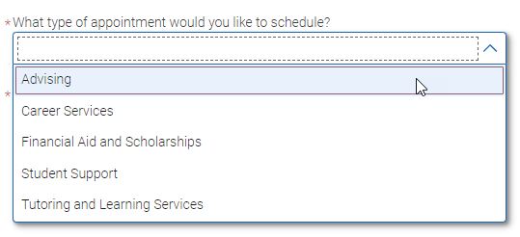

1. Click the second drop-down menu, scroll down, and select “DRC Bronco Access Mentors” under “Disability Resource Center Advising”

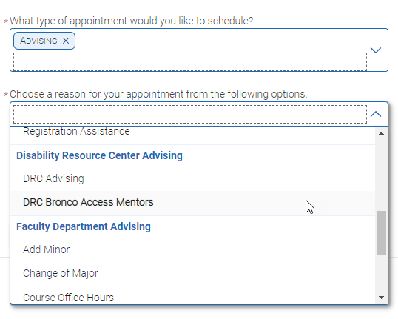

1. Click the third drop-down menu and select your preferred date (optional)

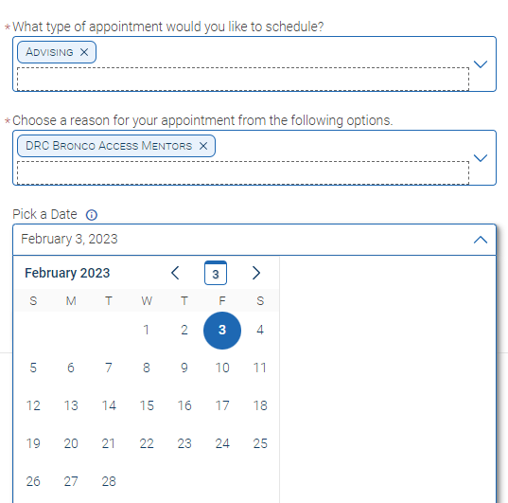

1. Click the blue “Find Available Time” button

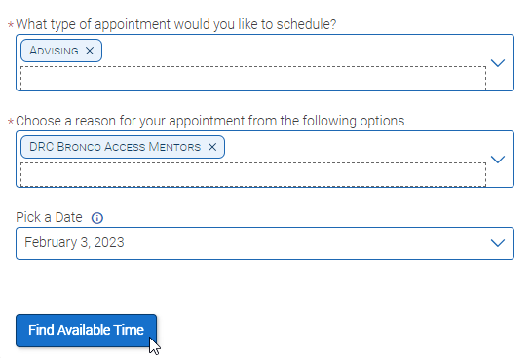

Your screen should now look something like this:

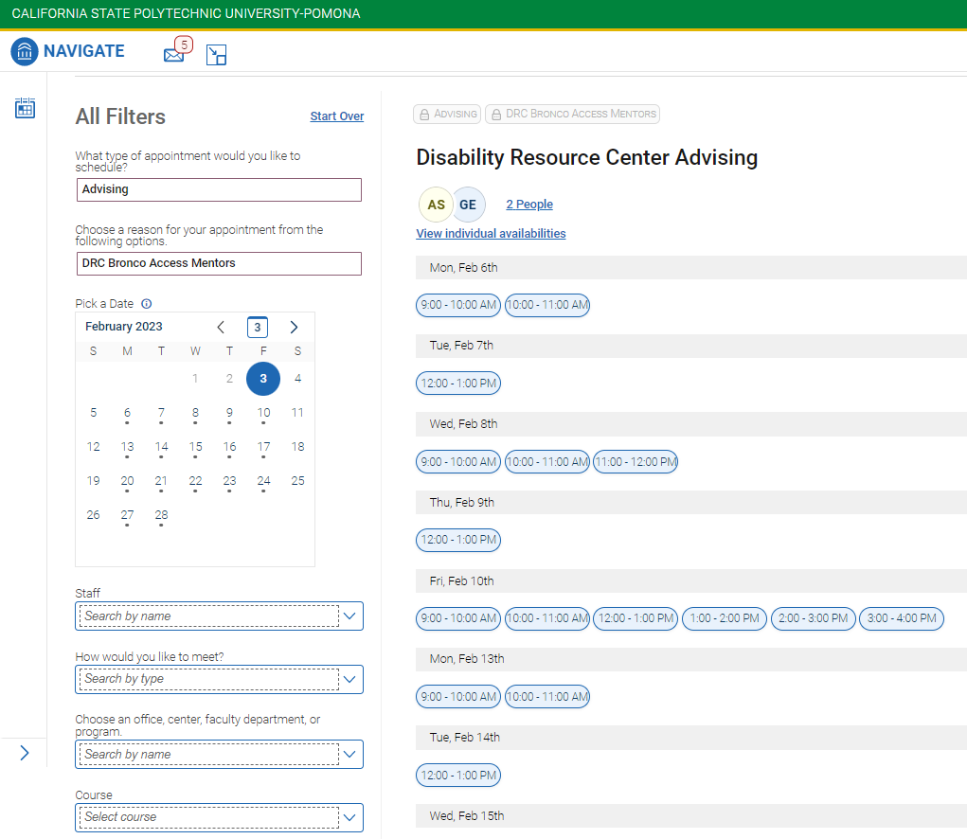

1. Select your preferred timeslot from the options listed. If you would like to filter by staff name or mode of meeting, you may do so on the bottom left

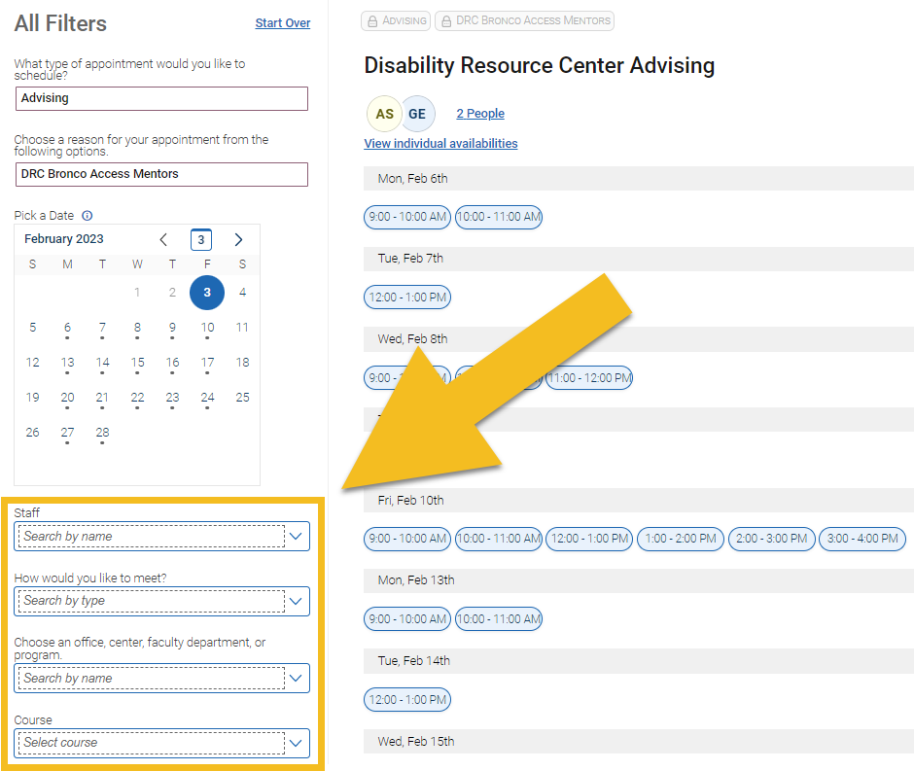

1. Review your appointment details, enter any information that your mentor may find helpful, and click the blue “Schedule” button at the bottom to finish scheduling your appointment. You should receive a reminder by email with any relevant details about meeting time and location

