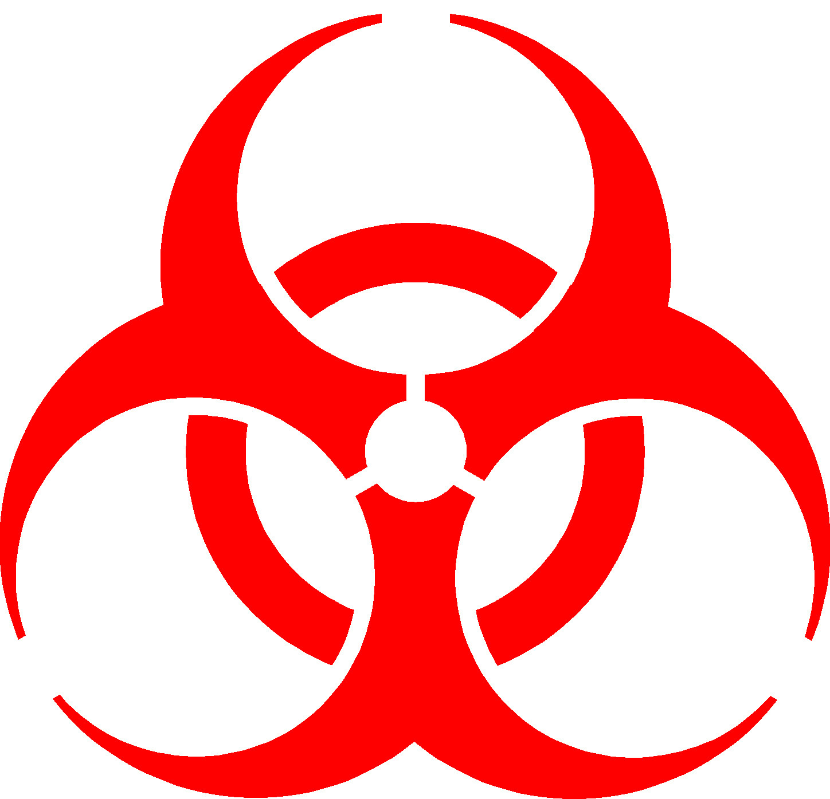
BIOHAZARD
AUTHORIZED PERSONNEL ONLY!
HAZARD: Click here to enter text.
LOCATION: Click here to enter text.
INSTRUCTIONS: Click here to enter text.
 | NAME | ROOM | PHONE
PRINCIPAL  INVESTIGATOR | Click here to enter text. | Click here to enter text. | Click here to enter text.
ALTERNATE | Click here to enter text. | Click here to enter text. | Click here to enter text.

INSTRUCTIONS:
Hazard: First, identify the Biosafety level in the hazard area.
- Biosafety Level 1 (BSL1)
- Animal Biosafety Level 1 (ABSL1)
- Biosafety Level 2 (BSL2)
- Animal Biosafety Level 2 (ABSL2)
Following the Biosafety level, identify the hazard specific to this area. (e.g. Class II bacteria and toxin)
Location: Identify the location in standard building/room format. (e.g. 4-3-720A) Referring to Building 4, 3rd floor, room 720A.
Instructions: Identify any special instructions for this area such as required PPE, immunizations required or special entry procedures or security measures.

List the PI contact as well as an alternate contact for this area.

Display this placard on all doors and within your Biosafety plan. Contact information should be updated as necessary and should reflect any recent staff changes.

