Guidebook for the Use of Personal
Protective Equipment

Revised September 4, 2019

Table of Contents

 | Page
- Introduction. . . . . . . . . . . . . . . . . . . . . . . . . . . . . . . . . . . . . . . . . . . . . . . . . . . . . . . . . . . . . . . . | 4
- What is Personal Protective Equipment? . . . . . . . . . . . . . . . . . . . . . . . . . . . . . . . . . . . . . . . | 4
- What regulations require PPE? . . . . . . . . . . . . . . . . . . . . . . . . . . . . . . . . . . . . . . . . . . . . . . | 4
- What is university policy? . . . . . . . . . . . . . . . . . . . . . . . . . . . . . . . . . . . . . . . . . . . . . . . . . . . | 4
- How is this Guidebook Arranged? . . . . . . . . . . . . . . . . . . . . . . . . . . . . . . . . . . . . . . . . . . . . . | 4
- How Are Job Safety Classifications Used to Establish the Personal Protective Equipment Requirements . . . . . . . . . . . . . . . . . . . . . . . . . . . . . . . . . . . . . . . . . . . . . . . . . . . . | 5
- What Personal Protective Equipment Is Required for My Job Safety Classification? . . . | 6
- What Additional Information Is Available? . . . . . . . . . . . . . . . . . . . . . . . . . . . . . . . . . . . . . . | 6
APPENDICIES
Appendix I. Working Titles and Job Safety Classifications . . . . . . . . . . . . . . . . . . . . . . . . | 27
Appendix II. Eye Protection Selection Chart. . . . . . . . . . . . . . . . . . . . . . . . . . . . . . . . . . . . | 30
Appendix III - Chemical Glove Selection Table . . . . . . . . . . . . . . . . . . . . . . . . . . . . . . . . . . | 32

- Introduction

- What is Personal Protective Equipment?

Personal Protective Equipment (PPE) refers to specialized clothing or equipment worn by employees for protection against health and safety hazards. Personal Protective Equipment is usually designed to protect a certain part of the body such as eyes, ears, hands or feet. Examples of PPE are gloves, construction hard hats, steel toe work boots, and rubber aprons.

When employees might be exposed to hazards in their work activity, an effort is always made, in the first instance, to introduce engineering or administrative controls to reduce the hazard. When it is not feasible or effective to sufficiently reduce the exposures by use of such controls, employees will be required to wear Personal Protective Equipment.

- What Regulations Require the Use of Personal Protective Equipment?

The regulations concerning PPE are found in Title 8 of the California Code of Regulations. The most pertinent information appears in Article 10, Group 2, entitled “Personal Safety Devices and Safeguards.” Sections 3381 through 3385 discuss equipment for protecting hearing, eyes, body, hands and feet.

- What is the University Policy?

It is the policy of California State Polytechnic University, Pomona, to maintain, insofar as it is reasonably within the control of the University to do so, a campus environment for students, faculty, staff and visitors that will not adversely affect their health and safety nor subject them to avoidable risks of accidental injury. No individual or employee shall be required to perform any task, which is determined to be unsafe or unreasonably hazardous. Furthermore, the University shall ensure that all operational activities are carried out in compliance with existing environmental laws, rules, regulations, and campus policies, in order to protect the environment.

- How is this Guidebook arranged?

This Guidebook establishes a baseline determination of what minimum Personal Protective Equipment is appropriate for an employee of California State Polytechnic University, Pomona, who is engaged in a particular type of work. A comprehensive list of recommended PPE, specific to the hazards the employee is likely to come in contact with may be generated through the online RSS Assessment application. Supervisors may complete the online hazard assessment using the following instructions:

- Access the RSS Assessment application at https://csu.risksafety.solutions (login credentials are the same as your CPP login). You will be prompted to create a new assessment at which time it will first ask you to set up your group and location(s).
- Once the group has been set up and associated with a location, you will be prompted to complete and submit the hazard questionnaire. Upon submittal, the system will generate a list of hazards and recommended PPE for members in the lab and those working adjacently.
- Group members will receive an email asking them to review and acknowledge the assessment, which includes the PPE recommendations. Once all lab members have acknowledged the assessment, the process is considered complete.

Employees should contact their supervisors if there are questions concerning the information in the Guidebook or if a hazard assessment needs to be completed online for their location(s).

Please note that several University departments have developed their own guidelines explaining what equipment is required in particular work situations. Whenever such departmental guidelines exist, they will take precedence over the listing in this Guidebook.

Selecting appropriate PPE requires an understanding of the University’s Table of Job Safety Classifications. At California State Polytechnic University, Pomona, each employee is assigned to one of 21 Job Safety Classifications. The required PPE for an employee is determined by the Job Safety Classification of that employee. Because the Job Safety Classification System is of central importance, the next section of this Guidebook (Section 3) provides a review of that classification system.

Subsequently, Section 4 presents the actual controlling table that lists Personal Protective Equipment. That table describes the required PPE for each of the 21 job safety classifications, with the classifications arranged in alphabetical order.

Finally, Chapter 5 provides additional information regarding Personal Protective Equipment.

- How Are Job Safety Classifications Used to Establish the Personal Protective Equipment Requirements

Employees at California State Polytechnic University, Pomona, are assigned to one of 21 job safety classifications. Each of these safety categories represents a certain set of safety concerns. Employees whose work involves similar hazards are assigned to the same Job Safety Classification.

Using this classification system, it is possible to provide safety information to employees and supervisors in an organized fashion. For example, the Job Safety Classifications are used when listing the type of safety training an employee should receive. Similarly, the classification system is utilized to inform employees of the applicable mandatory safe work practices.

With regard to Personal Protective Equipment, there is again a utilization of the Job Safety Classification System. A separate listing of PPE requirements is provided for each classification. Within the master list of Requirements for Use of Personal Protective Equipment, an employee simply locates the section for his/her Job Safety Classification, and that is where the required PPE will be listed.

The benefit of this reliance on the Job Safety Classification is that attention is focused not on an employee’s job title or department affiliation, but rather on safety hazards of the job for which the employee is hired.

Remember that the Job Safety Classification system is based first and foremost on safety and health issues pertaining to the type work performed by Cal Poly employees. Thus, employees in different departments may be in the same job category if they perform the same general type of work. Similarly, employees in a single department among whom there is frequent interaction, may not be in the same safety classification if their assigned duties take them into significantly different work environments.

A librarian and a counselor work in different departments and perform entirely different work. Yet from a safety viewpoint, the tasks are sufficiently similar that the basic precautions each employee should follow are similar.

By contrast a livestock technician and an instructional support technician, both in the Animal and Veterinary Science Department, may be communicating and interacting regularly with regard to a variety of departmental issues. Nevertheless, they are in different job safety categories because of differences in hazards to which each is potentially exposed.

Table 1 (below) may be used as a quick reminder of the twenty-one Job Safety Classifications at Cal Poly University. The jobs are listed in alphabetical order and consecutive code numbers are assigned to each job classification.

Table 1: Job Safety Classifications

Job Safety  Classification | Code  Number |  | Job Safety  Classification | Code  Number
Construction Worker | 10 |  | Livestock Worker | 120
Copier/Press Operator | 20 |  | Maintenance Worker | 130
Custodial Worker | 30 |  | Mechanic | 140
Driver | 40 |  | Media Operator | 150
Electronics Worker | 50 |  | Medical Worker | 160
Engineering Worker | 60 |  | Office Worker | 170
Equipment Operator/Material Handler | 70 |  | Photography Worker | 180
Equipment Worker | 80 |  | Public Safety Worker | 190
Field/Grounds Worker | 90 |  | Radiation Worker | 200
Food Handler | 100 |  | Safety Worker | 210
Laboratory Worker | 110

Any employee who has questions regarding which job safety classification he or she belongs to should refer to Appendix 1, “Working Titles and Job Safety Classifications.” Using this table an employee may search for his or her working title and then view the corresponding Job Safety Classification. In certain cases, a single working title may relate to more that one job safety classification. Here clarification may be obtained by reference to the column that lists department names

- What Personal Protective Equipment Is Required for My Job Safety Classification?

Table 2, beginning on page 8, is the master listing of Requirements for the Use of Personal Protective Equipment. In this table, the PPE requirements pertaining to each of the twenty-one job safety classifications are listed.

The Job Safety Classifications appear in alphabetical order, starting with Construction Worker. For each classification, various types of protective equipment are listed in the left column, and to the right you will find a discussion of the work situations for which that equipment will be needed.

In most cases, an employee will not wear every item of personal protective equipment during his/her entire work shift. In fact, certain equipment may only be needed when performing a particular specialized task. Review carefully the explanations in the right column of the table.

Finally, remember that a department may have developed its own requirements for personal protective equipment. In such cases, the departmental guidelines take precedence.

- What Additional Information Is Available?

In certain situations an employee will need to make a careful choice between several variations of personal protective equipment based on the exact details of the hazardous work being undertaken. With eye protection and respiratory protection, for example special design features are incorporated in certain equipment models to provide necessary protection in certain special situations.

Eye protection is generally utilized when there is a risk of receiving eye injuries such as punctures, abrasions or burns. However, in certain situations specialty goggles may be required. A variety of eye protection is available and the choice should be made based on the specific tasks an employee will be performing. For a detailed listing of alternative types of eye protection please refer to Appendix 2.

As with eye protection, there are a number of types of respiratory protection available. The choice will be made based on expected air contamination.
Table 2: Requirements for Use of Personal Protective Equipment

Construction Worker (10)
Personal Protective Equipment Type | Conditions Requiring the Use of PPE
protective clothing | when exposed to chemicals, grease or paint, or when required by manufacturer's specification or by MSDS
leather apron | when welding, brazing, cutting or gouging metal
safety shoes (steel toe, slip and puncture resistant) | potential exposure to foot injuries from falling hazards, crushing and penetrating actions
chemical splash goggles | when handling chemicals
either: (1) safety glasses with side shields or (2) goggles. Add face shield when working under severe conditions. | when exposed to flying particles, chips, sand, etc. during activities such as chopping, sawing
welding helmets or welding face shields | when welding, brazing, cutting or gouging metal
dust mask or respiratory protection | When working in high dust & debris environment, or when required by the manufacturer’s specification or MSDS. Use of dust mask is a minimum protection. The use of respiratory protection requires compliance with the Campus Respiratory Protection Program (Copy available on the EH&S Web Site at http://www.cpp.edu/~ehs/files/occupational/doc/RespiratoryProtection.doc) , administered by EH&S
ear plugs or ear muffs | when working in noisy environment or operating noisy equipment that can result in hearing damage or loss
chemical resistance gloves | when using chemicals or working in unsanitary conditions (see Appendix III - Chemical Glove Selection Table for information on selecting the appropriate type of gloves)
cotton or leather gloves | when handling abrasive materials, operating tools and power equipment that can result in lacerations and injuries to hands
traffic safety vests | when working near vehicular traffic areas, performing traffic control, or working in inclement weather or darkness
construction hard hat | when exposed to falling hazards that can result in head injuries
raincoats | when working outdoor in raining weather

Copier/Press Operator (20)
Personal Protective Equipment Type | Conditions Requiring the Use of PPE
protective clothing:  shop coat or apron | when exposed to chemicals, ink or paint, or required by manufacturer’s specification or MSDS
shoes with closed toes & heel and with flat sole, or boots | use for all activities for minimum protection against minor lacerations, burns, and other injuries to feet
safety shoes (steel toe, slip and puncture resistant) | potential exposure to foot injuries from falling hazards, crushing and penetrating actions, hot or corrosive substances
chemical splash goggles | when handling chemicals
either: (1) safety glasses with side shields  or (2) goggles | when operating tools and power equipment that can result in eye injuries
dust mask or respiratory protection | When working in high dust & debris environment, or when required by the manufacturer’s specification or MSDS. Use of dust mask is a minimum protection. The use of respiratory protection requires compliance with the Campus Respiratory Protection Program (Copy available on the EH&S Web Site at http://www.cpp.edu/~ehs/files/occupational/doc/RespiratoryProtection.doc), administered by EH&S
ear plugs or ear muffs | when working in noisy environment or operating noisy equipment that can result in hearing damage or loss
chemical resistance gloves | when using chemicals or inks (see Appendix III - Chemical Glove Selection Table for information on selecting the appropriate type of gloves)
cotton or leather gloves | when handling abrasive materials, operating tools and power equipment that can result in lacerations and injuries to hands

Custodial Worker (30)
Personal Protective Equipment Type | Conditions Requiring the Use of PPE
short sleeve shirts and long pants | use for all activities for minimum protection against minor lacerations, burns and other injuries
protective clothing | when exposed to chemicals, grease or paint or required by manufacturer's specification or MSDS
closed toes & heel with flat sole shoes or boots | use for all activities for minimum protection against minor lacerations, burns, and other injuries to feet
safety shoes (steel toe, slip and puncture resistant) | potential exposure to foot injuries from falling hazards, crushing and penetrating actions
chemical resistant and/or rubber boots | when using chemicals or working in abnormally wet conditions
chemical splash goggles | when handling chemicals
either: (1) safety glasses with side shields or (2) goggles. Add face shield when working under severe conditions. | when working overhead, operating tools and power equipment that can result in eye injuries
dust mask or respiratory protection | When working in high dust & debris environment, or when required by the manufacturer’s specification or MSDS. Use of dust mask is a minimum protection. The use of respiratory protection requires compliance with the Campus Respiratory Protection Program (Copy available on the EH&S Web Site at http://www.cpp.edu/~ehs/files/occupational/doc/RespiratoryProtection.doc), administered by EH&S.
ear plugs or ear muffs | when working in noisy environment or operating noisy equipment that can result in hearing damage or loss
chemical resistance gloves | when using chemicals or working in unsanitary conditions (see Appendix III - Chemical Glove Selection Table for information on selecting the appropriate type of gloves)
cotton or leather gloves | when handling abrasive materials, operating tools and power equipment that can result in lacerations and injuries to hands
safety vests | when working in vehicular traffic areas, performing traffic control, or working outside in an inclement weather or darkness
construction hard hat | when exposed to falling hazards that can result in head injuries
raincoats | when working outdoor in raining weather

Driver (40)
Type of Personal Protective Equipment | Conditions Requiring the Use of PPE
short sleeve shirts and long pants | use for all activities for minimum protection against minor lacerations, burns and other injuries
protective clothing | when exposed to chemicals or oil, or required by manufacturer’s specification or MSDS
closed toes & heel with flat sole shoes or boots | use for all activities for minimum protection against minor lacerations, burns, and other injuries to feet
seat belt | while driving
traffic safety vest | when stopped for an emergency
cotton or leather gloves | when outside vehicle to place wheel chocks or emergency flares

Electronics Worker (50)
Type of Personal Protective Equipment | Conditions Requiring the Use of PPE
protective apron or shop coat | when exposed to chemicals, electric sparks, or required by manufacturer's specification or MSDS
shoes with closed toes & heel, flat sole; or boots | use for all activities for minimum protection against minor lacerations, burns, and other injuries to feet
safety shoes (steel toe, slip and puncture resistant) | potential exposure to foot injuries from falling hazards, crushing and penetrating actions, hot or corrosive substances
chemical splash goggles | when handling chemicals
either: (1) safety glasses with side shields or (2) goggles. Add face shield when working under severe conditions. | when there is any danger of flying particles, sparks or corrosive materials that may result in eye injuries
dust mask or respiratory protection | when working in high dust & debris environment, or required by the manufacturer’s specification or MSDS. Use of dust mask is a minimum protection. The use of respiratory protection requires compliance with the Campus Respiratory Protection Program (Copy available on the EH&S Web Site at http://www.cpp.edu/~ehs/files/occupational/doc/RespiratoryProtection.doc), administered by EH&S
ear plugs or ear muffs | when working in noisy environment or operating noisy equipment that can result in hearing damage or loss
chemical resistance gloves | when using chemicals (see Appendix III - Chemical Glove Selection Table for information on selecting the appropriate type of gloves)
cotton or leather gloves | when handling abrasive materials, operating tools and power equipment that can result in lacerations and injuries to hands

Engineering Worker (60)
Type of Personal Protective Equipment | Conditions Requiring the Use of PPE
protective apron or lab coat | when exposed to chemicals, or paint or required by manufacturer's specification or by MSDS
shoes with closed toes & heel, flat sole; or boots | use for all activities for minimum protection against minor lacerations, burns, and other injuries to feet
safety shoes (steel toe, slip and puncture resistant) | potential exposure to foot injuries from falling hazards, crushing and penetrating actions, hot or corrosive substances
chemical splash goggles | when handling chemicals
either: (1) safety glasses with side shields or (2) goggles. Add face shield when working under severe conditions. | when operating tools and power equipment that can result in eye injuries
dust mask or respiratory protection | when working in high dust & debris environment, or required by the manufacturer’s specification or MSDS. Use of dust mask is a minimum protection. Use of respiratory protection requires compliance with the Campus Respiratory Protection Program (Copy available on the EH&S Web Site at http://www.cpp.edu/~ehs/files/occupational/doc/RespiratoryProtection.doc), administered by EH&S
ear plugs or ear muffs | when working in noisy environment or operating noisy equipment that can result in hearing damage or loss
chemical resistance gloves | when using chemicals (see Appendix III - Chemical Glove Selection Table for information on selecting the appropriate type of gloves)
cotton or leather gloves | when handling abrasive materials, operating tools and power equipment that can result in lacerations and injuries to hands
hardhat | in situations where items may fall from overhead
welding helmet or welding face shield | when welding
leather apron | when welding

Equipment Operator/Material Handler (70)
Type of Personal Protective Equipment | Conditions Requiring the Use of PPE
protective clothing | when exposed to chemicals, grease or paint or required by manufacturer's specification or MSDS
safety shoes (steel toe, slip and puncture resistant) | potential exposure to foot injuries from falling hazards, crushing and penetrating actions
chemical resistant and/or rubber boots | when using chemicals or working in abnormally wet conditions
chemical splash goggles | when handling chemicals
either: (1) safety glasses with side shields or (2) goggles. Add face shield when working under severe conditions. | when working overhead, or operating tools and power equipment that can result in eye injuries
dust mask or respiratory protection | when working in high dust & debris environment, or when required by the manufacturer’s specification or MSDS. Use of dust mask is a minimum protection. The use of respiratory protection requires compliance with the Campus Respiratory Protection Program (Copy available on the EH&S Web Site at http://www.cpp.edu/~ehs/files/occupational/doc/RespiratoryProtection.doc), administered by EH&S
ear plugs or ear muffs | when working in noisy environment or operating noisy equipment that can result in hearing damage or loss
chemical resistant gloves | when using chemicals or working in unsanitary conditions (see Appendix III - Chemical Glove Selection Table for information on selecting the appropriate type of gloves)
cotton or leather gloves | when handling abrasive materials, operating tools and power equipment that can result in lacerations and injuries to hands
safety vests | when working in vehicular traffic areas, performing traffic control, or working outside in an inclement weather or darkness
construction hard hat | when exposed to falling hazards that can result in head injuries

Equipment Worker (80)
Type of Personal Protective Equipment | Conditions Requiring the Use of PPE
protective clothing | when exposed to chemicals, or paint or required by manufacturer's specification or MSDS
shoes with closed toes & heel, flat sole; or boots | use for all activities for minimum protection against minor lacerations, burns, and other injuries to feet
safety shoes (steel toe, slip and puncture resistant) | potential exposure to foot injuries from falling hazards, crushing and penetrating actions, hot or corrosive substances
chemical splash goggles | when handling chemicals
either: (1) safety glasses with side shields or (2) goggles. Add face shield when working under severe conditions. | when operating tools and power equipment that can result in eye injuries
dust mask or respiratory protection | when working in high dust & debris environment, or when required by the manufacturer’s specification or MSDS. Use of dust mask is a minimum protection. The use of respiratory protection requires compliance with the Campus Respiratory Protection Program (Copy available on the EH&S Web Site at http://www.cpp.edu/~ehs/files/occupational/doc/RespiratoryProtection.doc), administered by EH&S
ear plugs or ear muffs | when working in noisy environment or operating noisy equipment that can result in hearing damage or loss
chemical resistance gloves | when using chemicals (see Appendix III - Chemical Glove Selection Table for information on selecting the appropriate type of gloves)
cotton or leather gloves | when handling abrasive materials, operating tools and power equipment that can result in lacerations and injuries to hands

Field/Grounds Worker (90)
Type of Personal Protective Equipment | Conditions Requiring the Use of PPE
protective clothing or tyvek suit | when exposed to chemicals, herbicides or fungicides or required by manufacturer’s specification or MSDS
shoes with closed toes & heel, flat sole; or boots | use for all activities for minimum protection against incidental lacerations and other injuries to feet
chemical resistant and/or rubber boots | when using chemicals or working in abnormally wet conditions
chemical splash goggles | when handling chemicals
either: (1) safety glasses with side shields or (2) goggles. Add face shield when working under severe conditions. | When exposed to flying particles, chips, sand, etc. during activities such as chopping, sawing, mowing
dust mask or respiratory protection | When working in high dust & debris environment, or when required by the manufacturer’s specification or MSDS. Use of dust mask is a minimum protection. The use of respiratory protection requires compliance with the Campus Respiratory Protection Program(Copy available on the EH&S Web Site at http://www.cpp.edu/~ehs/files/occupational/doc/RespiratoryProtection.doc), administered by EH&S.
ear plugs or ear muffs | when working in noisy environment or operating noisy equipment that can result in hearing damage or loss
chemical resistant gloves | when using chemicals, herbicides or working in unsanitary conditions (see Appendix III - Chemical Glove Selection Table for information on selecting the appropriate type of gloves)
cotton or leather gloves | when handling abrasive materials, operating tools and power equipment that can result in lacerations and injuries to hands
safety vests | when working in vehicular traffic areas, performing traffic control, or working outside in an inclement weather or darkness
sun hat | when working outdoor in hot weather
construction hard hat | when exposed to falling hazards that can result in head injuries
raincoats | when working outdoor in raining weather
chaps | when using chainsaw

Food Handler (100)
Type of Personal Protective Equipment | Conditions Requiring the Use of PPE
protective clothing | when exposed to chemicals or required by manufacturer's specification or MSDS
shoes with closed toes & heel, flat sole; or boots | use for all activities for minimum protection against minor lacerations, burns, and other injuries to feet
chemical splash goggles | when handling chemicals
either: (1) safety glasses with side shields or (2) goggles. Add face shield when working under severe conditions. | when operating tools and power equipment that can result in eye injuries
dust mask or respiratory protection | when working in high dust & debris environment, or when required by the manufacturer’s specification or MSDS. Use of dust mask is a minimum protection. The use of respiratory protection requires compliance with the Campus Respiratory Protection Program (Copy available on the EH&S Web Site at http://www.cpp.edu/~ehs/files/occupational/doc/RespiratoryProtection.doc), administered by EH&S
ear plugs or ear muffs | when working in noisy environment or operating noisy equipment that can result in hearing damage or loss
chemical resistant gloves | when working in unsanitary conditions or using chemicals (see Appendix III - Chemical Glove Selection Table for information on selecting the appropriate type of gloves)
protective gloves | when work may involve cuts from knives or machinery

Laboratory Worker (110)
Personal Protective Equipment | Conditions Requiring the Use of PPE
protective clothing: lab coats, rubber or neoprene apron | when exposed to chemicals, or required by manufacturer's specification, MSDS or SOP of laboratory
shoes with closed toes & heel, flat sole; or boots | use for all activities for minimum protection against minor lacerations, burns, and other injuries to feet
chemical splash goggles | when handling chemicals
either: (1) safety glasses with side shields or (2) goggles. Add face shield when working under severe conditions. | when required by SOP of the laboratory or when handling chemicals or operating tools and power equipment that can result in eye injuries
dust mask or respiratory protection | When working in high dust & debris environment, or when required by the manufacturer’s specification or MSDS. Use of dust mask is a minimum protection. The use of respiratory protection requires compliance with the Campus Respiratory Protection Program (Copy available on the EH&S Web Site at http://www.cpp.edu/~ehs/files/occupational/doc/RespiratoryProtection.doc), administered by EH&S.
ear plugs or ear muffs | when working in noisy environment or operating noisy equipment that can result in hearing damage or loss
chemical resistant gloves | when using chemicals or when required by SOP of the laboratory (see Appendix III - Chemical Glove Selection Table for information on selecting the appropriate type of gloves)
cotton or leather gloves | when handling abrasive materials, operating tools and power equipment that can result in lacerations and injuries to hands

Livestock Worker (120)
Personal Protective Equipment | Conditions Requiring the Use of PPE
protective clothing | when exposed to unpredictable behavior of animals or when exposed to chemicals or paint or required by manufacturer’s specification or MSDS
shoes with closed toes & heel, flat sole; or boots | use for all activities for minimum protection against minor lacerations, burns, and other injuries to feet
safety shoes (steel toe, slip and puncture resistant) | potential exposure to foot injuries from falling hazards, crushing and penetrating actions, hot or corrosive substances
chemical splash goggles | when handling chemicals
either: (1) safety glasses with side shields or (2) goggles. Add face shield when working under severe conditions. | When handling chemicals
dust mask or respiratory protection | When working in high dust & debris environment, or when required by the manufacturer’s specification or MSDS. Use of dust mask is a minimum protection. The use of respiratory protection requires compliance with the Campus Respiratory Protection Program (Copy available on the EH&S Web Site at http://www.cpp.edu/~ehs/files/occupational/doc/RespiratoryProtection.doc), administered by EH&S.
ear plugs or ear muffs | when working in noisy environment or operating noisy equipment that can result in hearing damage or loss
chemical resistance gloves | when using chemicals (see Appendix III - Chemical Glove Selection Table for information on selecting the appropriate type of gloves)
cotton or leather gloves | when handling abrasive materials, holding ropes, working with animals that may bite, or operating tools and power equipment that can result in lacerations and injuries to hands

Maintenance Worker (130)
Personal Protective Equipment | Conditions Requiring the Use of PPE
protective clothing | when exposed to chemicals, oil or paint or required by manufacturer's specification or MSDS
fire resistant clothing | for an electrician working in a situation designated as Hazard Category 2 or lower (see Campus Electrical Safety Program)
flash suit jacket and pants | for an electrician working in a situation designated as Hazard Category 3 or higher (see Campus Electrical Safety Program)
shoes with closed toes & heel, flat sole; or boots | use for all activities for minimum protection against minor lacerations, burns, and other injuries to feet
safety shoes (steel toe, slip and puncture resistant) | potential exposure to foot injuries from falling hazards, crushing and penetrating actions, hot or corrosive substances
chemical splash goggles | when handling chemicals
either: (1) safety glasses with side shields or (2) goggles. Add face shield when working under severe conditions. | when handling chemicals, operating tools and power equipment that can result in eye injuries
dust mask or respiratory protection | When working in high dust & debris environment, or when required by the manufacturer’s specification or MSDS. Use of dust mask is a minimum protection. The use of respiratory protection requires compliance with the Campus Respiratory Protection Program (Copy available on the EH&S Web Site at http://www.cpp.edu/~ehs/files/occupational/doc/RespiratoryProtection.doc), administered by EH&S.
ear plugs or ear muffs | when working in noisy environment or operating noisy equipment that can result in hearing damage or loss
chemical resistant gloves | when using chemicals or working in unsanitary conditions (see Appendix III - Chemical Glove Selection Table for information on selecting the appropriate type of gloves)
cotton or leather gloves | when handling abrasive materials, operating tools and power equipment that can result in lacerations and injuries to hands
hard hat | when working in an area where material or equipment may fall and strike a person's head, or when working with electricity in a situation designated as Hazard Category 1 or higher (see Campus Electrical Safety Program)
flashsuit hood | for an electrician working in a situation designated as Hazard Category 3 or higher (see Campus Electrical Safety Program)
sun hat | when working outdoors in hot weather
traffic safety vest | when working on or near roadways

Mechanic (140)
Personal Protective Equipment | Conditions Requiring the Use of PPE
protective clothing | when exposed to chemicals, oil or paint or required by manufacturer’s specification or MSDS
safety shoes (steel toe, slip and puncture resistant) | potential exposure to foot injuries from falling hazards, crushing and penetrating actions, hot or corrosive substances
chemical splash goggles | when handling chemicals
either: (1) safety glasses with side shields or (2) goggles. Add face shield when working under severe conditions. | When handling chemicals, operating tools and power equipment that can result in eye injuries
dust mask or respiratory protection | When working in high dust & debris environment, or when required by the manufacturer’s specification or MSDS. Use of dust mask is a minimum protection. The use of respiratory protection requires compliance with the Campus Respiratory Protection Program (Copy available on the EH&S Web Site at http://www.cpp.edu/~ehs/files/occupational/doc/RespiratoryProtection.doc), administered by EH&S.
ear plugs or ear muffs | when working in noisy environment or operating noisy equipment that can result in hearing damage or loss
chemical resistance gloves | when using chemicals or vehicle fluids (see Appendix III - Chemical Glove Selection Table for information on selecting the appropriate type of gloves)
cotton or leather gloves | when handling abrasive materials, operating tools and power equipment that can result in lacerations and injuries to hands
bump hat | when movement under a vehicle may result in head injury

Media Operator (150)
Personal Protective Equipment | Conditions Requiring the Use of PPE
protective clothing | when exposed to chemicals or paint or required by manufacturer's specification or MSDS
shoes with closed toes & heel, flat sole; or boots | use for all activities for minimum protection against minor lacerations, burns, and other injuries to feet
safety shoes (steel toe, slip and puncture resistant) | potential exposure to foot injuries from falling hazards, crushing and penetrating actions, hot or corrosive substances
chemical splash goggles | when handling chemicals
either: (1) safety glasses with side shields or (2) goggles. Add face shield when working under severe conditions. | when handling chemicals, operating tools and power equipment that can result in eye injuries
dust mask or respiratory protection | When working in high dust & debris environment, or when required by the manufacturer’s specification or MSDS. Use of dust mask is a minimum protection. The use of respiratory protection requires compliance with the Campus Respiratory Protection Program (Copy available on the EH&S Web Site at http://www.cpp.edu/~ehs/files/occupational/doc/RespiratoryProtection.doc), administered by EH&S.
ear plugs or ear muffs | when working in noisy environment or operating noisy equipment that can result in hearing damage or loss
chemical resistant gloves | when using chemicals (see Appendix III - Chemical Glove Selection Table for information on selecting the appropriate type of gloves)
cotton or leather gloves | when handling abrasive materials, operating tools and power equipment that can result in lacerations and injuries to hands

Medical Worker (160)
Type of Personal Protective Equipment | Conditions Requiring the Use of PPE
protective clothing: lab coat, apron | when exposed to chemicals or body fluids;  when required by manufacturer’s specification or MSDS
shoes with closed toes & heel, flat sole; or boots | use for all activities for minimum protection against minor lacerations, burns, and other injuries to feet
chemical splash goggles | when handling chemicals
either: (1) safety glasses with side shields or (2) goggles. | When handling chemicals, operating tools and power equipment that can result in eye injuries; when an infectious disease may be spread by droplet transmission
dust mask or respiratory protection | When working in high dust & debris environment, or when required by the manufacturer’s specification or MSDS. Use of dust mask is a minimum protection. The use of respiratory protection requires compliance with the Campus Respiratory Protection Program (Copy available on the EH&S Web Site at http://www.cpp.edu/~ehs/files/occupational/doc/RespiratoryProtection.doc), administered by EH&S.
ear plugs or ear muffs | when working in noisy environment or operating noisy equipment that can result in hearing damage or loss
chemical resistant gloves | when using chemicals or when there is a possibility of contact with blood or body fluid; when an infectious disease may be spread by contact (see Appendix III - Chemical Glove Selection Table for information on selecting the appropriate type of gloves)

Office Worker (170)
Personal Protective Equipment | Conditions Requiring the Use of PPE
as specified by supervisor | certain activities based on consultation with supervisor

Photography Worker (180)
Personal Protective Equipment | Conditions Requiring the Use of PPE
protective clothing:  shop coat or apron | when exposed to chemicals, ink or paint or required by manufacturer’s specification or MSDS
shoes with closed toes & heel, flat sole; or boots | use for all activities for minimum protection against minor lacerations, burns, and other injuries to feet
chemical splash goggles | when handling chemicals
either: (1) safety glasses with side shields or (2) goggles. Add face shield when working under severe conditions. | When handling chemicals or operating power equipment that can result in eye injuries
dust mask or respiratory protection | When working in high dust & debris environment, or when required by the manufacturer’s specification or MSDS. Use of dust mask is a minimum protection. The use of respiratory protection requires compliance with the Campus Respiratory Protection Program (Copy available on the EH&S Web Site at http://www.cpp.edu/~ehs/files/occupational/doc/RespiratoryProtection.doc), administered by EH&S.
chemical resistant gloves | when using chemicals or inks (see Appendix III - Chemical Glove Selection Table for information on selecting the appropriate type of gloves)

Public Safety Worker (190)
Personal Protective Equipment | Conditions Requiring the Use of PPE
short sleeve shirts and long pants | use for all activities for minimum protection against minor lacerations, burns and other injuries
closed toes & heel with flat sole shoes or boots | use for all activities for minimum protection against minor lacerations, burns, and other injuries to feet
safety shoes (steel toe, slip and puncture resistant) | potential exposure to foot injuries from falling hazards, crushing and penetrating actions, hot or corrosive substances
chemical splash goggles | when handling chemicals
either: (1) safety glasses with side shields or (2) goggles. Add face shield when working under severe conditions. | when handling chemicals, operating tools and power equipment that can result in eye injuries
dust mask or respiratory protection | When working in high dust & debris environment, or when required by the manufacturer’s specification or MSDS. Use of dust mask is a minimum protection. The use of respiratory protection requires compliance with the Campus Respiratory Protection Program (Copy available on the EH&S Web Site at http://www.cpp.edu/~ehs/files/occupational/doc/RespiratoryProtection.doc), administered by EH&S.
ear plugs or ear muffs | when working in noisy environment or operating noisy equipment that can result in hearing damage or loss
chemical resistant gloves | when in contact with chemicals or when there is a possibility of contact with blood or body fluid (see Appendix III - Chemical Glove Selection Table for information on selecting the appropriate type of gloves)
cotton or leather gloves | when handling abrasive materials or operating tools that can result in lacerations and injuries to hands
traffic safety vest | when standing on or near roadways
sun hat | when working outdoors on hot days

Radiation Worker (200)
Personal Protective Equipment | Conditions Requiring the Use of PPE
short sleeve shirts and long pants | use for all activities for minimum protection against minor lacerations, burns and other injuries
protective clothing:  lab coat or apron | when exposed to chemicals, isotopes, x-rays or required by manufacturer’s specification or MSDS
closed toes & heel with flat sole shoes or boots | use for all activities for minimum protection against minor lacerations, burns, and other injuries to feet
safety shoes (steel toe, slip and puncture resistant) | potential exposure to foot injuries from falling hazards, crushing and penetrating actions, hot or corrosive substances
chemical splash goggles | when handling chemicals
either: (1) safety glasses with side shields or (2) goggles. Add face shield when working under severe conditions. | When handling chemicals, operating tools and power equipment that can result in eye injuries
dust mask or respiratory protection | When working in high dust & debris environment, or when required by the manufacturer’s specification or MSDS. Use of dust mask is a minimum protection. The use of respiratory protection requires compliance with the Campus Respiratory Protection Program (Copy available on the EH&S Web Site at http://www.cpp.edu/~ehs/files/occupational/doc/RespiratoryProtection.doc), administered by EH&S.
ear plugs or ear muffs | when working in noisy environment or operating noisy equipment that can result in hearing damage or loss
chemical resistant gloves | when using chemicals or radioactive material (see Appendix III - Chemical Glove Selection Table for information on selecting the appropriate type of gloves)
cotton or leather gloves | when handling abrasive materials, operating tools and power equipment that can result in lacerations and injuries to hands

Safety Worker (210)
Personal Protective Equipment | Conditions Requiring the Use of PPE
short sleeve shirts and long pants | use for all activities for minimum protection against minor lacerations, burns and other injuries
protective clothing:  lab coat, apron or tyvek suit | when exposed to chemicals, ink or paint or required by manufacturer's specification or MSDS
closed toes & heel with flat sole shoes or boots | use for all activities for minimum protection against minor lacerations, burns, and other injuries to feet
safety shoes (steel toe, slip and puncture resistant) | potential exposure to foot injuries from falling hazards, crushing and penetrating actions, hot or corrosive substances
chemical splash goggles | when handling chemicals
either: (1) safety glasses with side shields or (2) goggles. Add face shield when working under severe conditions. | when handling chemicals, operating tools and power equipment that can result in eye injuries
dust mask or respiratory protection | When working in high dust & debris environment, or when required by the manufacturer’s specification or MSDS. Use of dust mask is a minimum protection. The use of respiratory protection requires compliance with the Campus Respiratory Protection Program (Copy available on the EH&S Web Site at http://www.cpp.edu/~ehs/files/occupational/doc/RespiratoryProtection.doc), administered by EH&S.
ear plugs or ear muffs | when working in noisy environment or operating noisy equipment that can result in hearing damage or loss
chemical resistant gloves | when handling chemicals, oil, inks or paint (see Appendix III - Chemical Glove Selection Table for information on selecting the appropriate type of gloves)
cotton or leather gloves | when handling abrasive materials, operating tools and power equipment that can result in lacerations and injuries to hands
traffic safety vest | when working on or near a roadway
sun hat | when working outdoors in hot weather
Appendix I - Working Titles and Job Safety Classifications

Working Title | Department | Job Safety Classification | Job Safety Number
Administrators | All Departments | Office Worker | 170
Ath Equip Tech | Kinesiology & Health Prom | Equipment Worker | 80
Auto Mechanic | Facilities Management | Mechanic | 140
Auto Mechanic | Hort/ Plant & Soil Sci | Mechanic | 140
Building Maintenance Wkr | Facilities Management | Maintenance Worker | 130
Building Maintenance Wkr | Housing Services | Maintenance Worker | 130
Building Service Engineer | Facilities Management | Maintenance Worker | 130
Camera Operator/Editor | I&IT Learning | Media Operator | 150
Carpenter | Facilities Management | Construction Worker | 10
Clerical/Secretarial | All Departments | Office Worker | 170
Coach | Athletics | Equipment Worker | 80
Counselor | Counsel & Psy Services | Office Worker | 170
Crop Tech | Hort/Plant & Soil Sci | Field/Grounds Worker | 90
Custodian | Facilities Management | Custodial Worker | 30
Custodian | Housing Services | Custodial Worker | 30
Data Control Tech | I&IT | Electronics Worker | 50
Director | Env Health & Safety | Safety Worker | 210
Dispatcher | Public Safety | Office Worker | 170
Duplicating Machine Op | Graphic Comm Services | Copier/Press Operator | 20
Electrician | Facilities Management | Maintenance Worker | 130
Engineer/Operator | I&IT | Electronics Worker | 50
Environmental Specialist | Env Health & Safety | Safety Worker | 210
Equipment Tech | Aerospace Engineering | Engineering Worker | 60
Equipment Tech | Ag Eng/Irr Science | Engineering Worker | 60
Equipment Tech | Chem & Mat Engineering | Engineering Worker | 60
Equipment Tech | Civil Engineering | Engineering Worker | 60
Equipment Tech | Computer Science | Electronics Worker | 50
Equipment Tech | Elect & Computer Eng | Electronics Worker | 50
Equipment Tech | Geological Science | Laboratory Worker | 110
Equipment Tech | I&IT | Electronics Worker | 50
Equipment Tech | Ind & Mfg Engineering | Engineering Worker | 60
Equipment Tech | Mechanical Engineering | Engineering Worker | 60
Equipment Tech | Music | Equipment Worker | 80
Equipment Tech | Physics | Laboratory Worker | 110
Faculty | Aerospace Engineering | Engineering Worker | 60
Faculty | Ag Eng/Irr Science | Engineering Worker | 60
Faculty | Animal & Vet Science | Laboratory Worker | 110
Faculty | Animal & Vet Science | Livestock Worker | 120
Working Titles and Job Safety Classifications (continued)

Working Title | Department | Job Safety Classification | Job Safety Number
Faculty | Arabian Horse Center | Livestock Worker | 120
Faculty | Biological Science | Laboratory Worker | 110
Faculty | Chem & Mat Engineering | Engineering Worker | 60
Faculty | Chemistry | Laboratory Worker | 110
Faculty | Civil Engineering | Engineering Worker | 60
Faculty | Computer Science | Electronics Worker | 50
Faculty | Elect & Computer Eng | Electronics Worker | 50
Faculty | Environmental Design | Construction Worker | 10
Faculty | Equine Res/Vet Clinic | Laboratory Worker | 110
Faculty | Geological Science | Laboratory Worker | 110
Faculty | Hort/ Plant & Soil Sci | Laboratory Worker | 110
Faculty | Hort/Plant & Soil Sci | Field/Grounds Worker | 90
Faculty | Hotel & Restr Mgmt | Food Handlers | 100
Faculty | Human Nutr & Food Sci | Food Handlers | 100
Faculty | Ind & Mfg Engineering | Engineering Worker | 60
Faculty | Kinesiology & Health Prom | Equipment Worker | 80
Faculty | Mechanical Engineering | Engineering Worker | 60
Faculty | Physics | Laboratory Worker | 110
Faculty☼ | Colleges | Office Worker | 170
Gardener | Facilities Management | Field/Grounds Worker | 90
Graphic Artist | I&IT | Photography Worker | 180
Groundsworker | Facilities Management | Field/Grounds Worker | 90
HazMat Specialist | Env Health & Safety | Safety Worker | 210
Heavy Equipment Operator | Facilities Management | Equipment Operator/Material Handler | 70
Industrial Hygienist | Env Health & Safety | Safety Worker | 210
Inst Support Asst | I&IT Learning | Media Operator | 150
Inst Support Asst | I&IT Learning | Media Operator | 150
Inst Support Tech | Animal & Vet Science | Laboratory Worker | 110
Inst Support Tech | Biological Science | Laboratory Worker | 110
Inst Support Tech | Chemistry | Laboratory Worker | 110
Inst Support Tech | College of Engineering | Engineering Worker | 60
Inst Support Tech | Environmental Design | Construction Worker | 10
Inst Support Tech | Equine Res/Vet Clinic | Laboratory Worker | 110
Inst Support Tech | Hort/ Plant & Soil Sci | Laboratory Worker | 110
Inst Support Tech | Physics | Laboratory Worker | 110
Interpreters | Disability Resource Center | Office Worker | 170
Laboratory Tech | Student Health Center | Laboratory Worker | 110
Working Titles and Job Safety Classifications (continued)

Working Title | Department | Job Safety Classification | Job Safety Number
Librarian | Library Services | Office Worker | 170
Light Equipment Operator | Proc & Sup Services | Equipment Operator/Material Handler | 70
Livestock Tech | Animal & Vet Science | Livestock Worker | 120
Livestock Tech | Arabian Horse Center | Livestock Worker | 120
Locksmith | Facilities Management | Maintenance Worker | 130
Media Production Specialist | I&IT Learning | Media Operator | 150
Mobil Driver | Behavioral Science | Driver | 40
Nurse(RN,RNP,LVN) | Student Health Center | Medical Worker | 160
Nursery Tech | Hort/Plant & Soil Sci | Field/Grounds Worker | 90
Painter | Facilities Management | Maintenance Worker | 130
Parking Officer | Parking & Transportation | Public Safety Worker | 190
Pharmacist | Student Health Center | Medical Worker | 160
Photographer | I&IT | Photography Worker | 180
Physician | Student Health Center | Medical Worker | 160
Plumber | Facilities Management | Maintenance Worker | 130
Police Officer | Public Safety | Public Safety Worker | 190
Production Specialist | I&IT | Electronics Worker | 50
Senior Safety Coordinator | Env Health & Safety | Safety Worker | 210
Skilled Laborer | Facilities Management | Maintenance Worker | 130
Slide Curator | Art | Photography Worker | 180
Slide Curator | College of Env Design | Photography Worker | 180
Technician | Physics | Laboratory Worker | 110
Theater Tech | Theater & Dance | Construction Worker | 10
Trainer | Athletic Department | Medical Worker | 160
Tree Trimmer | Facilities Management | Field/Grounds Worker | 90
TV Technician | I&IT Learning | Media Operator | 150
Vanpool Driver | Facilities Management | Driver | 40
Warehouse Worker | Mail Services | Equipment Operator/Material Handler | 70
X-Ray Tech | Student Health Center | Radiation Worker | 200
☼ Faculty in the Colleges of Agriculture, Arts, Engineering, Environmental Design, Hospitality Management, and Science please reference other Job Safety Classifications as appropriate.

Appendix II - Eye Protection Selection Chart
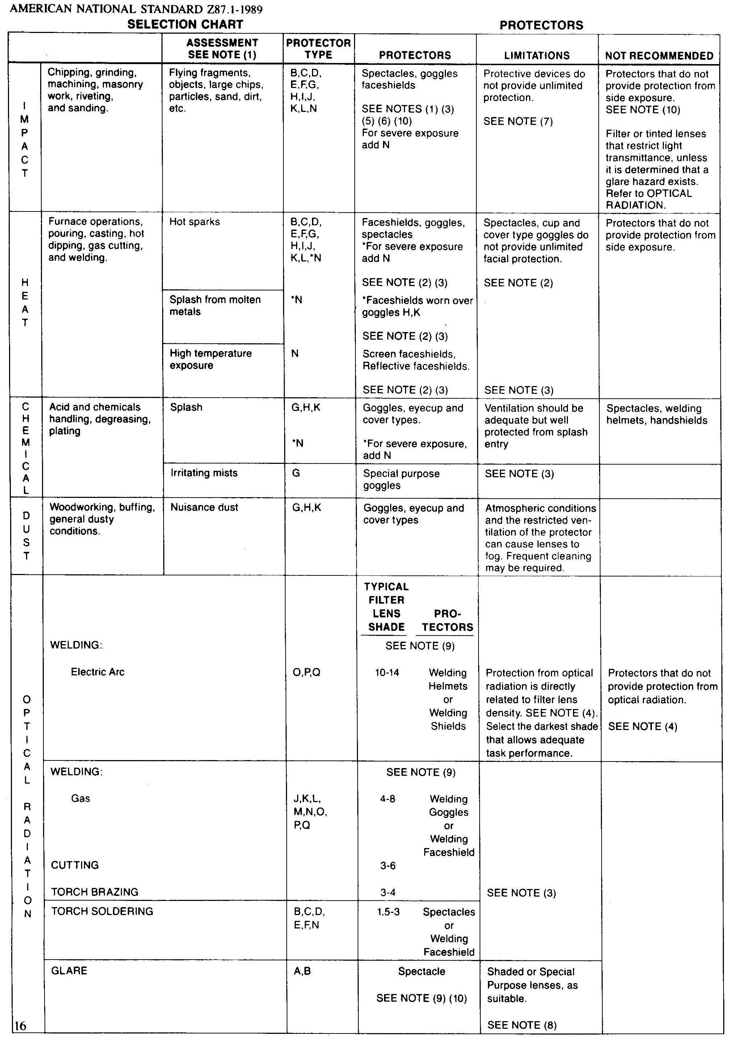
Eye Protection Selection Chart (continued)

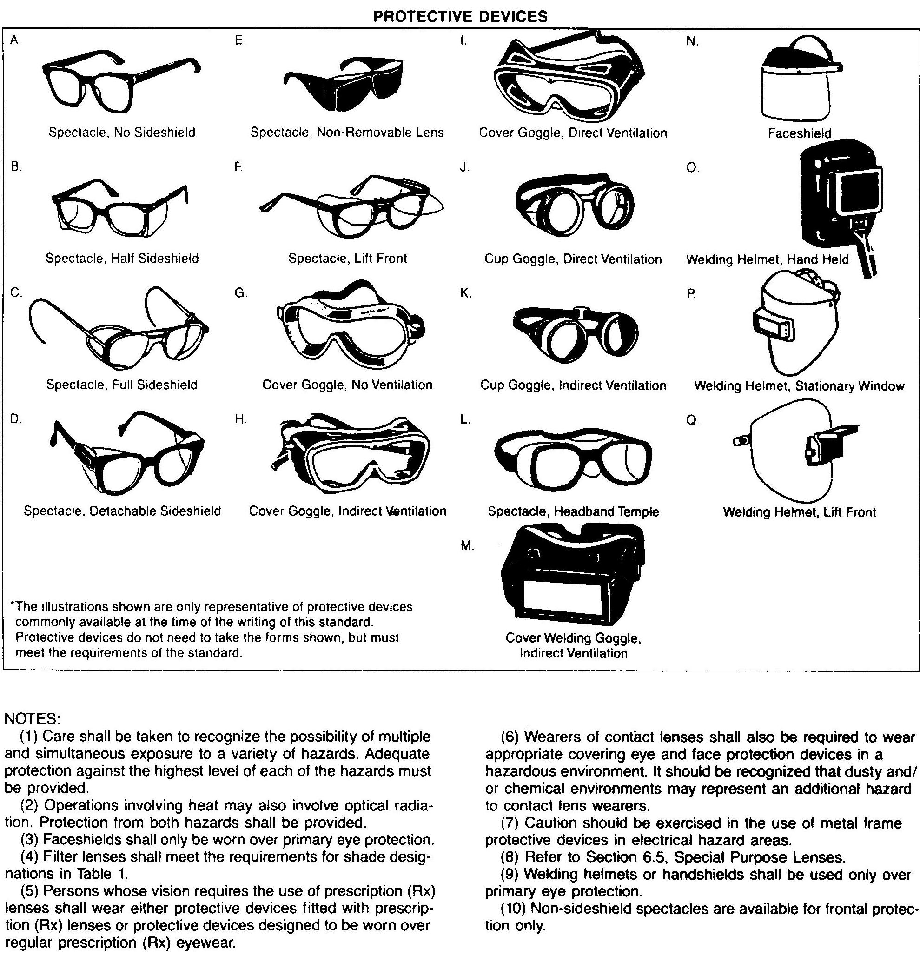
Appendix III - Chemical Glove Selection Table

Glove Material | Applications
Butyl | A synthetic rubber material that offers the highest permeation resistance to gas and water vapors. Especially suited for use with esters and ketones.
Neoprene | A synthetic rubber material that provides excellent tensile strength and heat resistance. Neoprene is compatible with some acids and caustics. It has moderate abrasion resistance.
Nitrile | A synthetic rubber material that offers chemical and abrasion resistance-a very good general-duty glove. Nitrile also provides protection from oils, greases, petroleum products and some acids and caustics.
PVC  (polyvinyl chloride) | A synthetic thermoplastic polymer that provides excellent resistance to most acids, fats and petroleum hydrocarbons. Good abrasion resistance.
PVA™  (polyvinyl alcohol) | A water-soluble synthetic material that is highly impermeable to gases. Excellent chemical resistance to aromatic and chlorinated solvents. This glove cannot be used in water or water-based solutions.
Viton® | A fluoroelastomer material that provides exceptional chemical resistance to chlorinated and aromatic solvents. Viton is very flexible, but has minimal resistance to cuts and abrasions.
SilverShield®/4H | A lightweight, flexible laminated material that resists permeation from a wide range of toxic and hazardous chemicals. It offers the highest level of overall chemical resistance, but has virtually no cut resistance.

More detailed information on chemical resistance of gloves can be found on the EH&S Web Site at http://www.cpp.edu/~ehs/files/occupational/xls/Permrate.xls.

see “Safety Training Matrix, “Appendix A, in Environmental Health and Safety Regulatory Training Requirements, Environmental Health and Safety Department, California State Polytechnic University, Pomona, 2009. Also available at http://www.cpp.edu/~ehs/files/occupational/doc/Regtraining.doc
see Mandatory Safe Work Practices, Environmental Health and Safety Department, California State Polytechnic University, Pomona, 2010. Also available at http://www.cpp.edu/~ehs/files/occupational/doc/safeworkpractices.doc
“Respiratory Protective Equipment Selection Guide,” Appendix 4, in Respiratory Protection Plan. Environmental Health and Safety Department, California State Polytechnic University Pomona, 2004. Also available at http://www.cpp.edu/~ehs/files/occupational/doc/RespiratoryProtection.doc .

