Access to this user guide is available on the EODA/HR Operations Offboarding Webpage.
Processing Step | Screen Shot
Step 1:  Select who is initiating the separation (choose one):  - Employee – You are the employee separating.  - HEERA Manager – You are the separating employee’s HEERA Manager.  - HEERA Manager Delegate – You are the delegate of the separating employee’s HEERA Manager.  - EODA/HR Operations or ELR&C – You are an HR employee separating an employee for any specific reason.  If ‘HEERA Manager Delegate’ is selected, you will be asked to identify the HEERA Manager of the employee that is separating.  - Note: Once the form is submitted the form will route for HEERA Manager approval. | 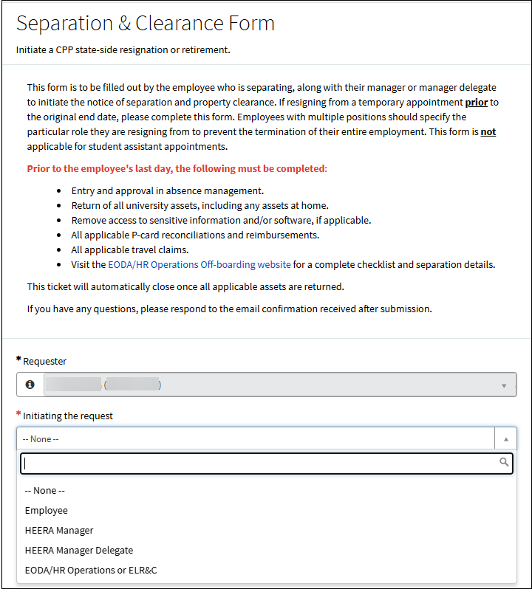  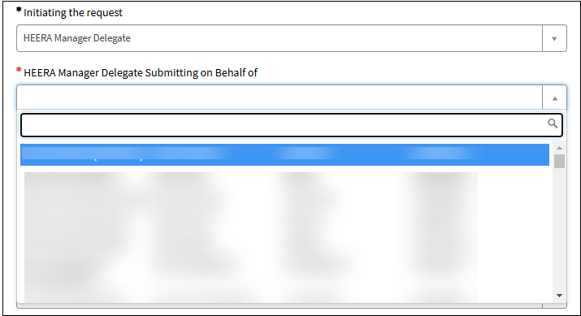
Step 2 (if you are not the Employee initiating the request):  If you are not the employee separating, you will be asked to identify who is separating.  - Refer to the ‘Employee Information’ section to verify that the correct employee was selected. | 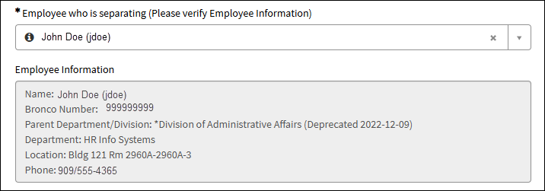
Step 3:  You will be asked if the employee is separating from all university positions.  - If ‘No’ is selected, you will need to enter which position the employee is separating from. This could be the working title and/or position number.  - If ‘No’ is selected and you are the employee initiating the request, you will need to select the HEERA Manager for the position you are separating from. | 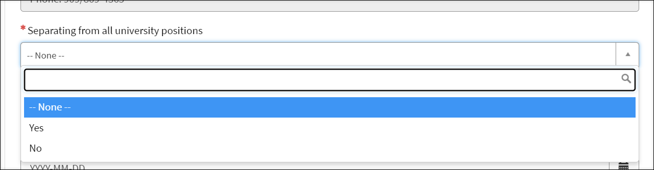  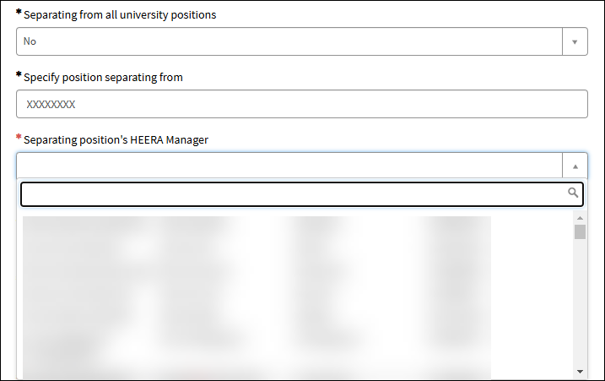
Step 4:  Provide the following:  - Date of Resignation Notice  - Last Day Worked on Campus or Remote  - Separation Date  If Separation Date is after Last Day of Work, you will be asked to provide which applicable leave credits will be charging and dates that were approved for each applicable leave credit. | 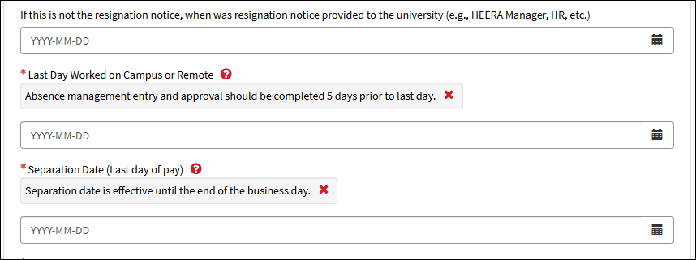  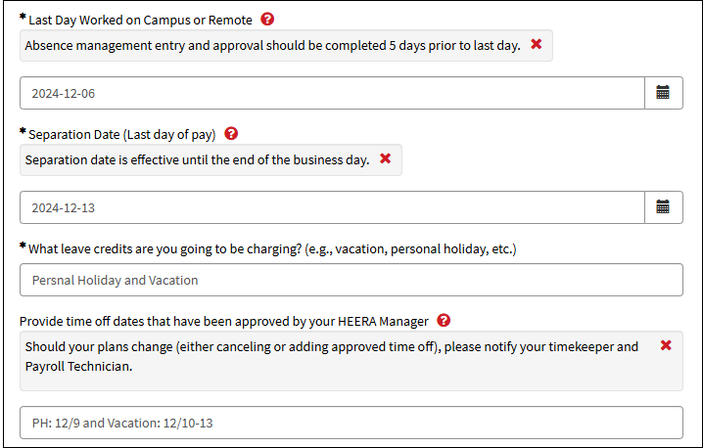
Step 5:  Select the Separation Type.  - Separation Type options vary depending on who is initiating the request. | 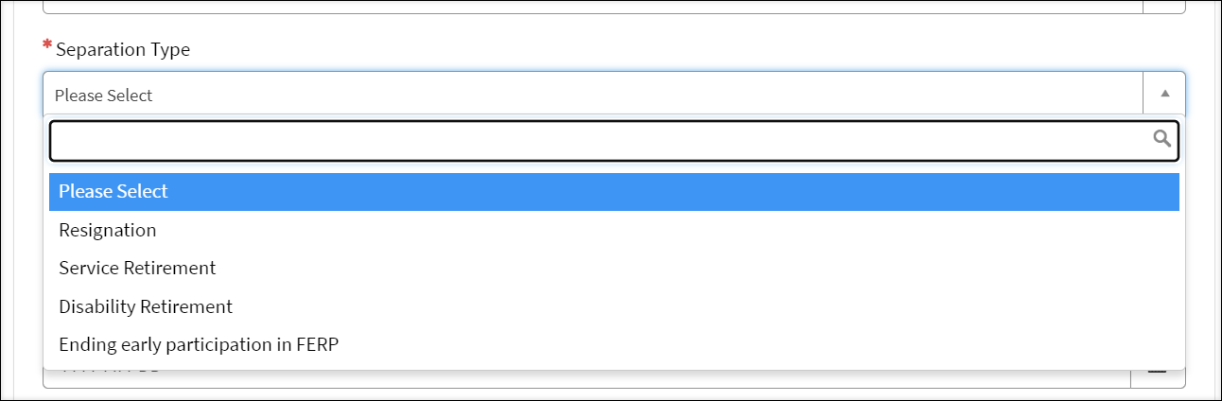
Step 6 (If Resignation):  If ‘Resignation’ is chosen, you will need to select a ‘Reason for Resigning’.  - If ‘Personal reasons’ is selected, you will need to select a “Personal reason’.  - If ‘Other/Unknown’ is select, you will need to specify in the ‘Other/Unknown reason’ open text field. | 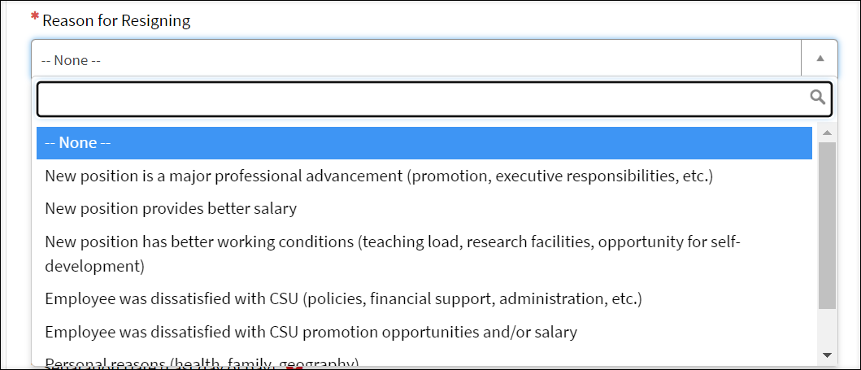  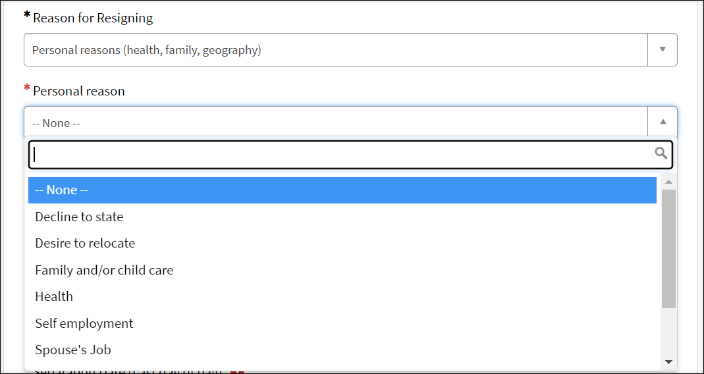  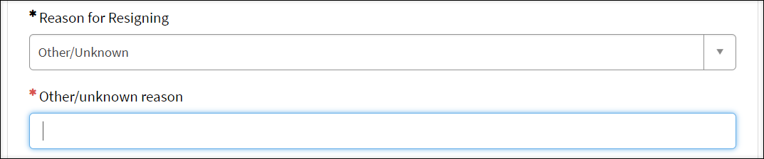
Step 6 (If Ending Early Participation in FERP):  If ‘Ending Early Participation in FERP’ is selected, you will be asked the following questions:  - Retiree Vision Coverage  - Retiree Dental Coverage  Use the help icon (?) to the right of each applicable field to view any help text. | 
Step 6 (If Disability Retirement):  If ‘Disability Retirement’ is selected, you will be asked the following in addition to the Vision and Dental questions listed on step 6:  - Retirement Date – As listed on your CalPERS Retirement Application.  - Are you transferring vacation hours to your VRA?  - If ‘Yes’ is chosen, you will be asked to select which VRA account(s) and the amount for each account.  Use the help icon (?) to the right of each applicable field to view any help text. | 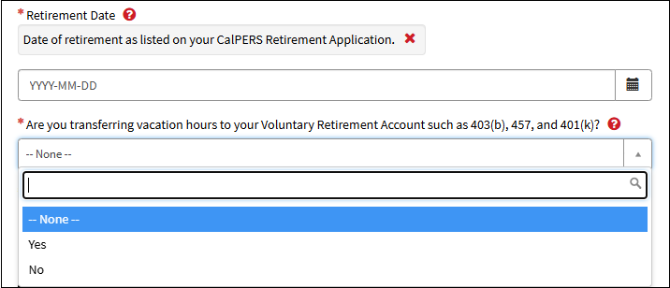  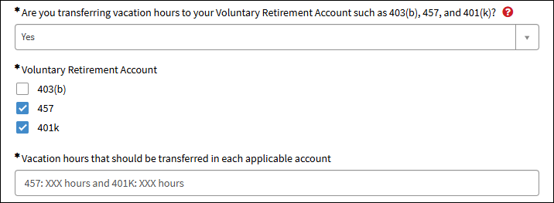
Step 6 (If Service Retirement):  If ‘Service Retirement’ is selected, you will be asked the following question in addition to the questions listed step 6 and 7:  - CalPERS Application Submittal Date  - (Required for Faculty Only) Will you be returning to participate in the Faculty Early Retirement Program (FERP)?  - If ‘Yes’ is selected, you will be asked if you will be transferring 48 hours of sick time into your FERP appointment. | 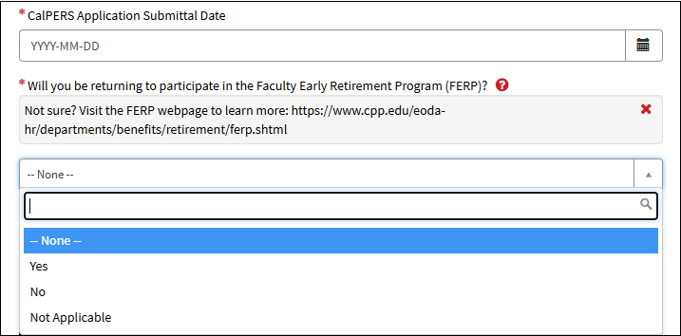  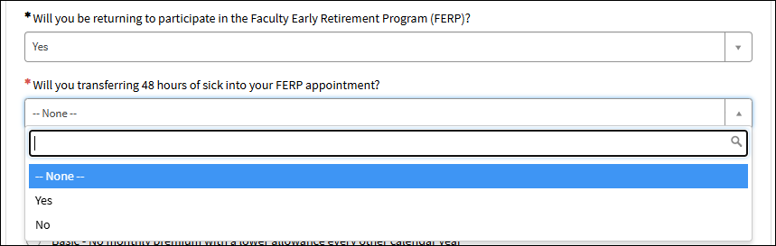
Step 7:  Is the separating employee a HEERA Manager or Lead? If ‘No’ is selected moved to Step 8, otherwise, if ‘Yes’ is selected you will be asked:  - If there are any employees reporting to this employee.  - If ‘Yes’, you will be asked to either provide the applicable department ID or list of employees.  - Who will be the new HEERA Manager and/or Lead for the employees.  - If ‘Yes’ is selected, you will be asked to provide the new HEERA Manager/Lead.  - If ‘No’ is selected, you will need to acknowledge that the employee(s) will roll up to the next HEERA Manager and, if applicable, identify who should be temporarily assigned. | 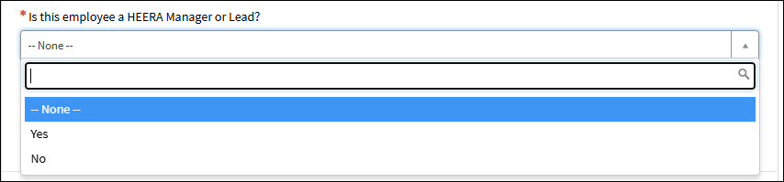  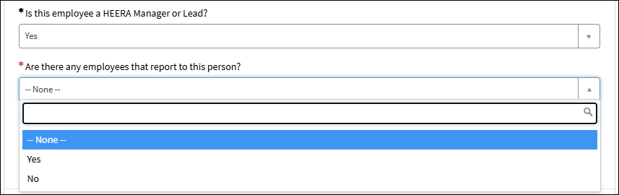  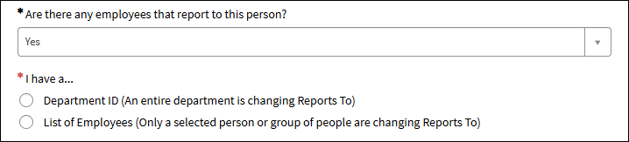  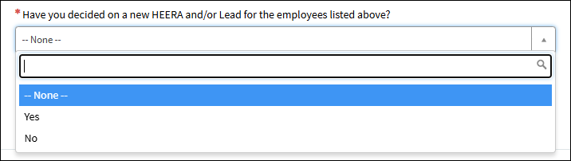  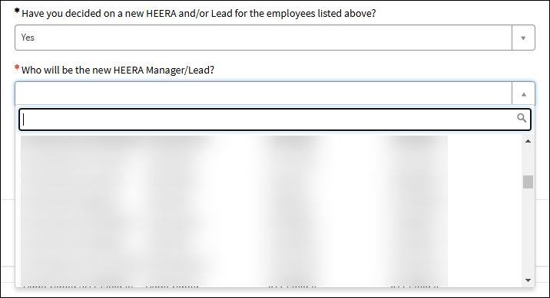  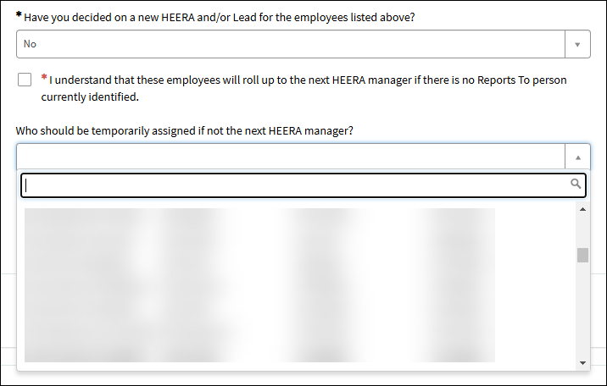
Step 8:  You will be asked the separating employee, is transferring to another CPP department.  - If ‘Yes’, provide the department the employee is transferring to.  - If ‘No’ is selected, you will be asked if the employee is transferring to another CPP Auxiliary, CSU Campus, or UC Campus.  If transferring to another CPP Auxiliary, CSU, or UC campus, you will be asked to select the applicable auxiliary or campus.  - If a CSU campus is selected, you will be asked if you are transferring vacation credits. If so, how many.  Use the help icon (?) to the right of each applicable field to view any help text. | 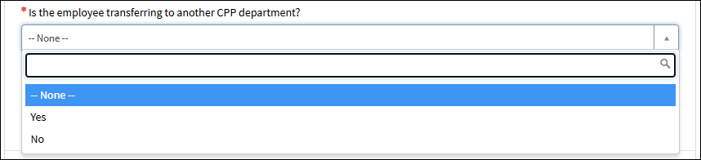  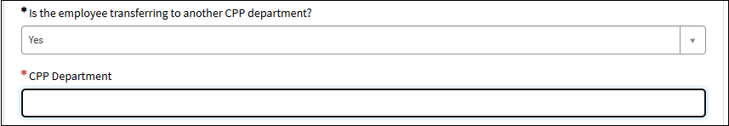  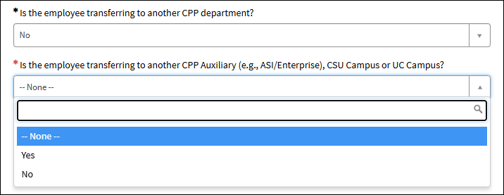  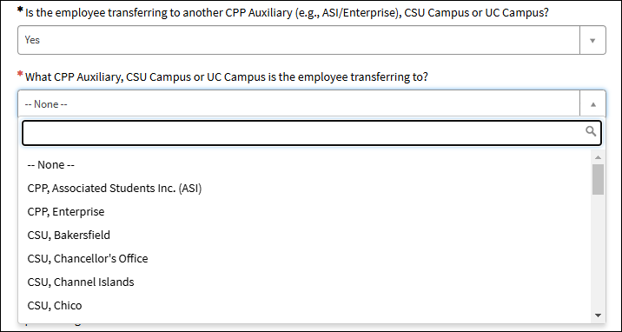  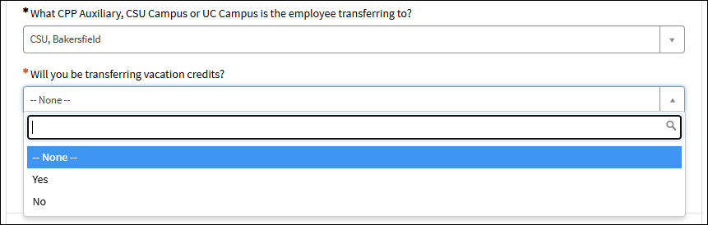  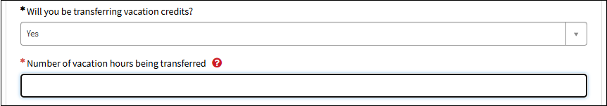
Step 9 (If request is initiated by Employee and separating from all positions):  You will be asked to acknowledge that your personal information has been updated. | 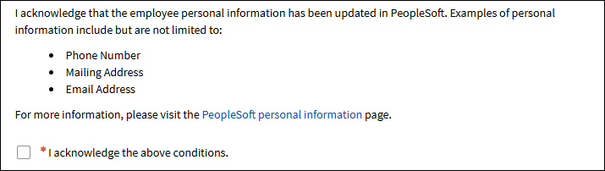
Ste 10:  Upload resignation letter (optional).  - Click the Upload button  - Navigate to the location of the file  - Select file  - Click ‘Open’ | 
Step 11:  Submit Employee Separation by clicking on the Submit button located on the top right of the screen. | 
Step 12:  Email notification sent to the employee that is separating. | 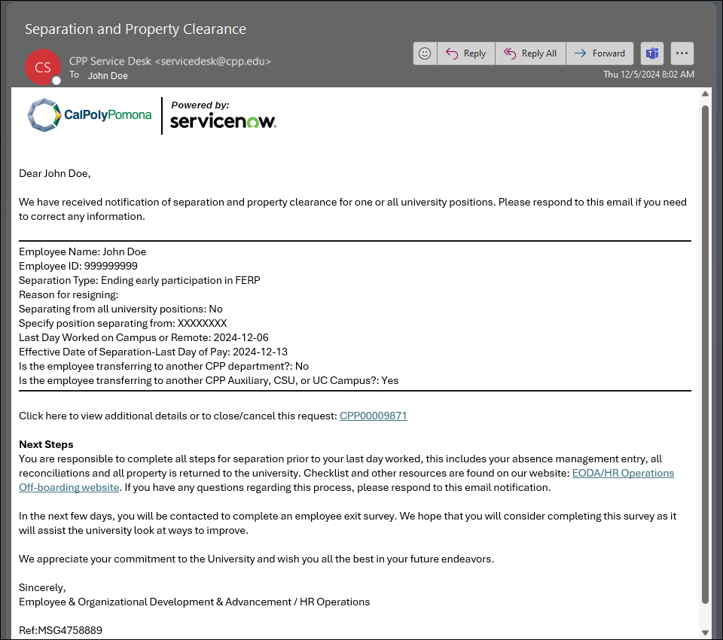
Step 13A:  Email notification sent to HEERA Manager. | 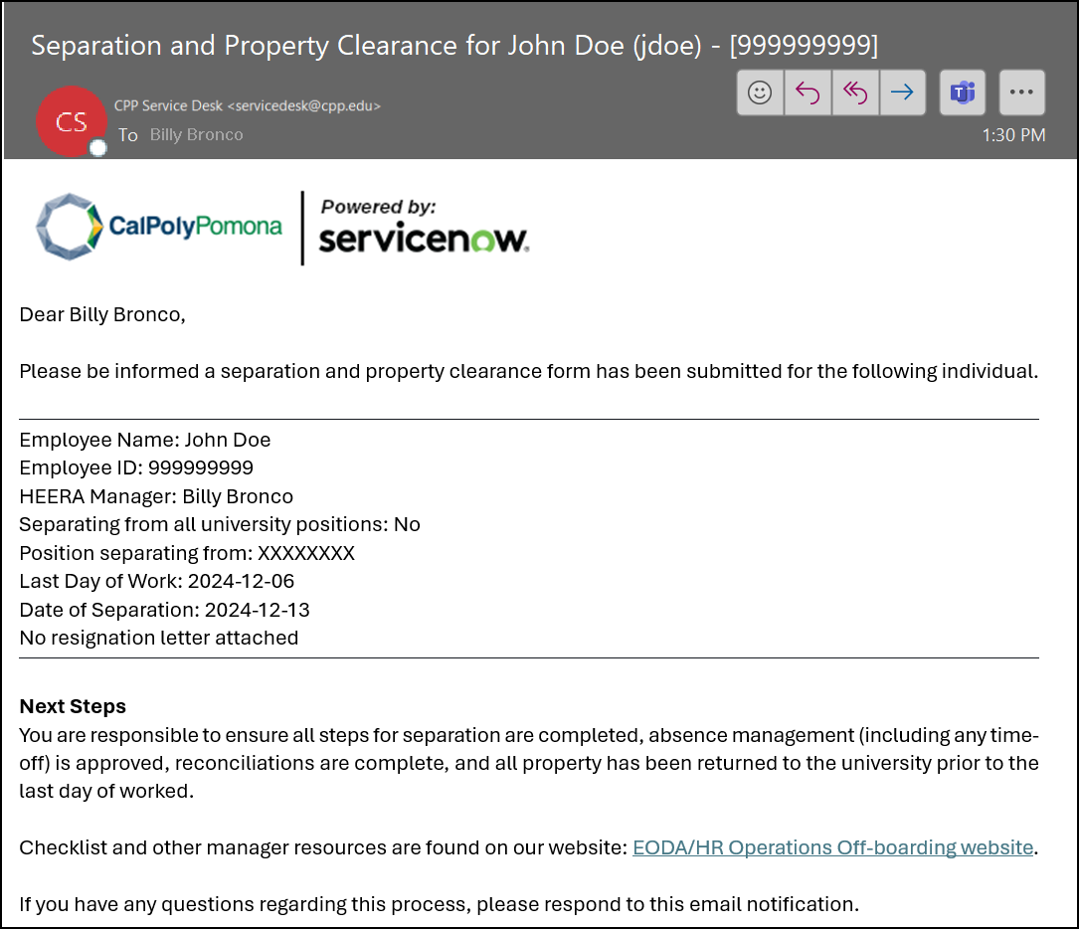
Step 13B (Applicable only if form was submitted by a HEERA Manager Delegate):  If form was submitted by a HEERA Manager Delegate, HEERA Manager approval is required.  If approved, continue with the remaining steps. Otherwise, business process ends and ticket automatically closes. | 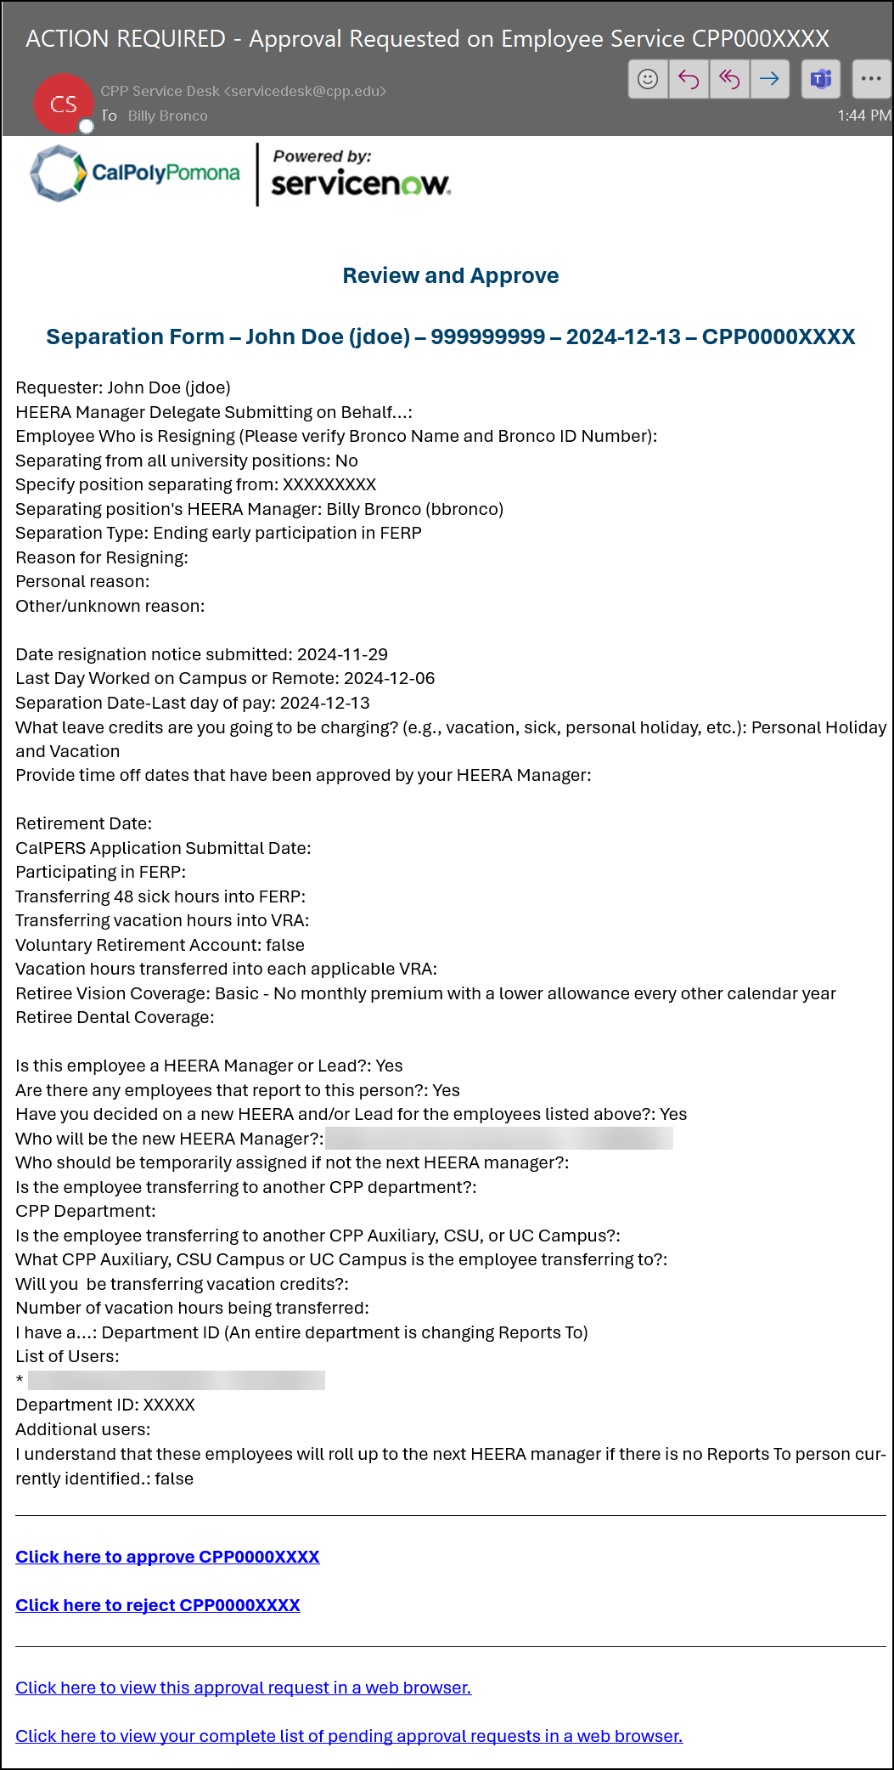
Step 14 (ACTION REQUIRED):  Property Clearance Task sent to HEERA Manager to ensure the collection of desktop and/or mobile computing equipment | 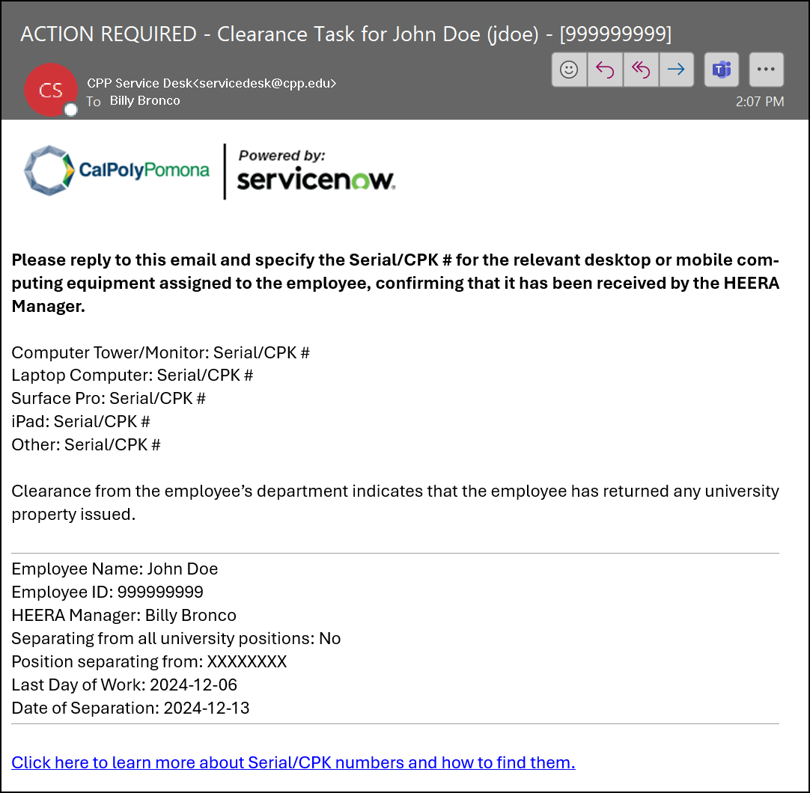
Step 15:  Email sent to University Property Clearance Team to ensure university property is collected.  Note: Each Property Clearance area (ex: Parking, Key Control, Procurement, IT, Accounting, etc.) will receive their own email with a task to complete. | This 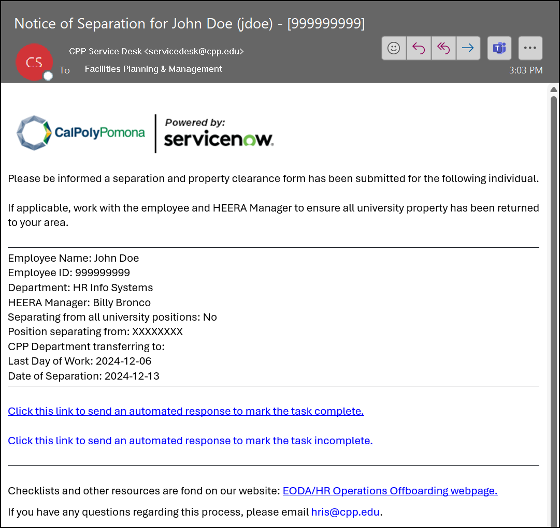
Step 16:  Email notification sent to EODA/HR Operations (e.g., Payroll, Benefits, etc.) and Employee Labor Relations & Compliance to ensure separation is processed timely and accurately. | 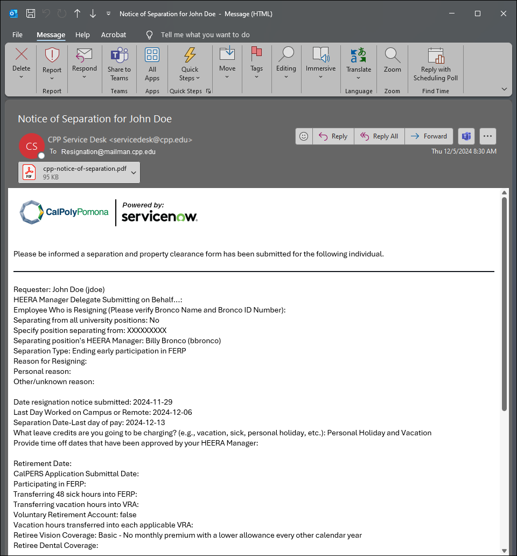
Step 17 (Applicable only if employee is separating from all university positions)  IT tasks trigger 24 hours after Separation Date to ensure that access to information resources is removed at the end of employment. | 