INTERFOLIO RTP STEP-BY-STEP RESOURCE
FOR CANDIDATES, DRTPC, DEPARTMENT CHAIRS or others who assist with RTP process management

Getting Started

- Log in to “My CPP”

- Click on “Online Services”

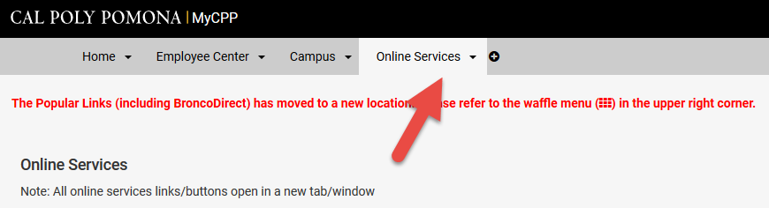

- Click on “Interfolio” from the A-Z listing

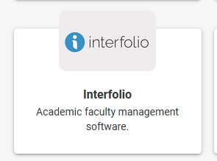

- Select sign in through “Partner Institution” button located on right-hand side of screen

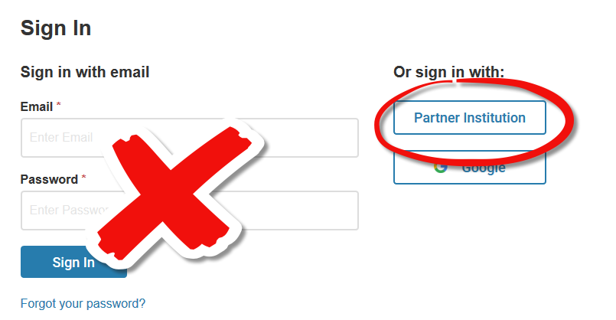

- Type “Pomona” in the search box, select “California State Polytechnic University, Pomona” and click “Sign In”

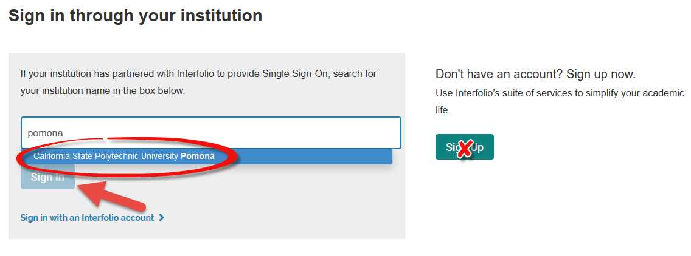

- You are now on the home page for Interfolio
