Resolution Specifying Adjustments to the use of Student Evaluations conducted in Academic Year 2020-2021 in current and future Periodic Evaluations and Performance Reviews of Faculty

WHEREAS the COVID-19 pandemic has disrupted the lives of all members of the Cal Poly Pomona community and, specifically, has caused major changes to the mode of instruction for nearly every class section offered in Academic Year 2020-2021, and

WHEREAS the need for remote instruction during this entire academic year has resulted in challenges for faculty and students, and

WHEREAS the transition to remote instruction necessitated an abrupt implementation of online student evaluations of teaching, and

WHEREAS it is of utmost importance to ensure that faculty are evaluated through a holistic and compassionate approach, and

WHEREAS the following policy adjustments are the result of consultation between the Academic Senate of California State Polytechnic University Pomona, the campus chapter of the California Faculty Association, and the Office of Faculty Affairs, be it therefore

RESOLVED that for student evaluations of teaching performed online in the Academic Year 2020- 2021, instructors be offered some flexibility for review purposes: specifically, instructors must include student evaluations for at least 50% (rounded up) of the class sections taught each term (Fall 2020 and Spring 2021) in Periodic Evaluations and Performance Reviews conducted in the current and future academic years, as shown in the following table:

Number of Class Sections Taught (each Semester) | Minimum Number of Evaluations to Include in Periodic Evaluations and Performance Reviews  (each Semester)
1 | 1
2 | 1
3 | 2
4 | 2
5 | 3
6 | 3

and that a memo documenting the right to these options will be issued by the Provost to the colleges to be placed in the personnel action file (PAF) of each faculty member teaching in Academic Year 2020-2021, and be it also

RESOLVED that the spirit of cooperation and collegiality evidenced in the negotiation of these adjustments is testimony to the commitment of all parties to “one team, one goal, student success,” and be it also

RESOLVED that this resolution be distributed to the President of Cal Poly Pomona, all Vice Presidents and Associate Vice Presidents in Academic Affairs, the Chairs of the CSU Academic Senates, and posted on the Cal Poly Pomona Academic Senate website.

Adopted by the Academic Senate of California State Polytechnic University, Pomona, on Wednesday, February 10, 2021.

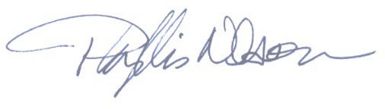Phyllis Nelson, Chair Academic Senate

