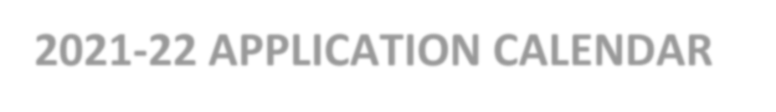
2022-23 CHANCELLOR’S DOCTORAL INCENTIVE PROGRAM (CDIP)
2021-22 APPLICATION CALENDAR

Nov./Dec. 2021 Campus announcement of the program
February 4, 2022 Completed applications due to the Office of Faculty Affairs (via Chancellor’s Office InfoReady)
Feb. 7-11, 2022 Campus Screening Committee evaluates applications
March 1, 2022 Campus nominations (with applications) for participation in the program due to Chancellor’s Office
May 2022 CDIP CSU Systemwide Selection Committee to review campus nominations May 31, 2022 Chancellor’s Office announces CDIP Selections

Current CDIP Information

