SYLLABUS FOR ECE 3201 Fall 2019

COURSE : INSTRUMENTATION SYSTEMS
TEXTS : Reference Textbooks
Thomas G. Beckwith, et al., Mechanical Measurements, 6th Ed., Pearson-Prentice Hall, 2007
Richard S. Figliola and Donald E. Beasley, Theory and Design for Mechanical Measurements, 6th Ed., John Wiley and Sons, 2014
James W Dally, et. al., Instrumentation for Engineering Measurements, 2 ed., John Wiley and Sons, Inc., 1993
Wolf & Smith, Student Reference Manual for Electronic Instrumentation Laboratories, Prentice Hall, 2004.
A fair portion of the material covered in this class is NOT in the textbooks. I suggest that you take good notes and use the many references in the library.
HOMEWORK : Some suggested homework problems are shown in Table1. Others may be posted on blackboard. Appropriate homework is due with each exam.
A one problem quiz will be given at the beginning of class each week (1 per week either Tuesday or Thursday). Put your name, and last 4 digits of bronco number on each quiz. All quizzes are open book.
INSTRUCTOR : R. FRANK SMITH , OFFICE TELEPHONE (909) 869-2528 , Room 9-324
e-mail rfsmith@cpp.edu, Webpage www.cpp.edu/~rfsmith
COURSE Topics
Some suggested videos will be posted on blackboard. There are numerous videos on YouTube and manufacturer’s webpages which will help you understand the course materials. You may be requested to watch some videos before class.
Week 1 Introduction to instrumentation systems, accuracy, precision, and sensitivity errors
Activity
Design a system block diagram of an instrumentation system.
Each block should clearly indicate its input and output. Assume each block will be designed by a different engineering group. The blocks will be combined for the system which will be performed by the system’s engineering group.
Your system block diagram will be used to explain to management how the system will function and what it will cost.
For Example
Automobile emission control system (EVAP)
Automobile cruise control
Bakery for loaves of bread
Irrigation system for lettuce farmer –open field or green house.
Cooling tower system for electrical generator system with steam turbine
Rover for next Mar’s trip
Reference: Applied Process Control Instrumentation, Jean Potvin, 1985
Frito-Lay bagging system

Suggested Videos
YouTube Experimental Uncertainty, Engineering Program, Engineer It
YouTube Propagaation of Uncertainty Part 1 and 2 Pro. Glenn Start, Wellesley College Physics
YouTube Propagaation of Uncertainty Part 3 Pro. Glenn Start, Wellesley College Physics
YouTube Uncertainty Calculation – Walter Lewin MIT Physics Department
YouTube Experimental Uncertainty by Engineeritprogram

Week 2 Voltmeter, ammeter, and batteries
Activity -- Watch video in preparation for an in class design problem
Suggested Videos
YouTube #237: 4-wire Resistance Measurement | Kelvin Connection
YouTube #275 Basics of Analog Panel Meters Analog meter movements|D’Arsonval
YouTube #276: Using a Current Shunt with a panel meter|Ammeter Scale Change
YouTube Battery Discharge Characteristics (Sponsored by NSF Grant)
YouTube EEVblog #35 2of2 - NiMH and NiCd Battery Charging Tutorial
There are many YouTube videos on battery topics such as State of Charge (SOC) , State of Health (SOH), Lithium Ion batteries, shelf life, temperature sensitivity, depth of discharge DOD), Watt-Hours vs weight, etc.

Week 3 Zener power supplies, series power supplies, and switching power supplies
Activity -- Watch video in preparation for an in class design problem of a zener power supply.
Suggested Videos
YouTube EEVblog #908 – zener diodes before you come to class.
YouTube RSD Academy – Building a linear power supply parts 4, , 5, and 6.

Week 4 EXAM 1
Week 4 Operational Amplifiers, and instrumentation amplifiers
Activity -- Watch video in preparation for an in class design problem of an operation Amplifier.
Suggested Videos
YouTube EEVblog #600 – OpAmps Tutorial – What is an Operation Amplifier
YouTube EEblog #479 – OpAmp Input Bias Current and many others.

Week 5 Analog to digital (A/D)s
Suggested Videos
YouTube Nuts and Bolts of the Delta –Sigma Converter, Bonnie Baker, TI
YouTube Understanding Analog to Digital Conversion, Bill Herd of Hackaday

Activity -- Watch video on sigma Delta converter
Week 6 Digital to analog (DAC) converters
Activity -- Watch video and do in class design problem

Week 7 Miscellaneous sensors, wire wrapped resistor –rotary and linear, rotary and linear encoders – Heidenhain, LVDTs, capacitive sensor, eddy-current sensors, piezoelectric sensors, photoelectric sensors, photodiodes, Hall Effect’ capacitive, magnetic , ultrasound, see Chapter 5 of Dally
Week 8 Exam 2
Week 9 Strain gages
Activity -- Watch video and do in class design problem

Week 10 Temperature sensors Activity -- Watch video and do in class design problem
Activity -- Watch video and do in class design problem

Week 11 Temperature sensors
Activity -- Watch video and do in class design problem

Week 12 Exam 3
Week 13 Flow sensors
Activity -- Watch video and do in class design problem

Week 14 Valve Selection
Activity -- Watch video and do in class design problem

Week 15 P&ID Diagrams and instrumentation documentation
Activity -- Watch video and do in class design problem
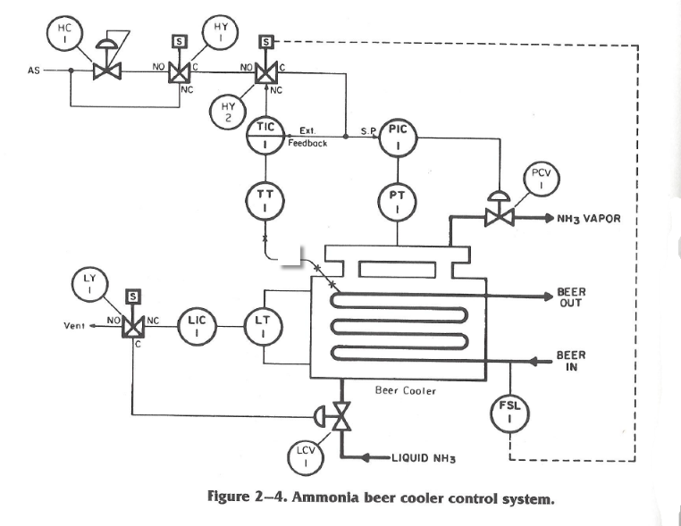

Week 16 Exam 4

Table 1. Suggested Homework Problems ( others may be posted on blackboard or in class)
Topics | Reading Assignments  Dally | Reading Assignments  Wolf/Smith | Suggested Problems : Dally | Suggested Problems: Wolf/Smith
1 | 1.1 and 1.2  1.3 thru 1.7 | Chapter 2  Page 116 | 1.14, 1.18, 1.19, 1.20, 1.27, 1.28,  Omit section 1.4.1 | 2.1, 2.2, 2.4, 2.5,2.11,
 | 3.1 -3.3.5 | Chapter 4 | 3.5,3.9,3 3.10, 3.15,3.16,3.17, | 4.2,4.5,4.9
2 | 6.1 thru 6.6 | Chapter 12 |  | 12.2,12.3,12.4,12.9,12.12, 12.13,12.14,12.24,12.26
 | 6.7 and 6.8 | Chapter 15 | 6.29,6.31,6.32,6.33 | 15.6 thru 15.18
3 | 4.1 thru 4.5.3 | Chapter 5 | 4.13,4.15,4.16, 4.19, 4.22, 4.28, 4.40, 4.43 | 5.9, 5.10, 5.11, 5.12, 5.14, 5.15, 5.18
 | same |  | same
4 | 5.1 -5.3 | Chapter 14 | 5.1, 5.2, 5.3,5.19 | 14.2, 14.8, 14.12, 14.16
 | 5.5 -5.9 | Chapter 14  Chapter 14 | 5.26,5.28,5.29,5.30,5.32,  5.38,5.39,5.40 | same
 | 7.1 – 7.7 |  | 7.9,7.11,7.13,7.14,7.22,  7.23,7.24,7.30 | 14.5, 14.6,
5 | same | Chapter 14 | same | 14.20, 14.21, 14.23, 14.24
6 | 11.1 thru 11.5 |  | 11.12,11.14,11.15,11.16,11.21,  11.23,11.32,11.33,11.34-37
 | 12.1-12.3 |  | 12.3,12.5,12.8,12.10,12.13,12.14

Grading
Homework for all homework assignments combined = 100points (25 points each exam)
Quizzes 10 points each = 10 points * number of quizzes( approx.. 140 pts)
Exams (4) 100 points each =400 points
Total approximately =
Exam and quiz scores will be posted on Blackboard.
Exams and quizzes are open book and notes. Your exam calculations must match your Scantron answer if you want credit for an answer. Attach homework problems to your exam not the Scantron. Put the numbre of problems you worked on the first page of your homework. I will provide the Scantron cards.
Some homework problems may also be posted on blackboard.
Homework Problems are due at the time an exam is given. Late problems will not be accepted. . PUT BOTH YOUR NAME AND last 4 digits of your BRONCO NUMBER on your exam and Homework. “All” is not a number for problems worked.
Guest speakers may be scheduled when possible. These will shift the course outline thus eliminating some topics.
Each student should have their own computer account. Use your account to access PSpice, MATLAB, or MathCAD in Lab 9-409.
Failing to earn at least 50% of the points possible will result in you receiving a poor grade.
You must complete all assignments in the course to get a passing grade. A (90-100), B (80-89), C (70-79), D (50-69).

GENERAL PROCEDURES

You must notify the professor ahead of time if it is impossible for you to take an exam on the scheduled date and time. Students who fail to do this will receive an automatic zero for the missed an exam, and they will forfeit the right to make it up. The professor reserves the right to not even to listen to the excuses of those who fail to notify. The final grade will include + and -.

Participation
Student participation in class discussions will be taken into account by the professor in deciding border-line cases when the final grade is calculated.

Attendance
Students are expected to attend all classes. Absences for any reason, even if necessary, will seriously your ability to comprehension of the material. “Getting the notes” will not substitute for attending class. If you are forced to miss a class, ask someone to tape record it or reconstruct the content, but the remedies will not excuse you from anything you missed by not being in class. If you miss a class any makeup quiz is at the professor’s discretion.

Academic Integrity
The university takes an extremely serious view of violations of academic integrity. As member of the academic community, faculty, staff, and students are dedicated to promoting an atmosphere of honesty and are committed to maintaining the academic integrity essential to the educational process. Inherent in the commitment is the belief that academic dishonesty in all forms violates the basic principles in integrity and impedes learning.
It is the responsibility of individual faculty members to identify instances of academic dishonesty and recommend penalties to the department chair or college dean in keeping the severity of the violation. Penalties may range from verbal chastisement to a failing grade in the course..
ANY STUDENT THAT VIOLATES UNIVERSITY POLICIES OR REGULATIONS may RECEIVE A GRADE OF F.

