Rearranging the Navigation Links:
- Click on the main (root) folder:
  - 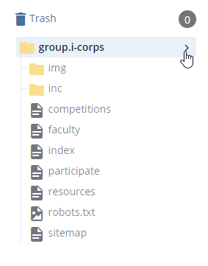
- Once the folder content is displaying on the right pane, Click on the Order field:
- When the order of the pages is shown, you can then drag and drop the pages to reorder them.
  - 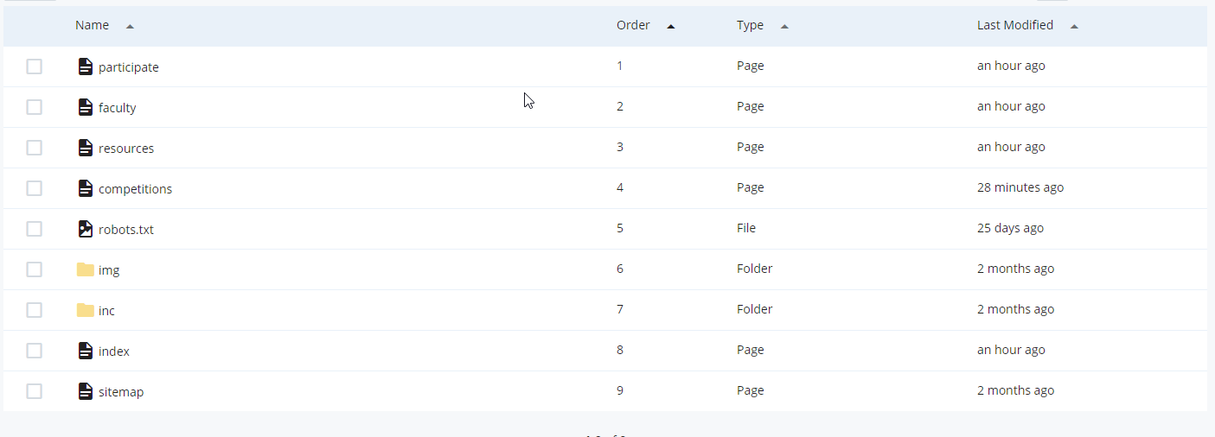
  - NOTE: the index page within the same folder level will always be on top regardless of where you placed it in the order, and will show as the “Home” tab. Read more on how to get around that.
- Go to /inc/navigation-default/ folder and click on site-navigation file
  - Confirm that the order of the pages is in the desired order
    - 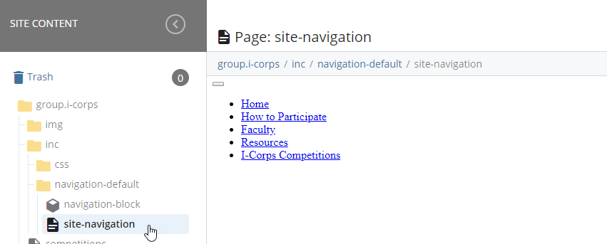
    - If you would like to Remove the “Home” tab and replace it with a customized link, edit the site-navigation and fill in the fields below:
      - Tab Title
      - Absolute path of the page
    - 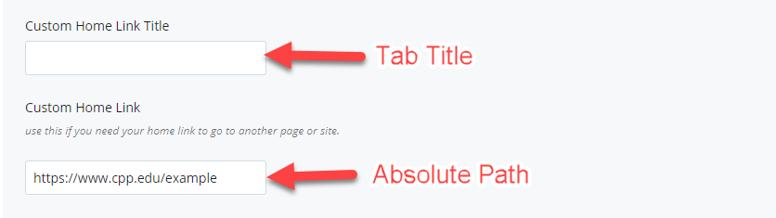
  - Publish and check an arbitrary page to see that the navigation links are showing in the order that was setup

