The New 2018 Cascade Template (Quick Start Guide)
- Start with Adding Content
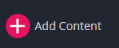
- Choose Content Page
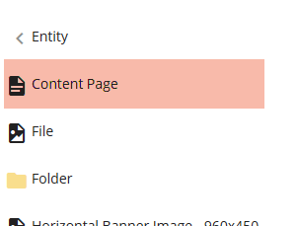
- Page Name:
  - New naming convention is that it can ONLY have lowercase letters, numbers, dashes, and/or underscores
  - 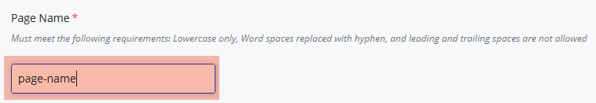
- Fill Out the Title of the Page
- SKIP Keywords and Description.
- Decide whether you would like to see this page on the page’s left navigation bar
  - 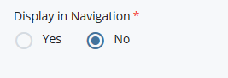

- Choose whether you’d like to display your content in a fixed (1200 pixels) width or span it from left to right of the screen (full width)
  - 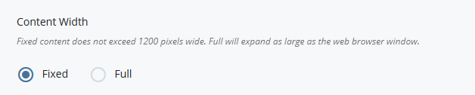
  - Click below to see how Full and Fixed width renders:
    - https://www-test.cpp.edu/~webredesign/2018/samples/page-width.shtml
- The following sections are where the page’s content body is developed (or put together):
  - JUMBOTRON Section:
    - 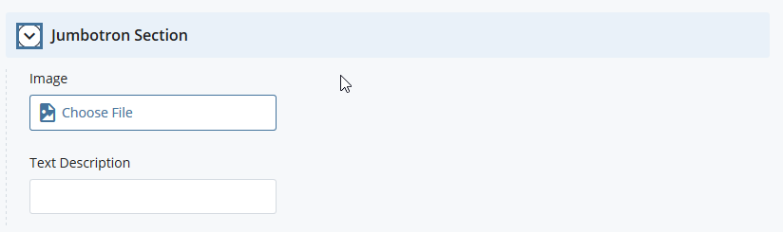
    - The image you uploaded will span from left to right and it will be giant sized so the more pixels you upload, the clearer and crisper your jumbotron(hero) image will be. (Although be mindful of the image’s file size. Too big will affect page’s load time)
  - SLIDESHOW Section: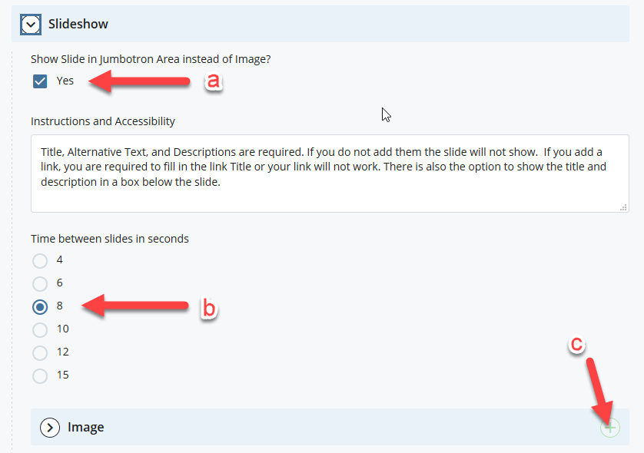
    - Choose ‘Yes’ if you would like the slideshow image(s) to span as wide as the browser’s width (full width)
    - Time between slides
    - To add more images, simply click this plus sign

  - CONTENT Section:
    - This dropdown menu shows the different pre-coded stylings that you can apply to your content. Refer to this link below to see how each are rendered on the screen. See samples here: https://www-test.cpp.edu/webredesign/2018/samples/index.shtml#qa-h2-3
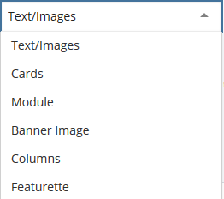
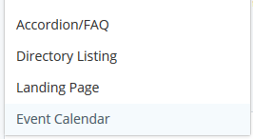
  - RIGHT COLUMN Section
    - This is usually the “Related Links” section

------------------------------------------------------------------------------------------------------------------------------------------

