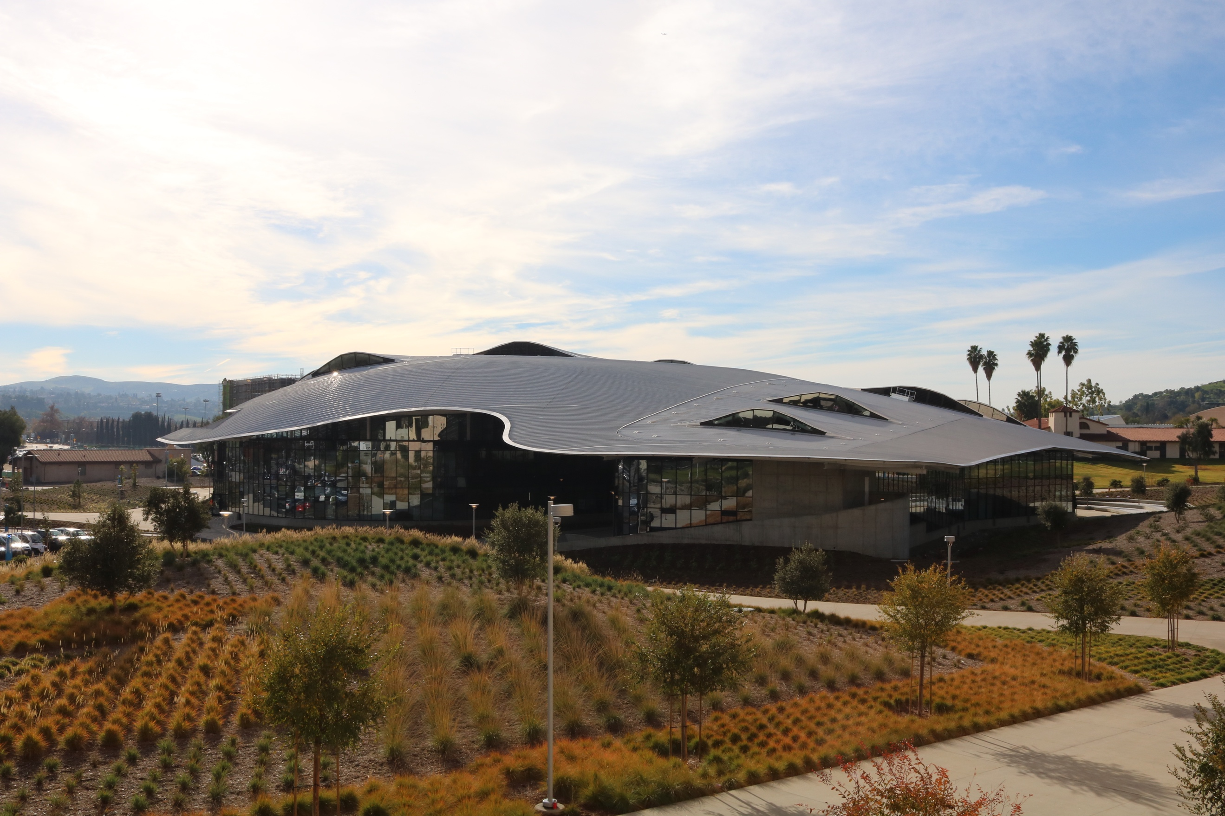

Cal Poly Pomona Student Services Building (121)

**Campus Parking**    
We ask our Tour Visitors to park in Structure One,. Structure One is located on off of Palm Drive and Oak Lane across from Voorhis Park.

Please note that if you are using a GPS locator on your mobile device, it will not take you to this location. Once you arrive on campus, please keep an eye out for Parking Structure One.

Parking Permits are required to   
 park on the campus, and there are   
 no free parking spots available. An   
 all-day parking permit is currently   
 $8.oo and can be purchased from   
 any of the yellow pay stations   
 located within the parking   
 structure.

**Congratulations!**   
You have scheduled a tour of Cal Poly Pomona! At the start of your visit a Cal Poly Pomona professional staff representative from the Office of Outreach, Recruitment & Educational Partnership will greet your group and lead a 15-minute presentation to discuss: admission requirements, deadlines, tuition, and majors.

Our tours are designed to provide prospective students with substantial knowledge about the university to make to make their own higher education dreams a reality.

**Campus Location**   
Cal Poly Pomona is located at 3801 W.

Temple Avenue in the city of Pomona; located just south of the 10 freeway and west of the 57 freeway.

­­

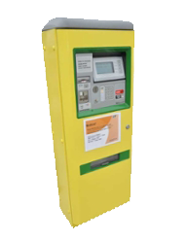

**Tour Details**    
The campus tour is approximately a 90-minute walk through the main areas on campus, and includes a tour of the freshmen residence halls. This is a WALKING TOUR of approximately 1.5 miles, so please wear comfortable walking shoes and bring a water bottle.

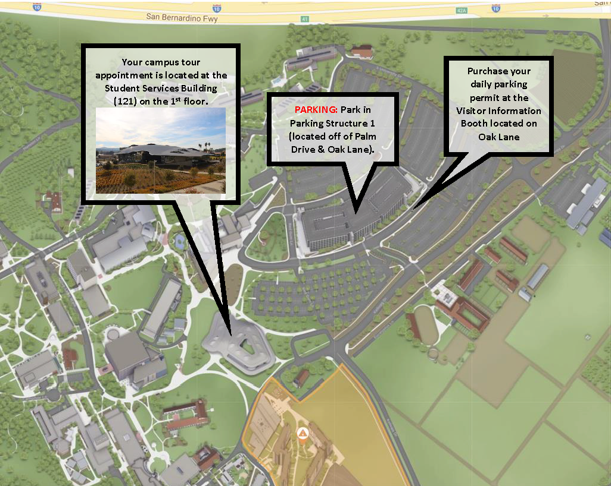

***\*Important\****

*Please note: As Southern California traffic and campus parking tends to be a bit unpredictable, please arrive on campus at least 20 minutes prior to your scheduled tour time.*

**Checking-In For Your Tour**   
Tour Check-in is located at the Student Services Building, East (#121) on the first floor Visitors Center.