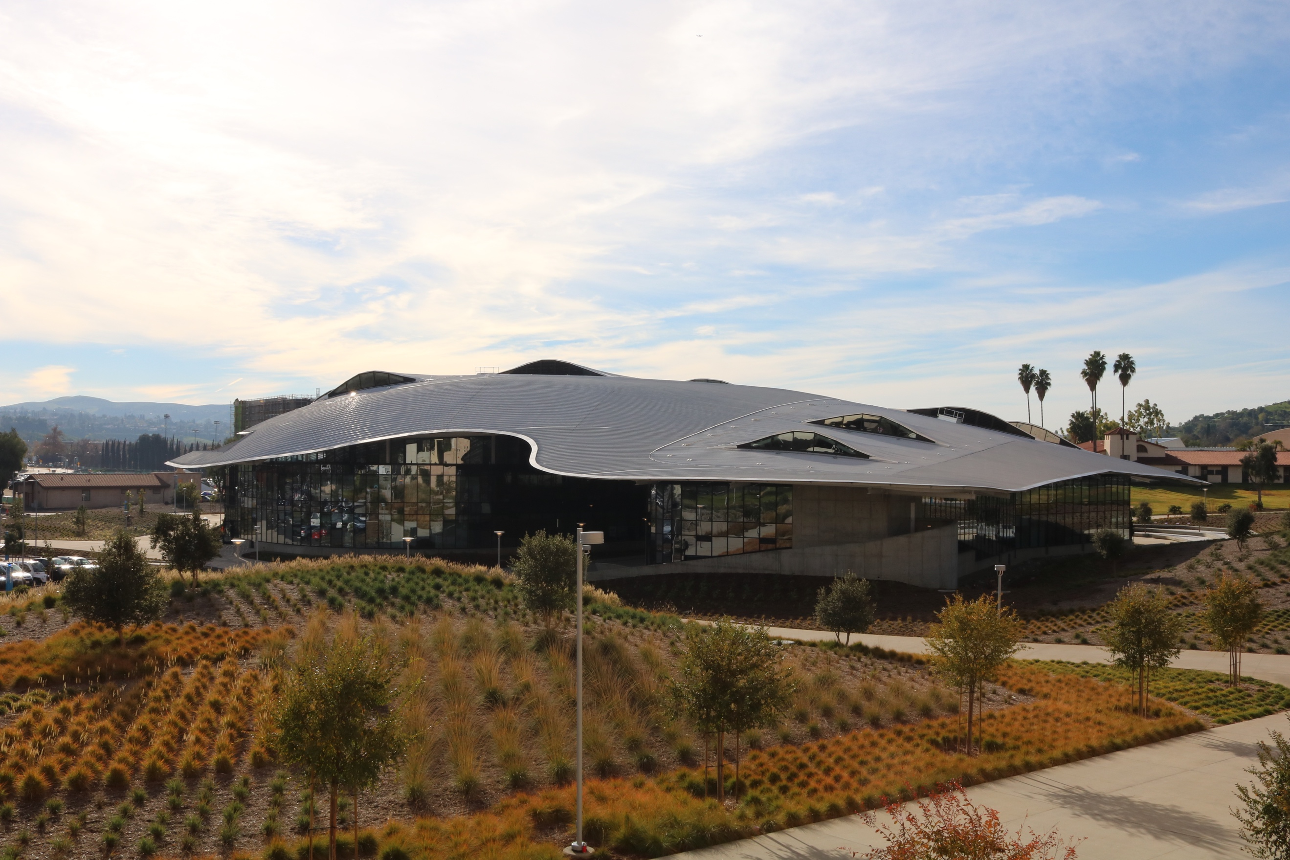

**Preparing for your Group Tour**

Cal Poly Pomona Student Services Building (121)

**During Your Tour**    
During the walking tour, your tour guide(s) will highlight programs and services, give your group insight into what it is like to be a Cal Poly Pomona student and share with you some of Cal Poly Pomona’s unique features. You will discover:

* The Power of Polytechnic
* An Affordable, Quality Education at a Great Location
* Get Connected to Campus Life
* Diversity
* Heritage
* Student Centered Philosophy
* Learn-by-Doing Education that prepares you for your career

**About the Group Tour!**   
Cal Poly Pomona Group Tours help educate young students about the exciting opportunities of higher education. Our tours are designed to not only enlighten students about Cal Poly Pomona, but give them the encouragement and knowledge they need to make their own higher education dreams a reality.

**Checking-In For Your Tour**   
Tour Check-in is located at the Student Services Building, East (#121) on the first floor Visitors Center. Have one chaperone check your group in at the Visitor Center. Be sure to look for the campus tour directional signage. Tours will begin inside the Visitors Center.

**Prepare**  
Have your students come prepared! Be sure to ask your students to think of questions to ask about college while on the tour! For more ideas on how to prepare for your tour email us at tours@cpp.edu.

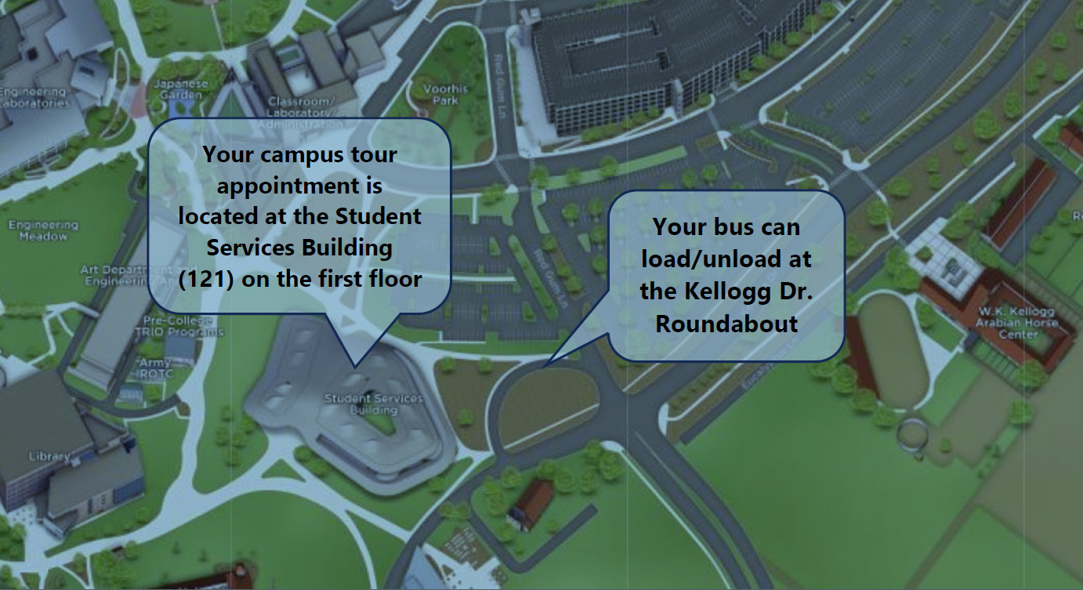­­

**Tour Visit Timeline**

* T-30 | Bus Drop Off: 30 minutes before tour time and students walk to Check-In location
* T-15 | Check-In: 15 minutes before your tour time. This allows students to regroup and use the restroom if needed.
* Tour Time | Campus Walking Tour: After the presentation your guide will begin the 60-minute tour
* T+1.25 | Tour Conclusion: Afterwards please enjoy the campus on your own! Eat lunch, visit the Bronco Bookstore, or head back to your bus at the same location you were dropped off.

***\*Important\**** *Please note: Due to the very full tour schedule, early and late arrivals cannot be accommodated.*