Sample Social Media Text Posts
Rankings Post Instructions and Samples for LinkedIn
- Open your LinkedIn account and create a post.
- Please tag the official Cal Poly Pomona LinkedIn page by using the @ symbol and typing: California State Polytechnic University-Pomona and the account should show up for you to click on (see image below)
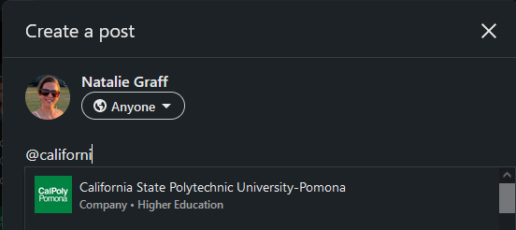
- Build your post using your own text, the sample text below, or some combination of your choosing!
  - Rankings Post Sample Text
So proud of my alma mater California State Polytechnic University-Pomona!
OR
As a board member supporting California State Polytechnic University-Pomona I’m proud to share this news!
Big news! Cal Poly Pomona is the No. 2 Public School in the West according to US News. 🎉
CPP also ranks:
No. 4️ Most Innovative School in the West
No. 6️ Best Undergraduate Teaching in the West
No. 6️ Top Performers on Social Mobility in the West
Learn more: https://bit.ly/3Dj00Wg https://lnkd.in/ge3BncpT

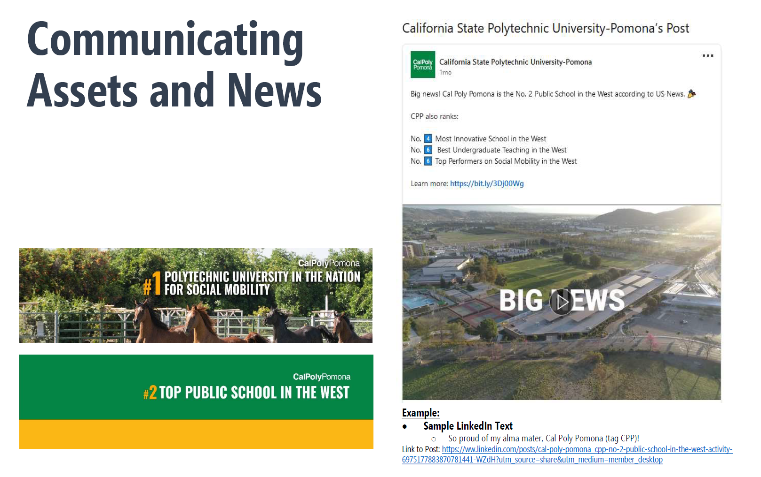

- Please also consider uploading one of the LinkedIn banners to your account (see image below)

