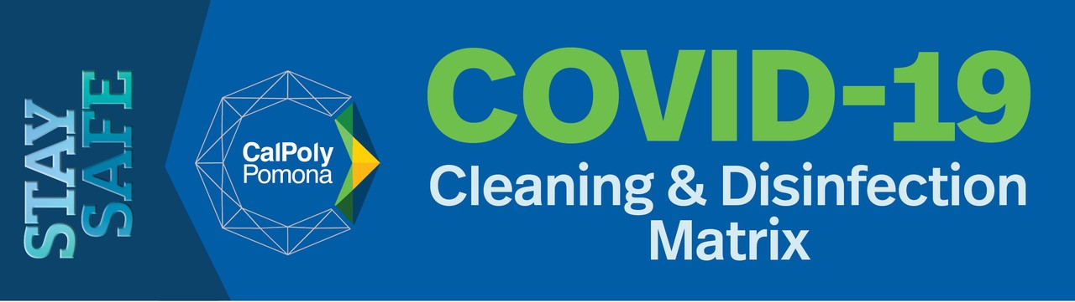
The following cleaning and disinfection matrix coincide with the guidance provided by Los Angeles County Public Health on the cleaning and disinfection of rooms or areas occupied by those with suspected or with confirmed COVID-19. It aims at limiting the survival of the virus in key environments.

http://publichealth.lacounty.gov/media/Coronavirus/docs/protection/CleaningMatrix.pdf

 | Routine Cleaning | Enhanced Cleaning | Deep Cleaning
Description | Regular cleaning practices implemented. | Routine cleaning practices PLUS additional cleaning and disinfecting of high touch surfaces during a communicable disease pandemic or local epidemic to prevent illness. | Routine and enhanced cleaning PLUS specialized cleaning services (i.e. electrostatic sprayer, Brightworks) of the space occupied by a person suspected or confirmed.
Personal Protective Equipment (PPE) | If chemicals are used, wear gloves to protect hands. Be sure to refer to Safety Data Sheets or follow the instructions on the chemical label. | Wear gloves PLUS splash goggles if there is a risk of splash.¹ Be sure to refer to Safety Data Sheets or follow the instructions on the chemical label. | Wear gloves, splash goggles, face shield, gowns/coveralls, respirator if there is a risk of splash.¹ Be sure to refer to Safety Data Sheets or follow the instructions on the chemical label.
Disinfectant | Use everyday janitorial cleaning supplies and disinfectants for regular surfaces such as floors, tables, desks, counters, sinks, toilets, and other hard-surfaced furniture and equipment. | Use routine cleaning disinfectants or other approved disinfectants¹ for regular surfaces PLUS an EPA-registered disinfectant approved for viral/bacterial pathogens for high-touch surfaces. | Use an EPA-registered disinfectant approved for emerging pathogens.²

Cleaning Actions | Perform the following practices:  - Dust hard surfaces  - Damp wipe hard surfaces free of debris  - Disinfect all surfaces  - Wet mop floors  - Vacuum carpet and mats  - f) empty trash and recycling | - Perform routine cleaning actions PLUS increase the frequency of cleaning and disinfecting of high touch non-porous objects/surfaces throughout the building.  - Clean with warm water and soap/detergent. Disinfect high-touch non-porous surfaces at least daily.  - Clean visible stains/debris on porous surfaces (e.g. carpet, rugs, furniture, and drapes) with appropriate cleaners indicated for use on the material.  - Disinfectant wipes and gloves for office suites and classroom/lab areas, as needed to be used for cleaning of the space by the occupants.  - e) Restocking hand-sanitizer dispensers in high traffic areas and entryways. | - Close off the space/area used by the ill occupant and wait up to 24 hours before entering if practical.¹  - Open outside doors and windows in the ill occupant’s area to increase air circulation if possible.¹  - Perform routine and enhanced cleaning actions PLUS thoroughly clean and disinfect ALL non-porous surfaces especially the high-touch surfaces (e.g. desk, table, hard-backed chair, doorknob, light switch, handle, computer, keyboard, mouse, telephones) in the ill occupant’s space/office, as well as on shared equipment (like tablets, touch screens, keyboards, remote controls), bathrooms, and shared spaces used by the ill individual with a focus on high-touch surfaces.  - For porous surfaces (carpet, sofa, chair, rug, and drapes) in the ill occupant’s space/office, remove visible contamination, clean with appropriate cleaners, and disinfect with a liquid/spray indicated for use on the material.  - Once thorough cleaning and disinfection have been completed space can be reoccupied after 24 hours.

Custodial Services
- Custodians are provided PPE and guidelines and provided training as needed on the appropriate techniques (as per CDC guidelines¹) for cleaning and disinfecting common, non-clinical spaces.
- Proper hand-washing protocol posters to be posted in each bathroom location across campus.
- All restrooms will be cleaned regularly using disinfectant, heavy use restrooms will receive additional cleaning.
- Ensure bathrooms are continuously stocked with soap and paper towels and ensure trashcans are emptied regularly. Relocate trashcans closer to the door so people can use the paper towel that they’ve dried their hands with to open the door and then drop it in the trashcans.
- Normal routine custodial services are as follows:

Classrooms & Labs
Clean chalkboards/white boards | 5 X a Week
Vacuum Floors | 1 X a Week
Mop Hard Floors | 1 X a Week
Spot vacuum floors | 5 X a Week
Spot mop floors | 5 X a Week
Empty trash and recycling | 5 X a Week
Dust all corners and horizontal surfaces | 1 X a Week

Offices
Dust all corners and horizontal surfaces | 1 X a Week
Wipe down horizontal surfaces and touchpoints | 1 X a Week
Empty trash and recycling | 1 X a Week
Mop hard floors | 1 X a Week
Vacuum floors | 1 X a Week

Conference & Breakrooms
Dust all corners and horizontal surfaces | 1 X a Week
Wipe down horizontal surfaces and touchpoints | 1 X a Week
Empty trash and recycling | 1 X a Week
Clean kitchenette sinks and wipe down countertops | 1 X a Week
Mop hard floors | 1 X a Week
Vacuum floors | 1 X a Week

Restrooms
Disinfect all surfaces | 5 X a Week
Dust all corners and horizontal surfaces | 1 X a Week
Check and replace stock, such as paper products and soap | 5 X a Week
Removal of rust and hard water deposits | 1 X a Week
Mop floors | 5 X a Week
Clean mirrors | 5 X a Week

Hallways, Public Gathering Areas and Entranceways
Dust all corners and horizontal surfaces | 1 X a Week
Spot Dust all corners and horizontal surfaces | 5 X a Week
Wipe down Horizontal Surfaces and Touchpoints | 1 X a Week
Spot wipe down horizontal surfaces and touchpoints | 5 X a Week
Empty trash and recycling | 5 X a Week
Vacuum floors | 1 X a Week
Mop hard floors | 1 X a Week
Spot vacuum floors | 5 X a Week
Spot mop floors | 5 X a Week
Wipe down door glass | 1 X a Week
Spot wipe door glass | 5 X a Week

1. CDC Coronavirus Disease 2019 (COVID-19) Environmental Cleaning and Disinfection Recommendations: www.cdc.gov/coronavirus/2019-ncov/community/organizations/cleaning-disinfection.html

2. EPA, List N: Disinfectants for Use Against SARS-CoV-2: www.epa.gov/pesticide-registration/list-n-disinfectants-use-against-sars-cov-2

3. Safer Return to Campus: www.cpp.edu/saferreturn

