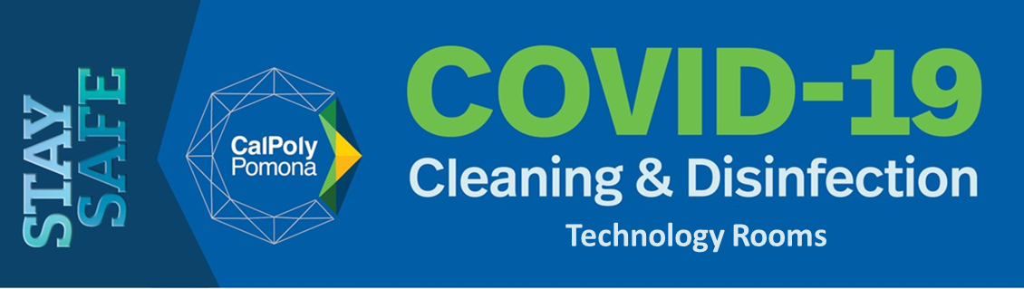

It is important to clean and disinfect work areas between use. Each room is provided with hand sanitizer, disinfecting wipes and PPE. Please follow these guidelines for appropriate cleaning/disinfecting of the space prior to departing the room.

- Obtain and apply gloves.
- Read instructions on disinfectant label. Clean and disinfect high-touch surfaces including, but not limited to, lectern, tables, chairs and seats, doorknobs, light switches, remotes, handles, desks, workstations, pens, whiteboard, etc., that have been used.
- Use proper glove removal techniques (shown below). Dispose of used cleaning and PPE materials in the regular trash.

Step 1: Grasp the outside edge near the wrist.
Step 2: Slowly peel away from the hand turning the glove inside-out. Hold the glove in the opposite gloved hand.
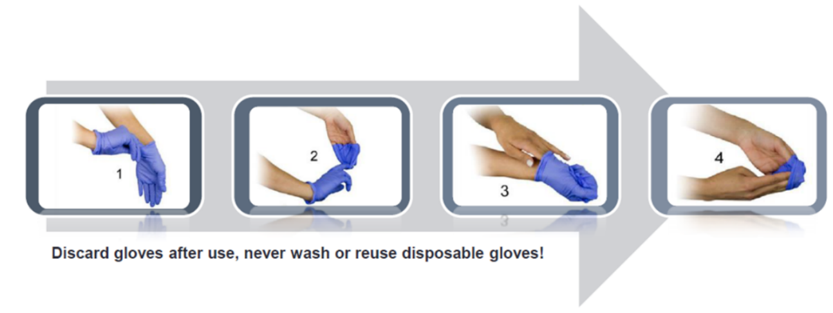
Step 3: Slide your ungloved finger under the wrist of the remaining glove, be careful not to touch the outside of the glove.
Step 4: Peel off from inside, creating a bag for both gloves.
Step 5: Discard the gloves and wash your hand thoroughly.

- Sanitize hands prior to leaving the room.

Cal Poly Pomona is committed to protecting the health and well-being of students, staff and faculty. We appreciate your attention to this important matter, so please do not hesitate to contact Environmental Health and Safety if you have any questions/concerns. Email us at ehs@cpp.edu.

