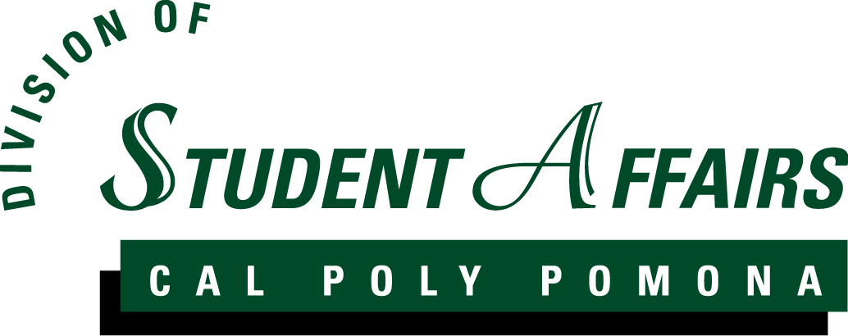

University Housing Services

Bonita Sol Roommate Conflict Assessment

Assessment Report

Felirose Tamparong

Choose One: Other

Date of Assessment Implementation: January 2018

Date of Report: June 2018

Purpose of Assessment
The purpose of this assessment was to determine the need for targeted programming revolving around roommate conflicts for transfer students.

Division Learning Outcome N/A

Targeted Learning Outcome
By participating and engaging in programs and resources provided by University Housing Services and PolyTransfer, residents will:

- Identify key issues with roommate conflicts and be able resolve issues before they escalate
- Gain insight and appreciation of campus resources available to them and how they can become involved
- Understand the rights and responsibilities associated with being part of the Cal Poly Pomona University Housing and campus community
- Develop a connect with the campus through interacting with fellow students, faculty and staff
- Develop an awareness of the resources for managing transitional issues they may encounter as a transfer student
- Feel comfortable and welcome on campus and in their residence
- Have fun and be excited to live in university housing throughout their time at Cal Poly Pomona
- Determine potential programming topics to assist in the reduction of roommate conflicts in the Transfer Housing residence community.

Assessment Methodology
This assessment was done utilizing the qualitative analysis of incident and informational reports submitted via Maxient by the Area Coordinator or Resident Advisor specifically highlighting roommate conflicts. A questionnaire was sent to random students that lived in the Transfer Housing Community.

Results
The results showed that residents who did not have to share a room or space prior to moving into university housing had difficulty resolving conflict. There were mixed reviews regarding the Resident Advisor involvement. Participants stated that they waited to tell the Resident Advisor in an effort to try to resolve the conflict themselves or they informed the Resident Advisor but did not want them to get involved. 100% of participants completed a Suitemate Agreement, however, only 57.1% used the Suitemate Agreement to resolve the conflict. 14.3% attended an event or program hosted by the PolyTransfer Office. However, this event was done in partnership with the Resident Advisor of the Transfer Community and was hosted at the end of the academic year.

Conclusion
As a review of the incidents, incident types, and incidents by subpopulations, the most frequent cases were those of roommate conflicts for transfer students. With these results, it shows that prior to living in university housing as a transfer student, some residents have not gained the knowledge, skills and experiences to develop a solution to resolve an ongoing roommate conflict. As a result, a shift in their academic focus changed due to the stress and frustration of the conflict in question. Rather than spending time on their academic and career growth, submitting reports to the Resident Advisors, meeting with university administrators, and managing their own health and well-being, became time consuming.

Implications for Practice
- Develop and offer passive and active programs to discuss effective ways to communication
- Closer partnership with the Bronco Transfer Center (PolyTransfers Office)

Closing the Loop
- Assist the PolyTransfer Office with marketing to the residents of the Transfer Housing Community
- Assist the PolyTransfer Office to host programs and events focusing on Transfer students transition to living on campus
- Partner with PolyTransfers to develop a required one-unit course that introduce transfer students to use resources physically on campus and online, as well as other topics such as time management, and effective communication

