Kurzweil Read the Web Google Chrome Extension

Install the Extension
  - Get Kurzweil’s Read the Web Extension from the Chrome Store.
  - Click the “Add to Chrome” button in the upper right side of your screen.
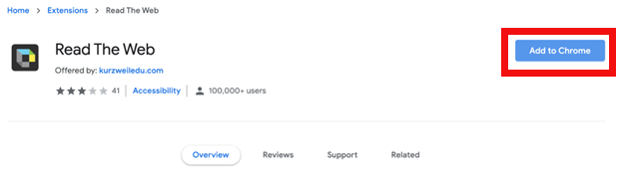
  - Once added, the Kurzweil logo will appear in the toolbar in the upper right corner of the window. The logo will appear greyed out when not in use. If there is a red line through it, the web page is not supported by Read the Web. NOTE: Not all websites will support the Read the Web extension.

Using Read the Web
  - Click the Kurzweil extension in the toolbar, login with your Kurzweil credentials.
  - Click on the page where you would like to start reading and a green cursor will appear
  - Click the play button to start reading. The forward and back buttons can skip forward and back
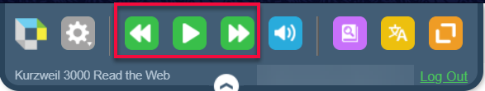

  - Voice and speed settings are in the first menu option with a gear
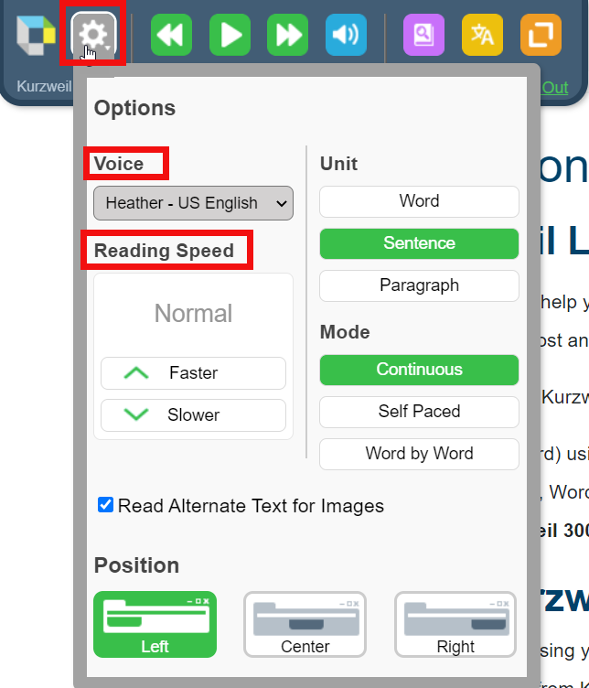
  - The toolbar can be moved to either the left, center, or right of the screen if it is blocking content on the website
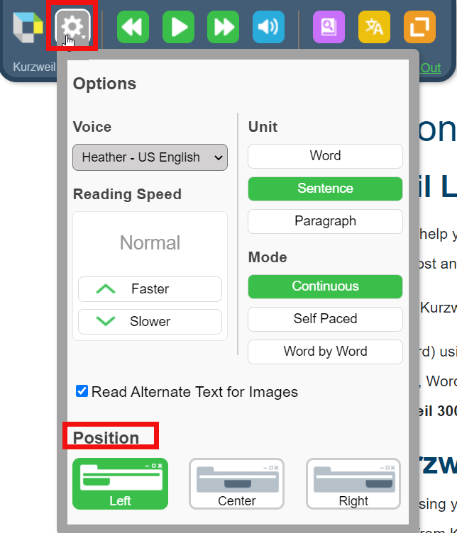

PDFs in Web Browser
If you clicked a link for a PDF and it opens in the browser, the Read the Web toolbar will now include a PDF button. If you click on this button the file will be converted to Kurzweil and open in Kurzweil’s web application.
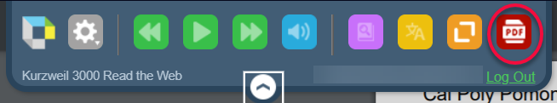

Kurzweil offers a Video Tutorial for Read the Web

