How to Attach Materials to a Saved Notetaking Express Recording
- Log-in to Notetaking Express using this link: https://www.ntehub.com/
- On the main page, select the “My Recordings” tab on the left side of the screen.
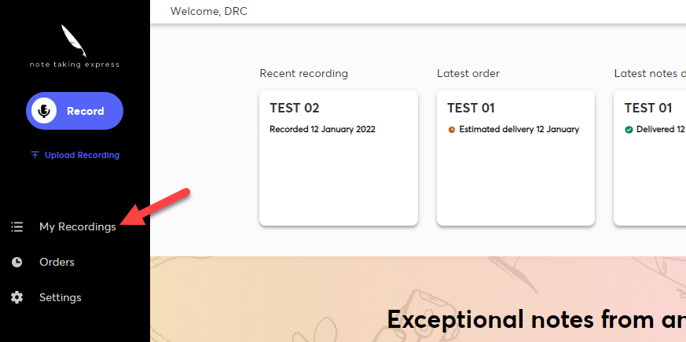
- Among your projects, locate the desired recording. On the project, select the three buttons on the right-hand side of the recording.
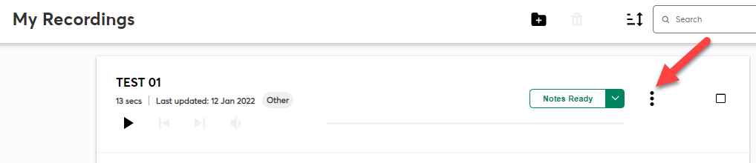
- Once the three dots are selected, a dropdown bar will appear with various options, select “Edit”.
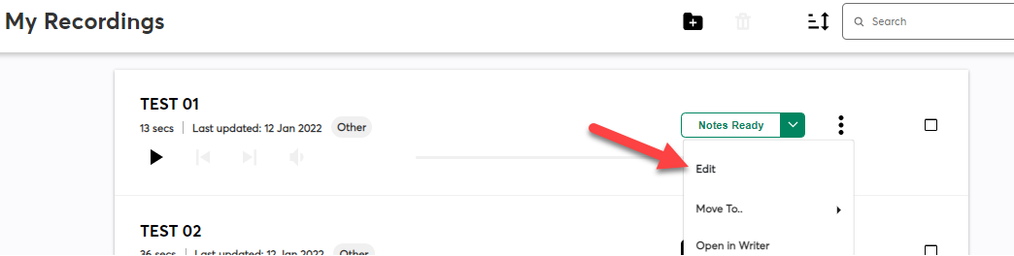

- A pop-up window will appear, under the title box of the recording, select the “Attach” link. This will pull up your File Explorer or Finder. Select the materials you would like to add from your computer, you are allowed to upload up to three files. Once selected, press the “Open” button to attach the material(s).
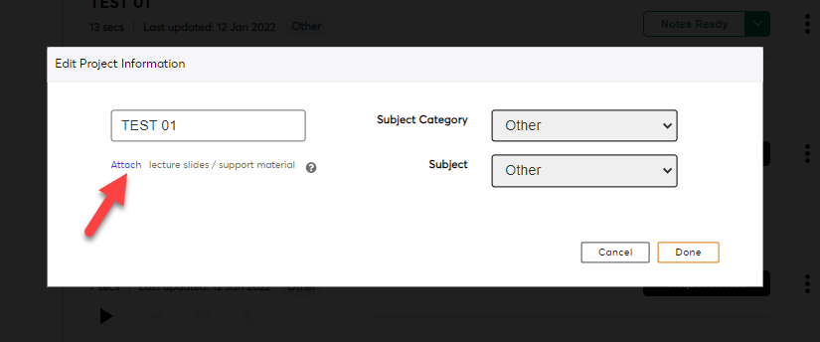
- Once you have attached your materials, confirm they have been uploaded. They can be found under the “Attach” button. Once this is confirmed, select the orange “Done” button in the bottom right-hand corner of the window.
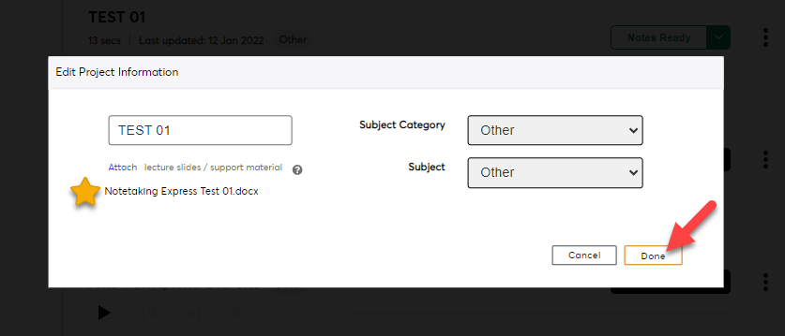
- To confirm the material has been attached, an “Updated Successfully.” notification will appear on the page. Once this is confirmed, you are all set!
