How to Change Your Notetaking Express Password
- Log-in to Notetaking Express using this link: https://www.ntehub.com/
- On the main page, select “Manage Your Account”:
  - In the bottom left corner of the main page, select the icon with four smaller boxes titled “Manage Account”. Or,
  - In the upper right corner of the page, select the circle with the initials of your account. Once this icon is selected, select the box titled “Manage Account”.
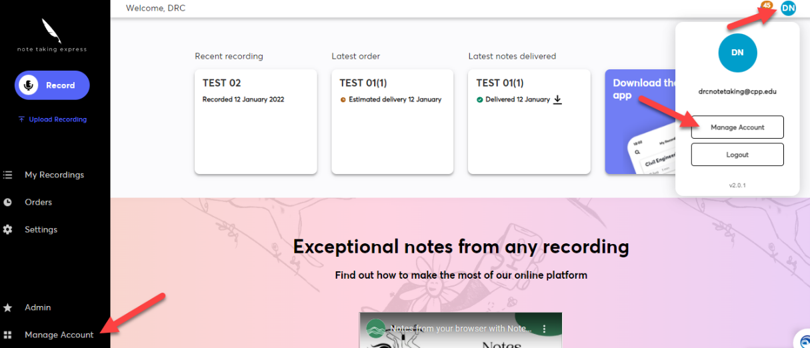
- On the “Manage Account” page, select the “Security and Privacy” box.
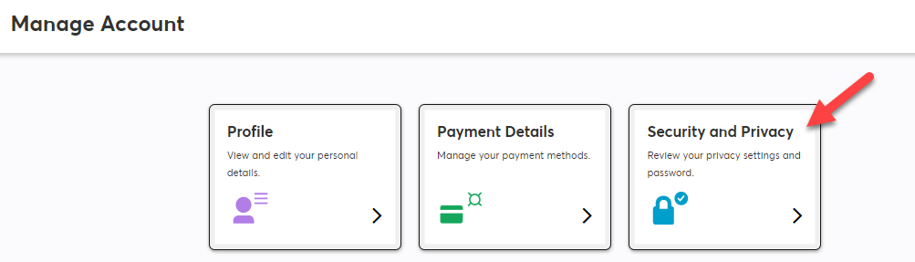

- On the “Security and Privacy” page, find the “Change Password” section. Input your current password, and new password. Input your new password a second time under the prompted box to confirm. Once complete, select the “Change Password” and the box to submit your new password. You are all set!
