How to Download Notes from Notetaking Express Hub
You will receive an email once your notes are ready and have been sent back. However, we encourage students to keep checking their NTE recordings to avoid any delays.
- Log-in to Notetaking Express Hub: https://www.ntehub.com/Account/Login?returnUrl=%2F
- Select the “My Recordings” tab on the left side of the main Notetaking Express page.
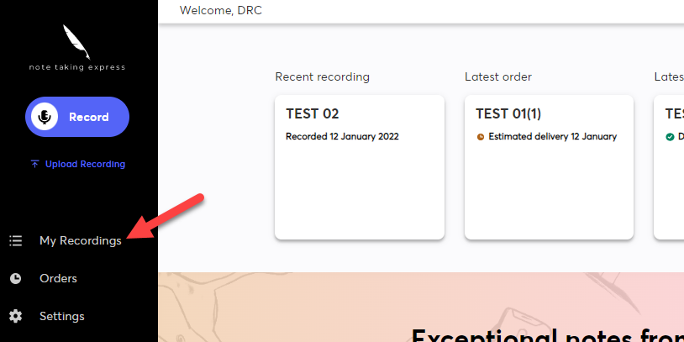
- Find the desired project recording on your “My Recordings” page. Once located, confirm your notes are ready. If the green icon “Notes Ready” appears, your notes are ready for review.
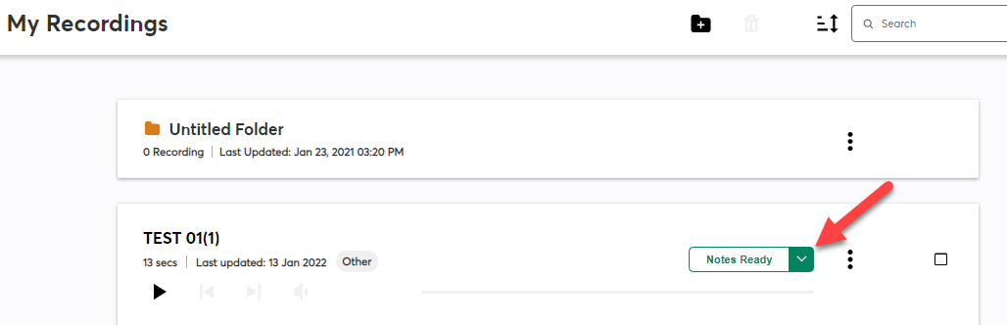

- Select the green “Notes Ready” icon to open to the dropdown bar. On the dropdown bar, select the “Download Notes” button with the downward arrow.
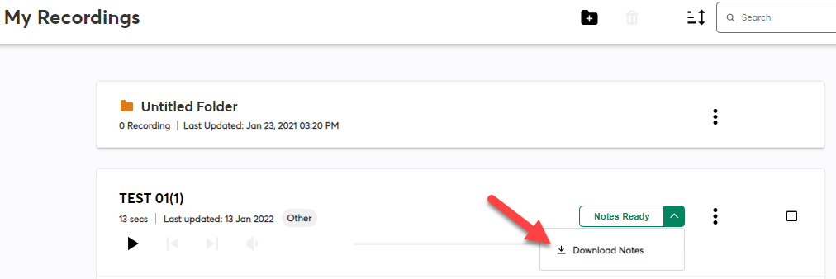
- This will download the notes onto your computer for review. Once you open the document, you are all set! Notes can be found on your Notetaking Express Hub, and will be sent to your Cal Poly Pomona email.

