Kurzweil for Windows
If you have Kurzweil installed on your computer, open Kurzweil and log-in with your credentials. If you need to install Kurzweil install the newest version (choose Subscription/Web-License Version).

How to Upload Books to your Kurzweil Library
- Select “File” menu, and choose “Open”
- Locate the file, and click “Open”
- Once the file has been opened, navigate to “File” menu, then click “Save to Library...”
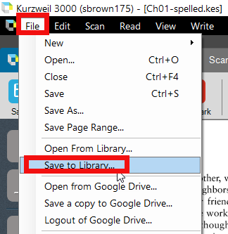
- Once you have clicked “Save to Library...” a new window will appear with the folders of your library. Select the folder you want to save the file in, then click “Save”
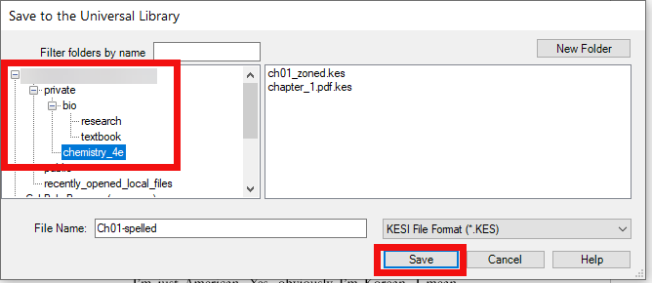

Reading and Options
- Click on the file where you would like to start reading
- Click the “Read” button (looks like a play button) at the top of the screen. The “previous/next sentence” buttons will have the audio read the next or previous sentence.
- If you would like Kurzweil to read a specific sentence, simply highlight it with your mouse and click “Read.”
- To pause the reading, click on the “Pause” button.
- To move on from page to page, click on the arrows on the arrows at the top right corner of the window
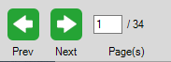

Changing Reading Speed and Voice
- Click on “Audio Options” and a drop-down menu will appear

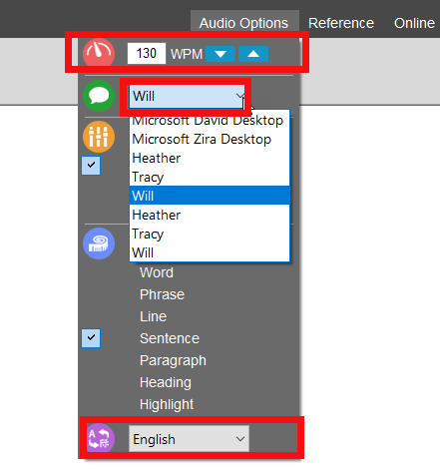
- In the drop-down menu you can select a voice, speed and language.
- You can also click “F11” to increase or “F12” to decrease the speed of the voice at anytime.

How to Highlight
- On the toolbar on the left, you will find the highlighting tool.
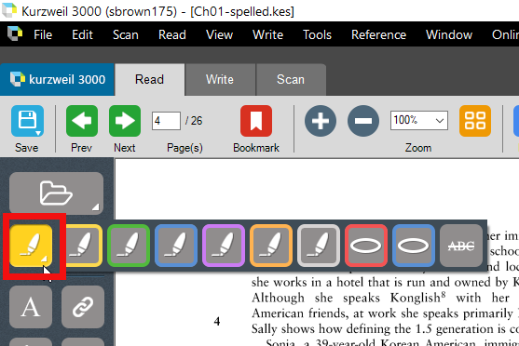
- Click the highlighting tool, to pick your color to start highlighting.
- After the highlighter selection is made, click and drag on the text that you wish to be highlighted.
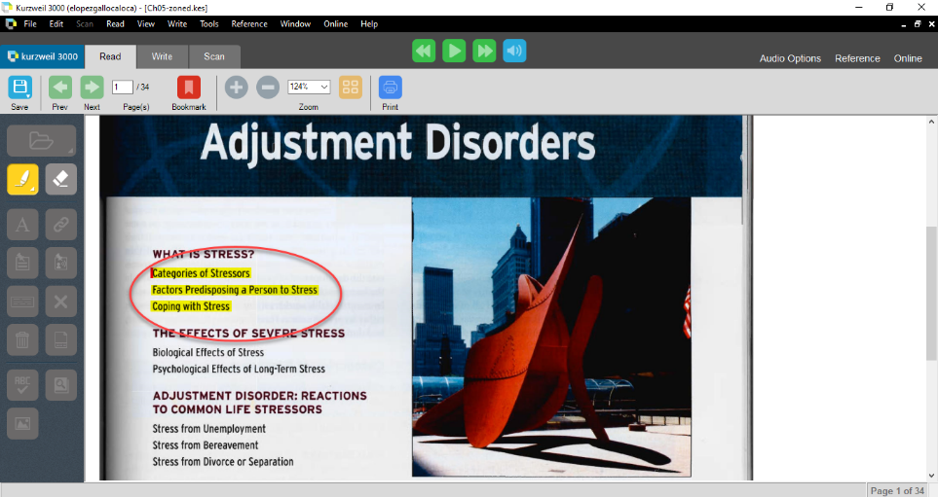

How to Add Notes
- We recommend the use of the sticky notes option.
- Click on the sticky notes icon in the toolbar menu. Click on the book where you want the note and start typing.
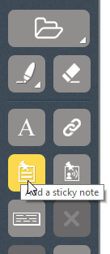

How to Extract Highlights and Annotations
- Click “File” and hover over “Extract”
- Click “Extract Notes & Highlighted Text...”
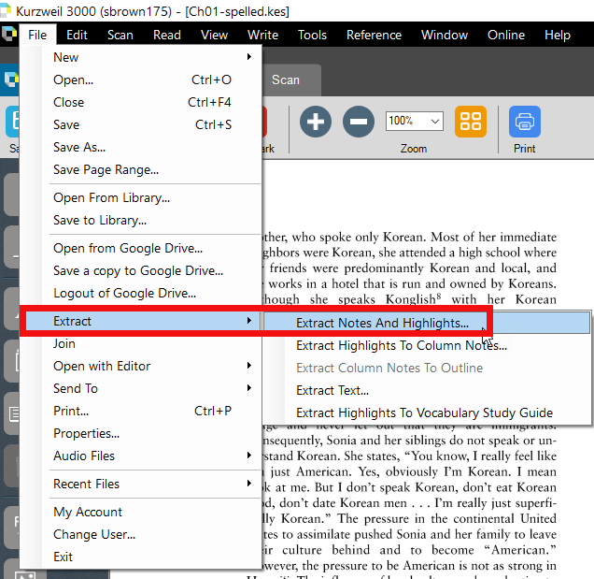
- The Extraction options window allows you to select which notes and color highlights to extract. Select your preferences and click “OK.”
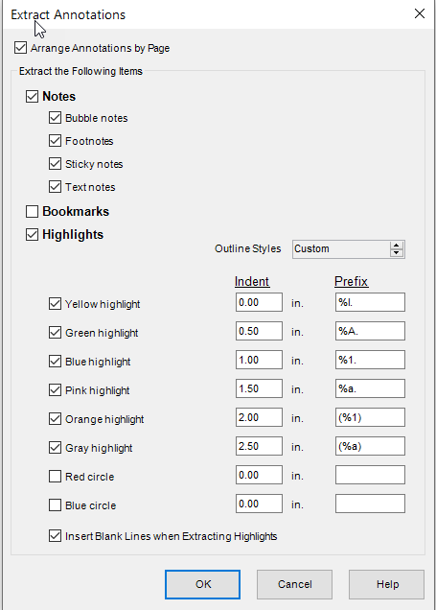
- The notes will be displayed in a new window, with your notes and highlights. We recommend copying and pasting this to a Word document for ease of access later.

How to Create Audio files
- Open document you want as an audio file. Select the “File” menu
- Select “Audio Files” and click on “Create Audio File...”
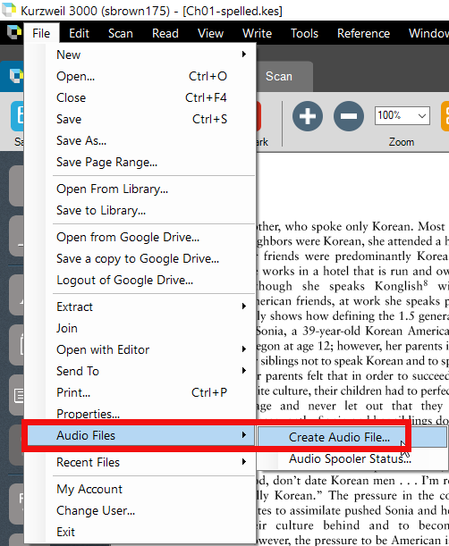
- In the Create Audio File window, select your options voice and speed. Choose the format MP3, and name your file. Choose your option of adding to iTunes or Windows Media Player. Click “Ok” to start creating the audio file
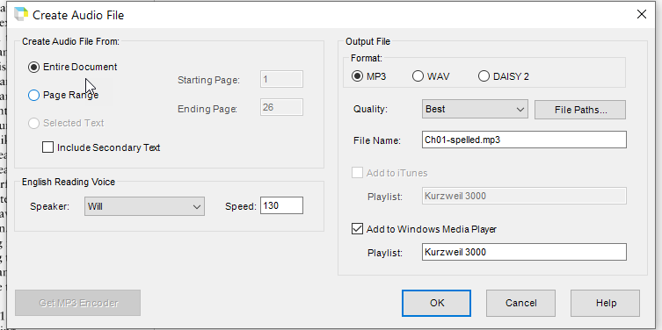
- A status bar will appear as a separate window.

