INTERFOLIO RTP STEP-BY-STEP RESOURCE
FOR CANDIDATES

How to view packet requirements

Before you begin, the DRTPC chair will create a case for you that includes instructions for submitting your packet with all the required documents and forms. You should be notified that your case is ready via email.

- Select “View Case” in the notification email

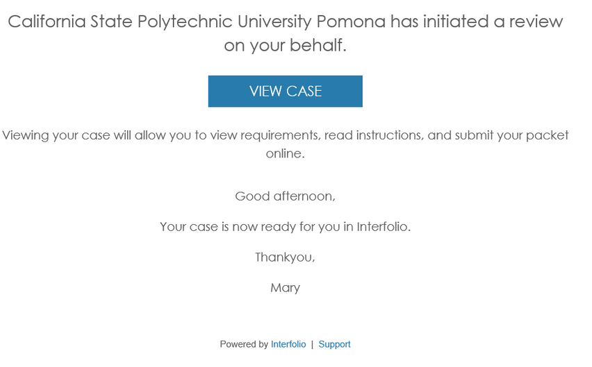

- You will be prompted to create a password that generates the Interfolio account you will use to collect and submit materials for your packet. If you already have an Interfolio account, the “View Case” button will take you to your account dashboard.

