MEMORIZATION TECHNIQUE
Elaborative Encoding - http://www.sdfsc-enews.org/chapter13.pdf

In order to encode incoming information, or an event, into long-term memory,
the best way to do this is to link, associate or connect the incoming information with something already in your memory in order to make it meaningful.

You can retrieve the memory, because you have an actual means to recall it, due to associating, linking or connecting the incoming information with something already in your memory.

There are visualization or guided imagery techniques you can also use to recall
memories. You can visualize your mind as having many rooms, full of many objects related to your memories, of which you can add a new memory by placing it in its most appropriate room and location.

This type 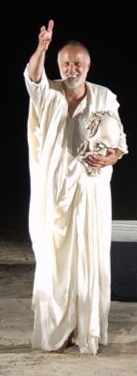of visualization and elaborative encoding known as Mnemonics was first used by Simonides, a Greek philosopher, back in 477 B.C., for his oratory speeches. Mnemonics has been used effectively throughout history and has played a major role, exerting a large influence on artistic and religious life, especially during the Middle Ages.

For instance:

1. Try to remember a guy whose name is Baker.
Or
2. Try to remember a guy who IS a baker.

Likely Result: You can remember the guy who is a baker, but not the guy whose name is Baker. Why? Because the person who is a baker creates a visual which you put in context.

The art of Elaborative Encoding memorization technique is to take content that is lacking in context and meaning and make it meaningful to us.

So what does that mean?

Well, say you want to memorize a speech using Elaborative Encoding. You don’t want to use notecards! Try this: Associate an image with every phase of the speech. For instance, when memorizing the beginning of your speech, think about the beginning topic and then associate that with a picture. It could be anything. Joshua Foer, in his TED Talk associated his beginning with a bunch of nudists riding bicycles and crashing into his front door!

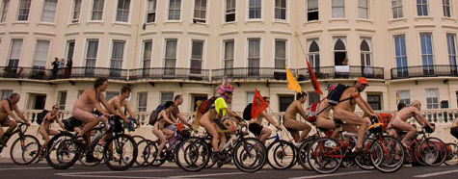

He associated the middle part of his speech with the characters from the Wizard of Oz.
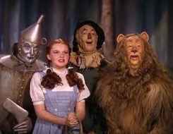
Then he associated the end part of his speech with Britney Speers dancing on his coffee table!
You choose the visuals to remember your speech! You become the artist!

See Joshua Foer: http://www.ted.com/talks/joshua_foer_feats_of_memory_anyone_can_do.html

Tips:
- Be deeply engaged in what you want to remember -- intend to remember.
- Use ear muffs and dark goggles when you work on remembering something (no distractions)
- Remember things TOPIC BY TOPIC.
- Practice memorizing random things with vivid images every morning for 15-20 minutes – MAKE IT FUN!

Our lives are the sum of our memories.

