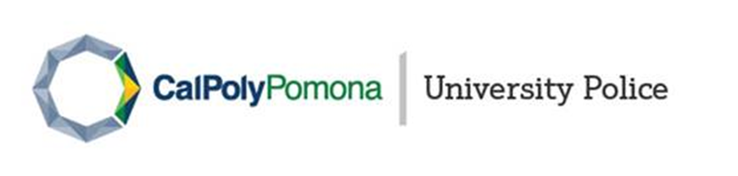
This timely warning bulletin is being issued on 08/27/2021 in compliance with the Jeanne Clery Act and the purpose is to provide preventative information to the campus community to aid members from becoming the victim of a similar crime. While these notices are primarily an attempt to increase safety awareness, they also serve to dispel myths and rumors regarding campus crimes or incidents.

The Crime

On 08/26/2021 the University Police Department (UPD) received the following crime information: On 08/14/2021 at approximately 03:00 am, a known suspect was invited to an apartment at the University Village. The suspect arrived at the apartment under the influence of alcohol and then consumed additional alcoholic beverages with the victim and her roommates. The suspect then went with the victim to her bedroom and later forced her to have sex with him multiple times before leaving the apartment in the morning. UPD is investigating this crime as an isolated incident of forcible rape and sexual battery.

Anyone with information that may assist in the investigation is urged to call UPD at 909-869-3070. Anonymous tips can be provided by calling the Anonymous Tip Hotline at 909-869-3399.

How to Stay Safe

- Most sexual assaults are committed by someone the victim knows, typically a date or acquaintance, rather than a stranger.
- An incapacitated person (for example, a person under the influence of drugs or alcohol) is incapable of giving consent.
- Alcohol and drugs are often used to create vulnerability to sexual assault.
- If you see a situation that may lead to a sexual assault, check in and provide support.

Support Resources

- Counseling & Psychological Services (CAPS): 909-869-3220
- Survivor Advocacy Services (SAS): 909-869-2196
- CPP Life Matters by Empathia (Faculty/Staff): 1-800-367-7474
- Office of Equity and Compliance (OEC): 909-869-4646

