Kohler Microscope Alignment Procedure

1. Before plugging in the microscope (or its light source) be certain it is turned OFF.
Reason: Plugging in a microscope or an illuminator that is set for high brightness is the number one cause of blowing the bulb. Some microscope (or illuminator) bulbs are very expensive and may take weeks or months to replace.

2. Rotate the 10x low power objective lens into viewing position.
Reason 1: Starting off with the 10x objective (with a lot of clearance) will allow you to bring the specimen into relatively close focus without damaging any of the higher power (low clearance) objectives which might occur if such a (longer) lens is rotated into a microscope slide.
Reason 2: The 10 x objective is typically used for initial alignment the optical system of the microscope.

3. Move the condenser lens all the way to the top just below the plane of the stage.
Reason: This will enable you to align the condenser lens by moving it away (down) from the specimen.

4. Place a microscope slide on the specimen stage, turn on the light & bring the specimen into focus.



Step 1: bring the image of the specimen into sharp focus.

5. Close the iris diaphragm at bottom of microscope and examine the small illuminated circle.
Reason: This step will allow you to properly align the condenser lens.

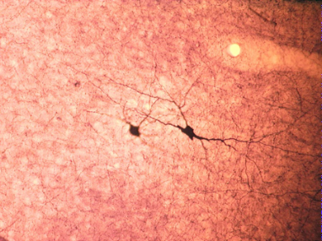
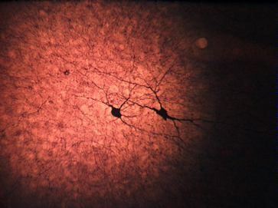

Step 2: Close the field iris to begin alignment of the condenser lens.

7. Slowly lower condenser and bring the dark blurred edges of the illuminated circle into focus.
Reason: This step will allow you to properly adjust the height of the condenser lens.

Step 3: Adjust the height of the condenser and bring edge of iris into sharp focus.

8. Use the condenser adjustment screws to center the illuminated circle.
Reason: This step will allow you to center the condenser lens.
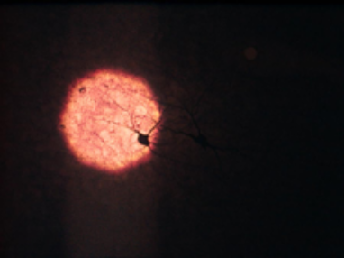


Step 4: Centering the condenser lens will also center the illuminated circle.

9. Open the iris diaphragm until the illuminated circle fills the entire microscopic field.
Reason: This step will allow you to view an evenly illuminated whole microscopic field.


Step 5: Opening the field iris will give you a full view of the microscopic field.

10. Congratulations! Your microscope is now aligned.
Note: Kohler alignment is necessary for optimizing microscopic viewing and for even illumination of the microscope field for photomicrography .

