**The 8th International Conference on Lattice Path Combinatorics and Applications is dedicated to Shreeram Shankar Abhyankar (1930 - 2013) and Philippe Flajolet (1948 - 2011).**

**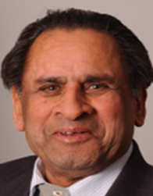          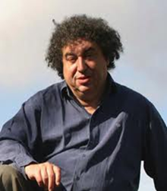**

**Shreeram Shankar Abhyankar                                                  Philippe Flajolet**

**We also are honoring George Andrews and Lajos Takács.**

**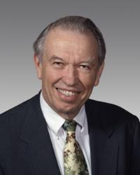                                             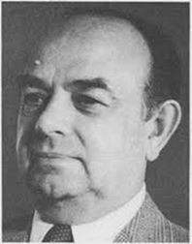**

**George Andrews                                                              Lajos Takács**

**Our Conference program includes several talks describing these well-known and influential mathematicians. At a dinner beginning at 7 pm on Monday, August 17 at the Kellogg West Hotel Center, Professor Cyril Banderier of CNRS/Univ. Paris-Nord, France (a graduate student and collaborator of Professor Flajolet), will present his talk on *The Analytic Combinatorics Point of View of Philippe Flajolet on Lattice Paths*. On Tuesday, August 18 from 4:20 pm-5:10 pm in the Library, room 1807, Professor Aliakbar Haghighiof Prairie View A&M University (who earned his Ph. D. with Professor Takács as his advisor) and Professor Sri Gopal Mohanty of McMaster University will jointly present a talk entitled, *Professor Lajos Takács: Life and Contribution to Combinatorics*. On Wednesday, August 19 from 3:00 pm-3:50 pm in the Cal Poly Pomona Library, room 1807, Professor Sudhir Ghorpade, Indian Institute of Technology Bombay, and Dr. Devadatta Kulkarni, Tata Consultancy Services, (both former graduate students of Professor Shreeram Abhyankar) will fondly recollect *Shreeram Abhyankar and His Work on Enumerative Combinatorics*. Later that same evening during the Conference banquet from 7:00- 10:00 pm in the Kellogg House, Professor Krishnaswami Alladi of the University of Florida will present his personal reflections on George Andrews and Shreeram Abhyankar.**

**During the Tuesday, August 18 dinner (beginning at 7 pm) at Kellogg West, Conference participants will be entertained by Professor Arthur Benjamin (Harvey Mudd College), a mathematician and a magician. In his fast-paced performance, he will demonstrate and explain how to mentally add and multiply numbers faster than a calculator, how to figure out the day of the week of any date in history and other amazing feats of mind. He has presented his mixture of math and magic to a wide range of audiences all over the world. All conference attendees are encouraged to come and enjoy this show.**

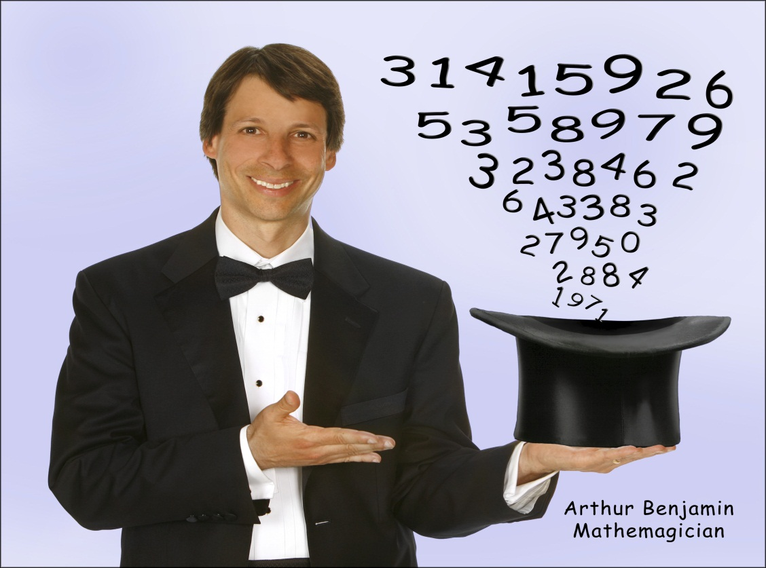

**In closing, an acknowledgement and deep appreciation is in order to the founder of Lattice Path Combinatorics International Conferences, Professor Sri Gopal Mohanty. It would indeed be difficult to overstate the importance and influence that Gopal Mohanty has had in conceiving and realizing this series of conferences on lattice path combinatorics for more than 3o years. For the interesting history of these conferences and the philosophy behind them, please read the account from the man himself in his article, *Reminiscing over*, reproduced below. He has helped so many people develop and express their own contributions in this rewarding area of combinatorics. Rest assured that Professor Mohany’s enthusiasm and commitment for lattice path combinatorics remains strong and vital today. Thank you Professor Mohanty for all that you have done and your constant support.**

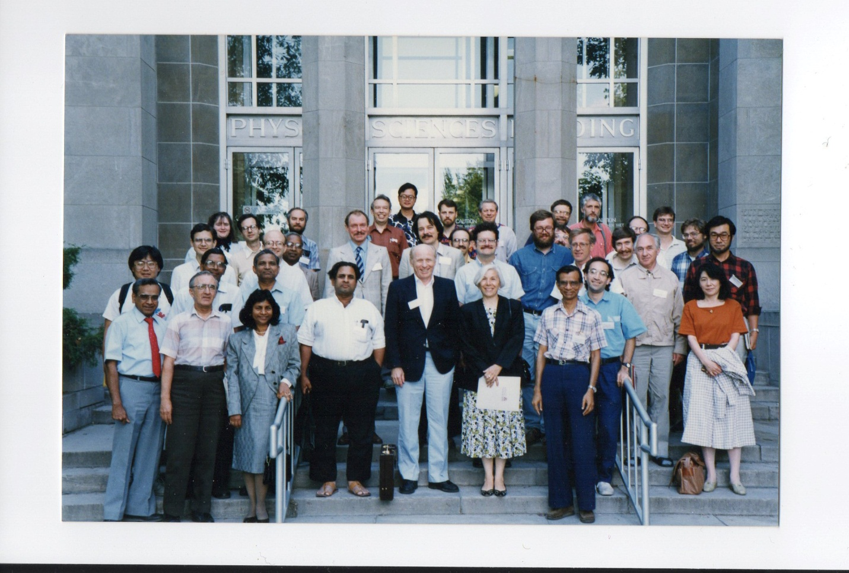

Second Lattice Path Combinatorics Conference 1990 – McMaster

This picture contains **Shreeram Abhyankar, George Andrew and Sri Gopal Mohanty.** Can you find them? Do you recognize other participants?

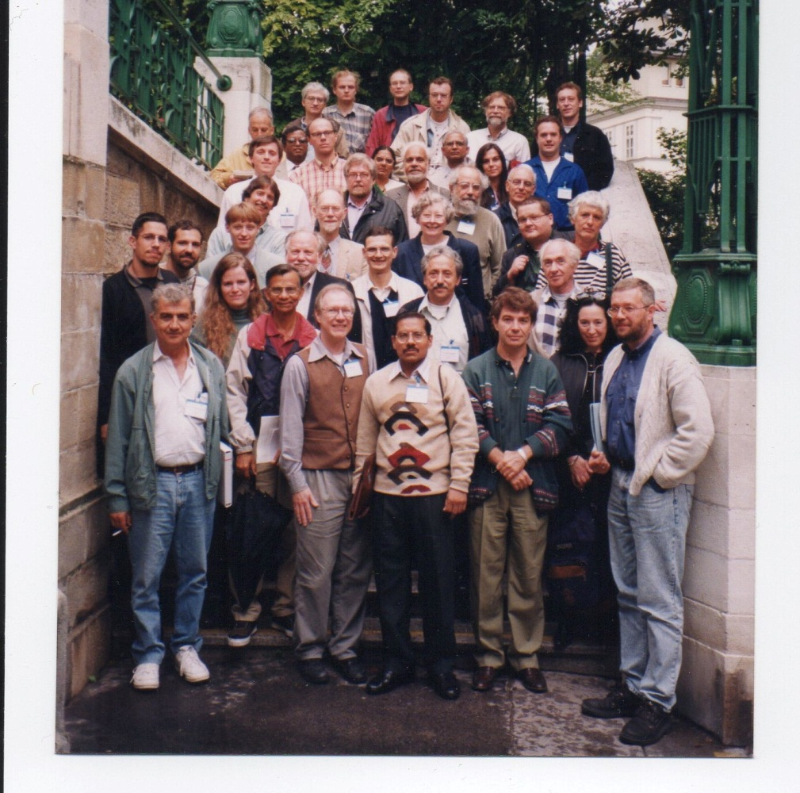

Fourth Lattice Path Combinatorics Conference 1998 – Vienna

Who do you recognize from this picture?